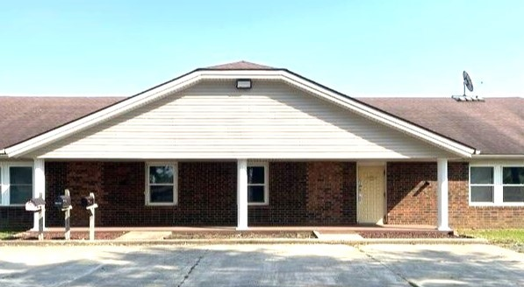

Awesome LOCATION!!
9100 S CR 800 W Daleville, IN
$1551.08. month/ 2659 sq ft
MLS #202313787

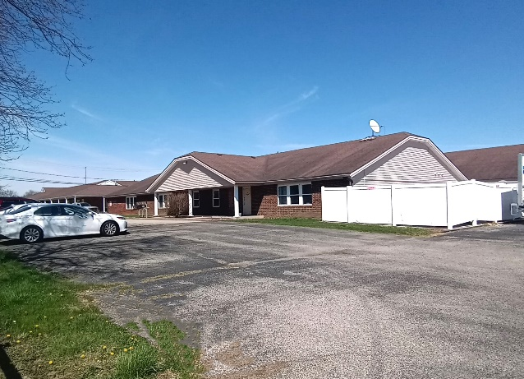
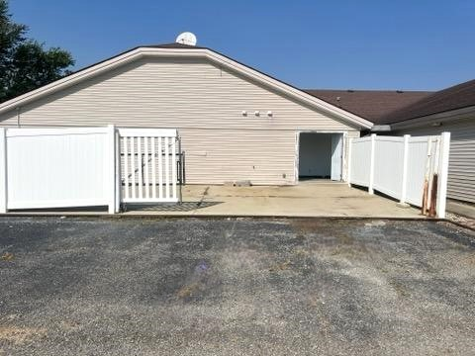
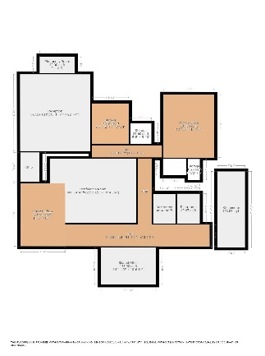

Property Details
- Approximately $1551.08 a month
- Cam $470.00
- 2659 sq ft of Leasable Space
- $3000.00 decoration credit w/ 5-year lease term
- 4 offices and 3 Storage areas
- Kitchenette, Large Conference room
- Close to I-69
- Building Signage
- Landlord onsite handles Snow Removal / Lawn Care
- Ample Parking

