
To arrange a private viewing contact: Dino Ramirez, Broker 219-999-2305 www.jrdagents.com

LEASING OPPORTUNITY

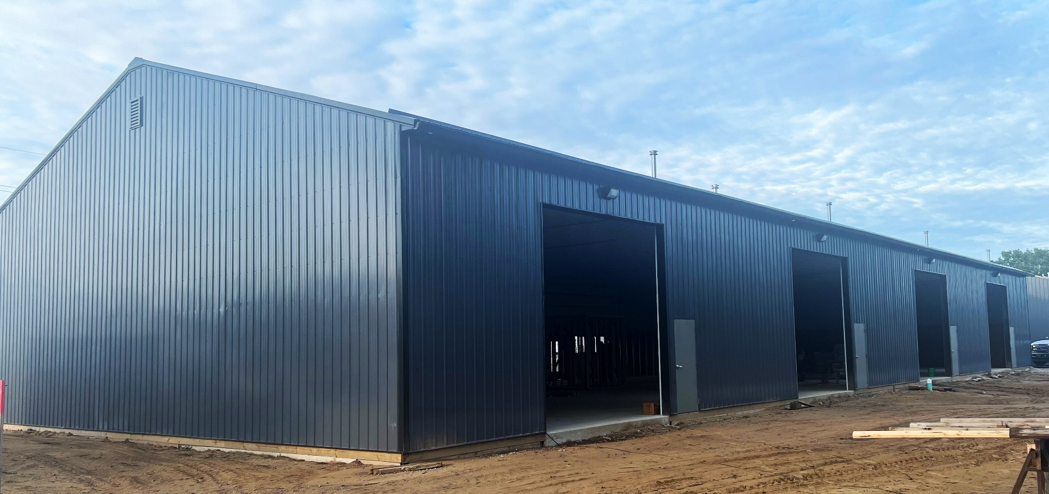

220 Division St. Schererville, IN 46375-1248

- 6” Thick reinforced concrete floors
- 16-foot ceiling height
- 4 - 14’ Garage Doors
- Lake County - Indiana
- Space Available: 8,400 sq. ft.
- Price Per SF: $ 12.50 / NNN
- Year Built: 2024
- Zoning Type: General Industry

PROPERTY OVERVIEW
This newly constructed 8,400-square-foot warehouse in the general industry zoning district of Schererville, IN, presents an excellent opportunity for various business operations. The facility includes 7,000 square feet of warehouse space and 852 square feet of office space with one bathroom.
Built for heavy-duty use, it features a 6-inch-thick reinforced concrete floor and a 16-foot ceiling height, ideal for vertical storage. The design emphasizes efficiency, with four 14-foot drive-in doors that simplify loading and unloading. Its modern construction and strategic location make it an ideal choice for businesses seeking to enhance their operations in a new facility.

LOCATION OVERVIEW

Located just 2 miles from both Route 41 and Route 30—bustling retail corridors known for their diverse retail options and commercial activity—this warehouse offers excellent accessibility. It is also only 5 miles from the Illinois/Indiana state border, positioning it strategically for interstate business. With proximity to key transport routes, including 15 miles from I-65, 6 miles from I-80/I-94, and 10 miles from I-90, the facility is ideal for businesses that depend on efficient interstate travel and logistics.
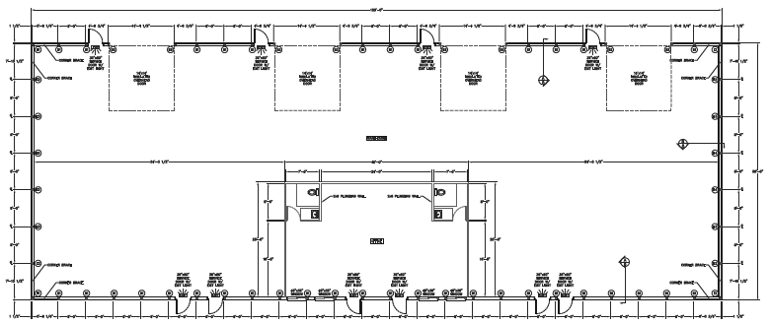

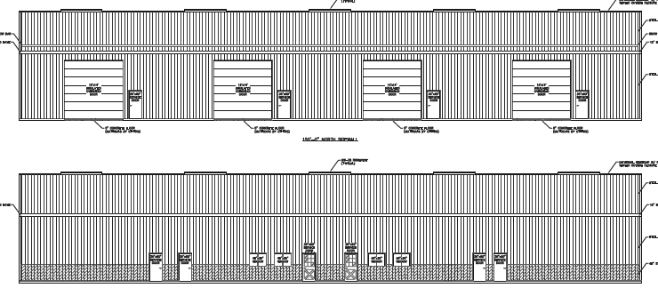

To arrange a private viewing contact: Dino Ramirez, Broker 219-999-2305 www.jrdagents.com
Dino Ramirez, Broker
219-999-2305
Dino@jrdagents.com
Jrdagents.com

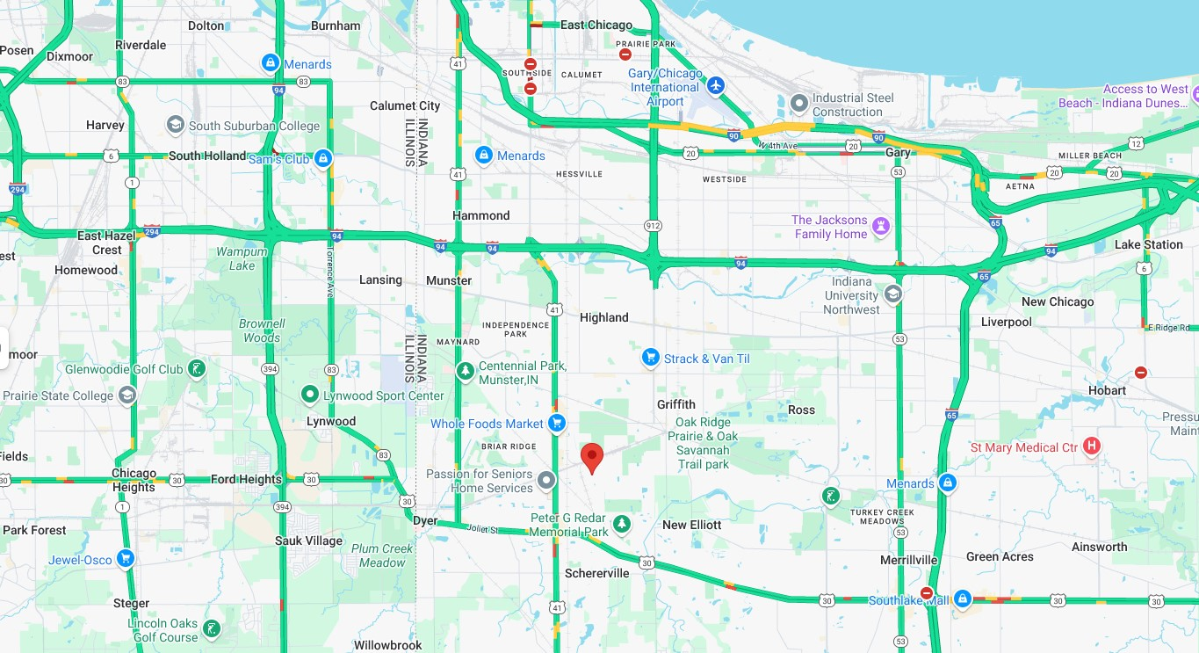

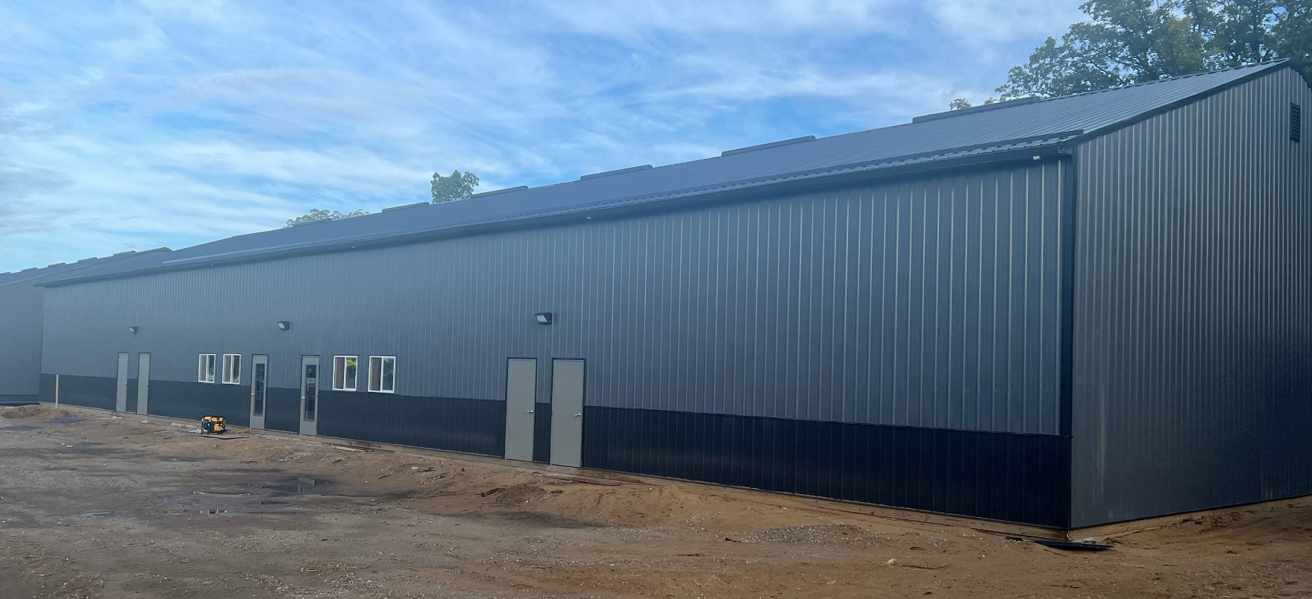

To arrange a private viewing contact: Dino Ramirez, Broker 219-999-2305 www.jrdagents.com
Dino Ramirez, Broker
219-999-2305
Dino@jrdagents.com
Jrdagents.com

