Shop for Rent in Peachland BC
4402 Maxwell Road Peachland BC

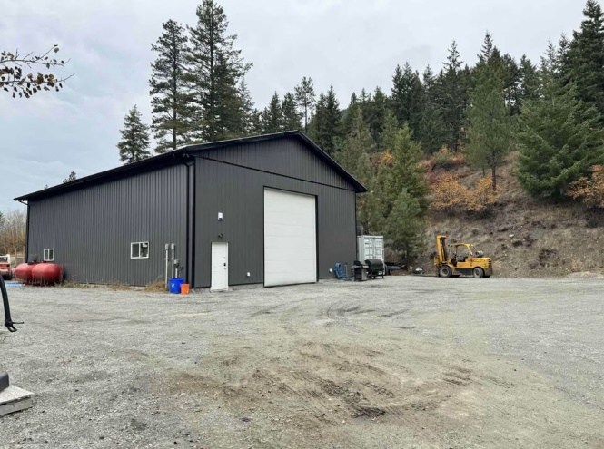

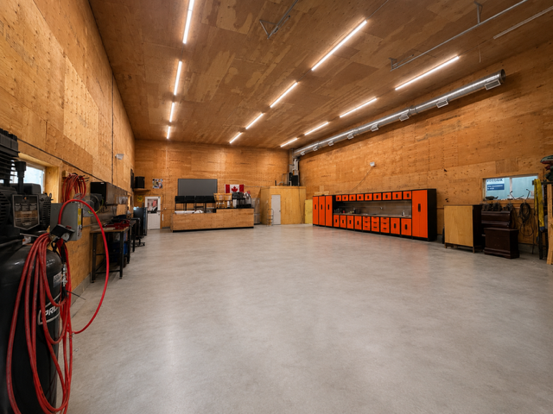

60x40 (2400 sq feet)
18 foot overhead door
22 foot ceilings
Bathroom with shower
100 amp single phase power Has 240 amp for welding.
Lots of parking available-negotiable

$4000 per month

Wayne 604-868-5388
Wayne@tullisrealty.com

