
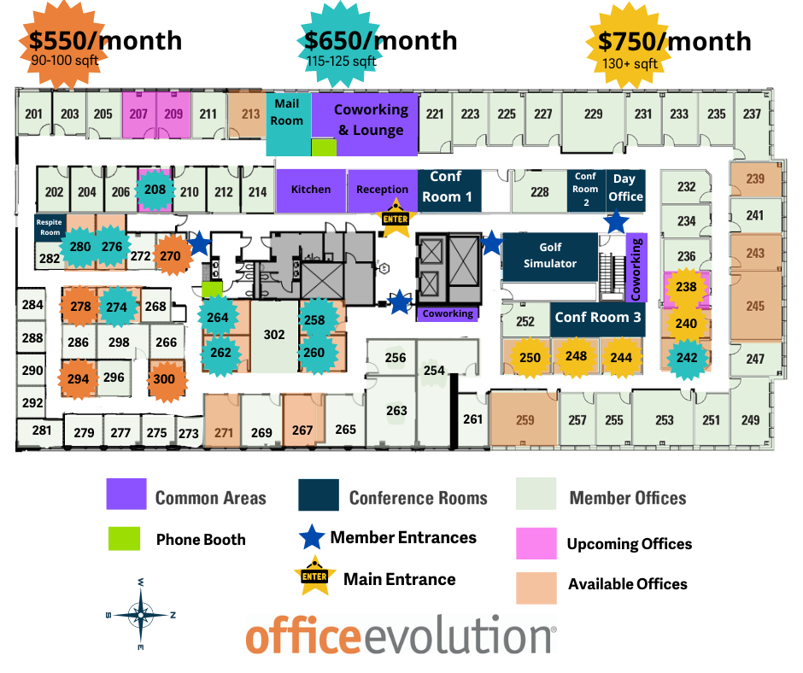

We require a security retainer, equal to one month’s rent, and up to a $199 Set-up Fee. This retainer can secure offices for you for up to 30 days and is refunded to you upon moving out less any damage and $300 in cleaning fees. The set-up fee is nonrefundable.

Suite # | Int/Ext | Ft 2 | Summer Sale Rate | Available?
207 | Ext | 116 | $900 | 8/1/24
209 | Ext | 116 | $900 | 8/1/24
213 | Ext/End | 173 | $1,500 | yes
239 | Ext | 147 | $1,200 | yes
243 | Ext | 158 | $1,350 | Yes
245 | Ext | 282 | $1,800 | Yes
259 | Ext | 292 | $1,900 | yes
267 | Ext | 165 | $1,400 | Yes
271 | Ext | 143 | $1,200 | Yes

Amenities Included with Private Office Plan - should you decide to opt out of any of the following, the pricing does not change.

- Furnishings –
  - 1 desk set, ergonomic adjustable work chair, and 2 guest chairs included per office.

- Internet (wired and wireless)
- Use of Private meeting Rooms, Day Office, Therapy Office and Golf Simulator (rates vary by room size and location. However, $60/month at Member Rates is included on the base rental rate.)
- 24/7 Unlimited Business Center Access at all Nationwide Locations
- Business Address & Private Mailbox
- Front Office Staff during standard business hours.
- High Quality Copier/Scanner access (Copies or Prints B&W $.15/page; Color $.30/page)
- Use of Community Kitchen
- Complimentary Hot Beverages, Beer, Hard Seltzers & Purified Water

Additional Costs
- Parking: There is a parking garage in the basement – Reserved spots are $80/month if available. Otherwise, the parking garage to the west of the building is free and members are required to park on the 2nd floor or higher if they are staying for more than 2 hours.
- Additional Employees - $50/month/additional employee & a one-time $25 set-up fee/additional employee (Only one employee is included in the base rent).
- Administrative Support - $10 for the first 5 minutes, $1.50/minute thereafter
- Notary and witnessing (where available) - $5.00 for signings at the front desk. $10 for signings away from the desk for up to 5 min, $1.50/minute thereafter
  - We will only provide 1 witness or notary. You may not walk around the office asking other members to witness. Please plan accordingly.
- Outgoing Fax by Business Center Manager - $10/fax
- Mail Forwarding - $20/occurrence plus 140% on postage
  - International mail forwarding - $35/occurrence + 140% on postage
- Postage – 140% of postage charge
- Replacing Mailbox/Keys/Fobs - $50 for each lost/unreturned item FOB or MB key, $100/office key
Early Membership Termination – Member termination of agreement before the contracted end date - $300 minimum restoration/cleaning Fee + the greater of 1/3 of the remaining agreement OR 2 month’s fee.

Payment Options
a. Check – No Add. Fee’s
b. Electronic Funds Transfer (ETF) – You send the money to us - No Add. Fee’s
c. ACH Payment – We automatically pull the money from your checking account – No Add. Fee’s
d. Debit or Credit Card – We automatically charge your card each month
Credit Card Fee - 2.5%
Debit Card Fee
- $3.95 for transactions up to $1,000
- $4.95 for transactions from $1,000-$2,000
- $9.95 for transactions over $2,000

Conference Rooms- 24/7 conference room access nationwide (13 front range locations). Rates vary some by location and are available at the online reservation website. Generally, they are as stated below.
  - Day Office $25/hr, Small Conference Room $25/hr, Medium Conference Room $30/hr, Large Conference Room $35/hr, Golf Simulator $30/hr, Therapy Office $20/hr, Massage Chair/Respite Room $FREE
  - Early Check-In – 5 minutes no charge-subject to availability
  - Conference Room Clean up – if the room is not returned to clean pre-meeting condition – there will be a $50 charge

