
EVERGREEN LOCATION SERVICES
337 Changebridge Rd, PO Box 180
Pine Brook, NJ 07058-0180

OFFICE SPACE FOR LEASE
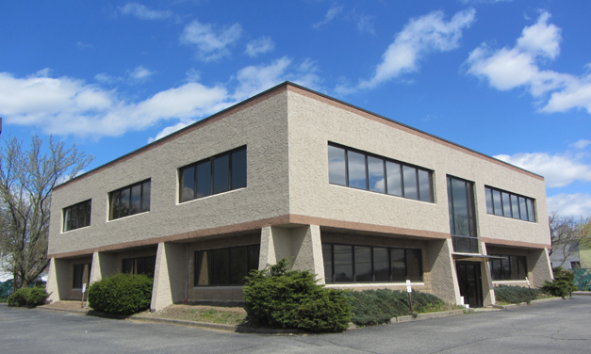
1130 Rte 46, Parsippany ( Morris County)

1575+/-sft
2nd floor
OR

800+/-sft
1st floor

B2 zone

Offered at $18.00sft + utilities

Prime location on Rte 46 West, easy access to Rte 287/80/280
Ample parking
Highway Signage
Strong demographics/High Traffic

For more information call Cathie Salamone direct 201 400 0660 or cathies@evergreencommercial.com or
Sal Bellafiore 201 400 8847 salb@evergreencommercial.com

*all information deemed reliable but not guaranteed*

