For sale
1025 Jackson St NE, Washington DC 20017

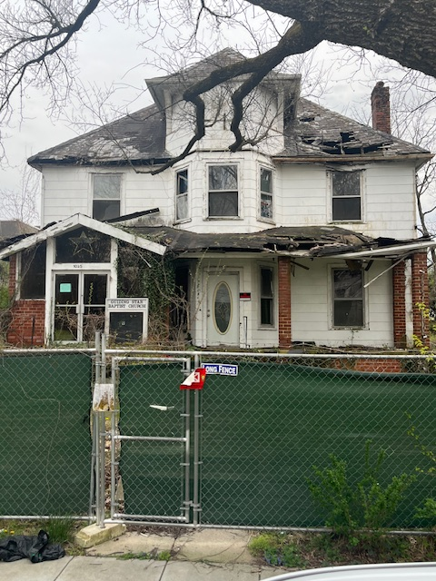

📢 Exclusive Off-Market Opportunity – Secure This Prime Brookland Property Before It Hits the Market! 📢
Incredible Development Opportunity in the Heart of Brookland!
Don't miss this rare chance to acquire a premium property in one of DC’s most sought-after neighborhoods. Whether you're a developer, investor, or looking for a unique project, this expansive lot offers exceptional potential.

📍 Property Details:
📍 Address: 1025 Jackson St NE, Washington, DC
🏡 Current Structure: An old Victorian-style home, formerly used as a family church. The structure is in poor condition and requires either a full renovation or demolition.
📐 Lot Size: 15,000 SF (100 ft x 150 ft) – a truly rare find in Brookland! Originally two separate 7,500 SF lots (50x150 each), the property was combined into one large parcel.

🔹 Zoning & Development Potential:
Zoning: R-2
This property presents an incredible opportunity for redevelopment.
✅ By-right development options:
1️⃣ Construct one semi-detached home (two units) and one single-family home (three total units).
2️⃣ Renovate the existing structure and build one new single-family home (two total units).
⚠️ Buyers are advised to conduct their own due diligence regarding development feasibility.

🏡 Ideal for Residential or Religious Use
📌 Development: With homes in Brookland selling for up to $1.5M, this property is a prime candidate for a profitable redevelopment project.
📌 Church Use: The land may also be ideal for a new or existing congregation looking for space.

💲 Pricing & Potential Returns
📌 Asking Price: $1,500,00 (Negotiable)

Brookland remains one of DC’s hottest neighborhoods, making this an unmissable investment opportunity!

- Access to Property: Due to safety concerns, interior access may not be possible. If required, a full indemnity and hold harmless agreement must be signed.
📢 Looking for a fast closing with an experienced buyer.

📞 Contact Information
For inquiries, please contact:
📲 Mr. Charles – 240-604-3583
Don’t miss this chance to acquire a high-value parcel in one of DC’s most vibrant neighborhoods. Act now before it’s gone! 🚀

