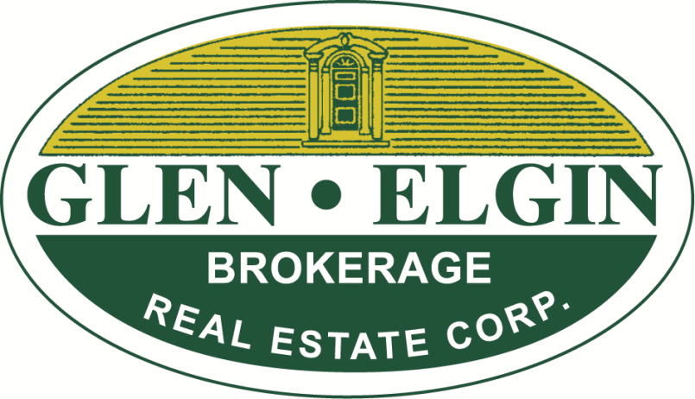
INTRODUCING

The WOOLVERTON HOUSE

Grimsby’s Newest “Premium”

Office Offering

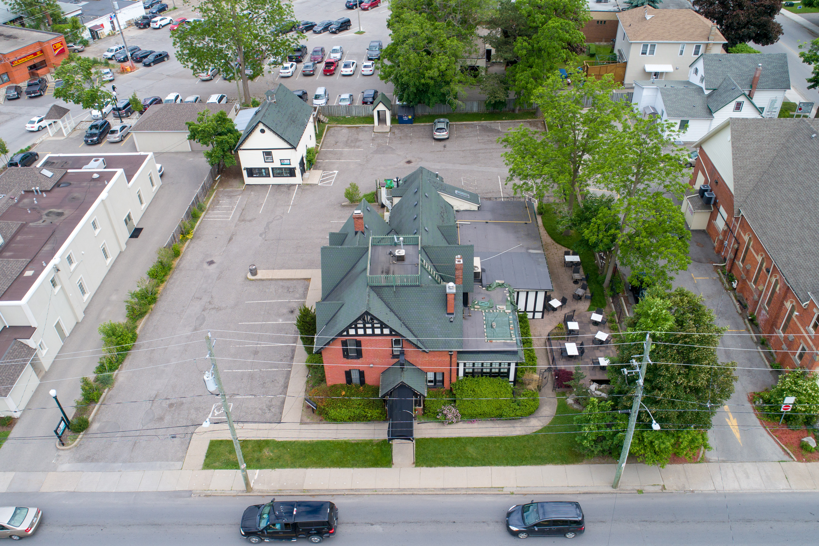

Property Address: No. 13 Mountain Street, Grimsby
* Lease Rate: $19/sq.ft.+ T.M.I. $6.50/sq.ft.

Nestled in the commercial core of the Town of Grimsby, the Woolverton House
features a Boutique Hotel, Coach House and “Now”- unique main floor office “For Lease”
offering 612 square feet plus basement storage. A classic building with large windows, high ceilings, special trim/finish features and much more. A unique and wonderful opportunity for special office space! Approaching interior completion, this is the last of the new office spaces that came to market this year.
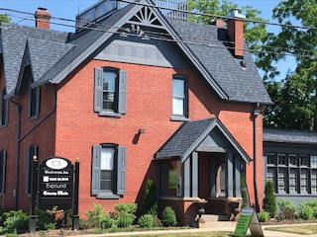

For further information contact:
David Jarvis, Broker of Record
davidjarvis@glenelgin.com
905-945-7730

THE WOOLVERTON HOUSE

NUMBER THIRTEEN MOUNTAIN STREET, GRIMSBY

MAIN FLOOR PREMIUM OFFICE OPPORTUNITIES

UNIT #1: LEASED LEASED

UNIT #2: LEASED LEASED

UNIT #3: 612 sq.ft. @ $19/sq.ft. $969.00/month (+ basement storage)

$204.87*

$1,173.87 + $157.61 H.S.T.

*TMI/Recovery Charge @ $6.50/sq.ft.

N.B. (i) Utilities are in addition to rents herein

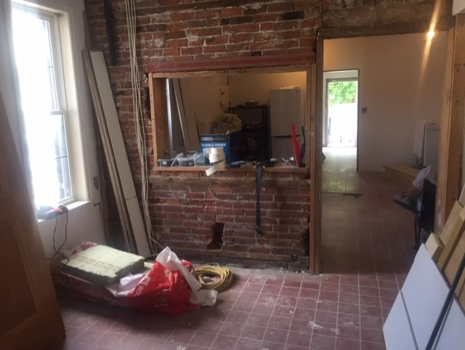
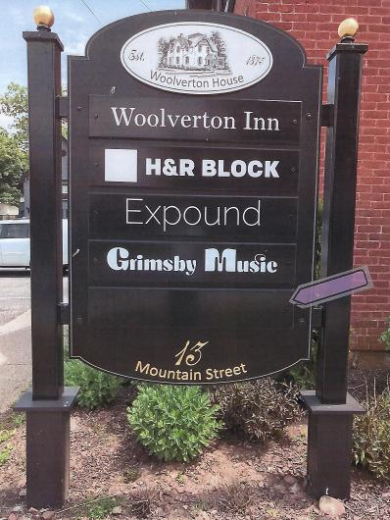

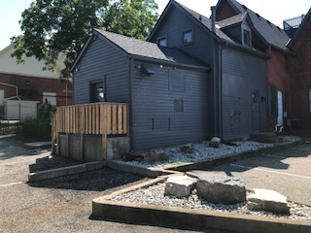

INTRODUCING

THE WOOLVERTON HOUSE

Grimsby’s Newest “Premium”

Office Offerings

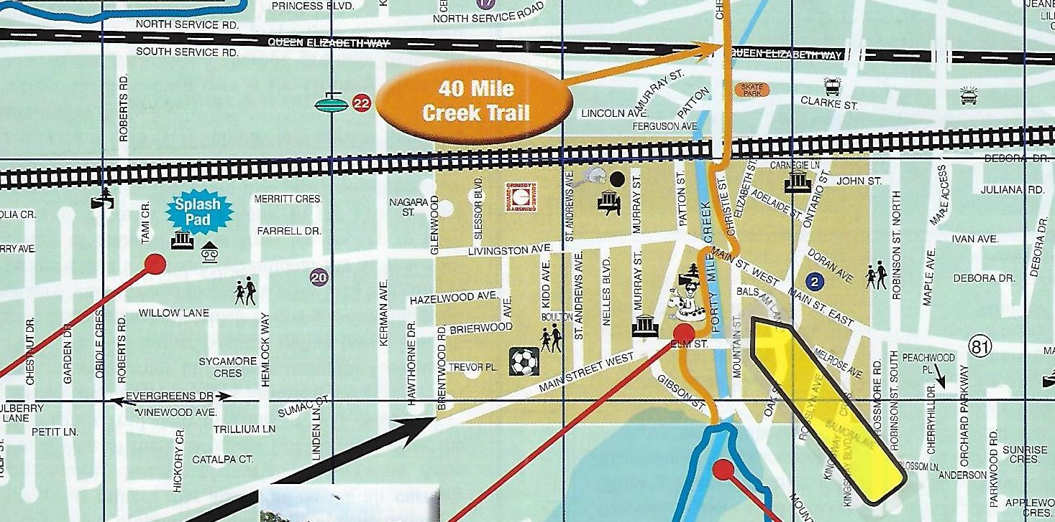

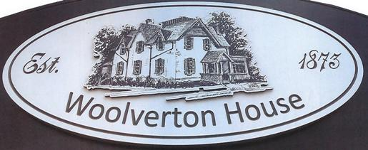

For further information contact:

David Jarvis, Broker of Record
davidjarvis@glenelgin.com
905-945-7730

E.&O.E.

