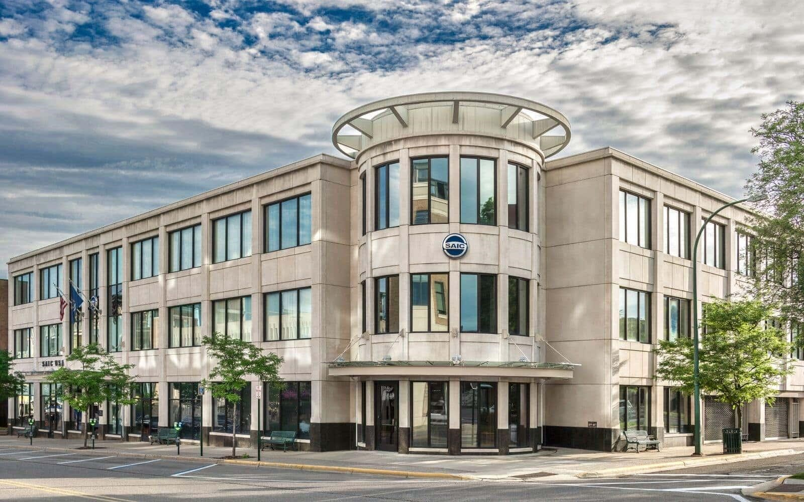
FOR LEASE 30,000 S.F

33

322 NORTH OLD WOODWARD BIRMINGHAM, MI

DECO REAL ESTATE BRAD HITCH:248-321-2400

D

Property Highlights: 30,000 S.F

- Premier Downtown Birmingham location
- 44 car private secure garage parking
- Two outdoor Entertainment balconies
- Quality millwork finishes
- Extensive glass line offices
- 2 kitchens
- Signage
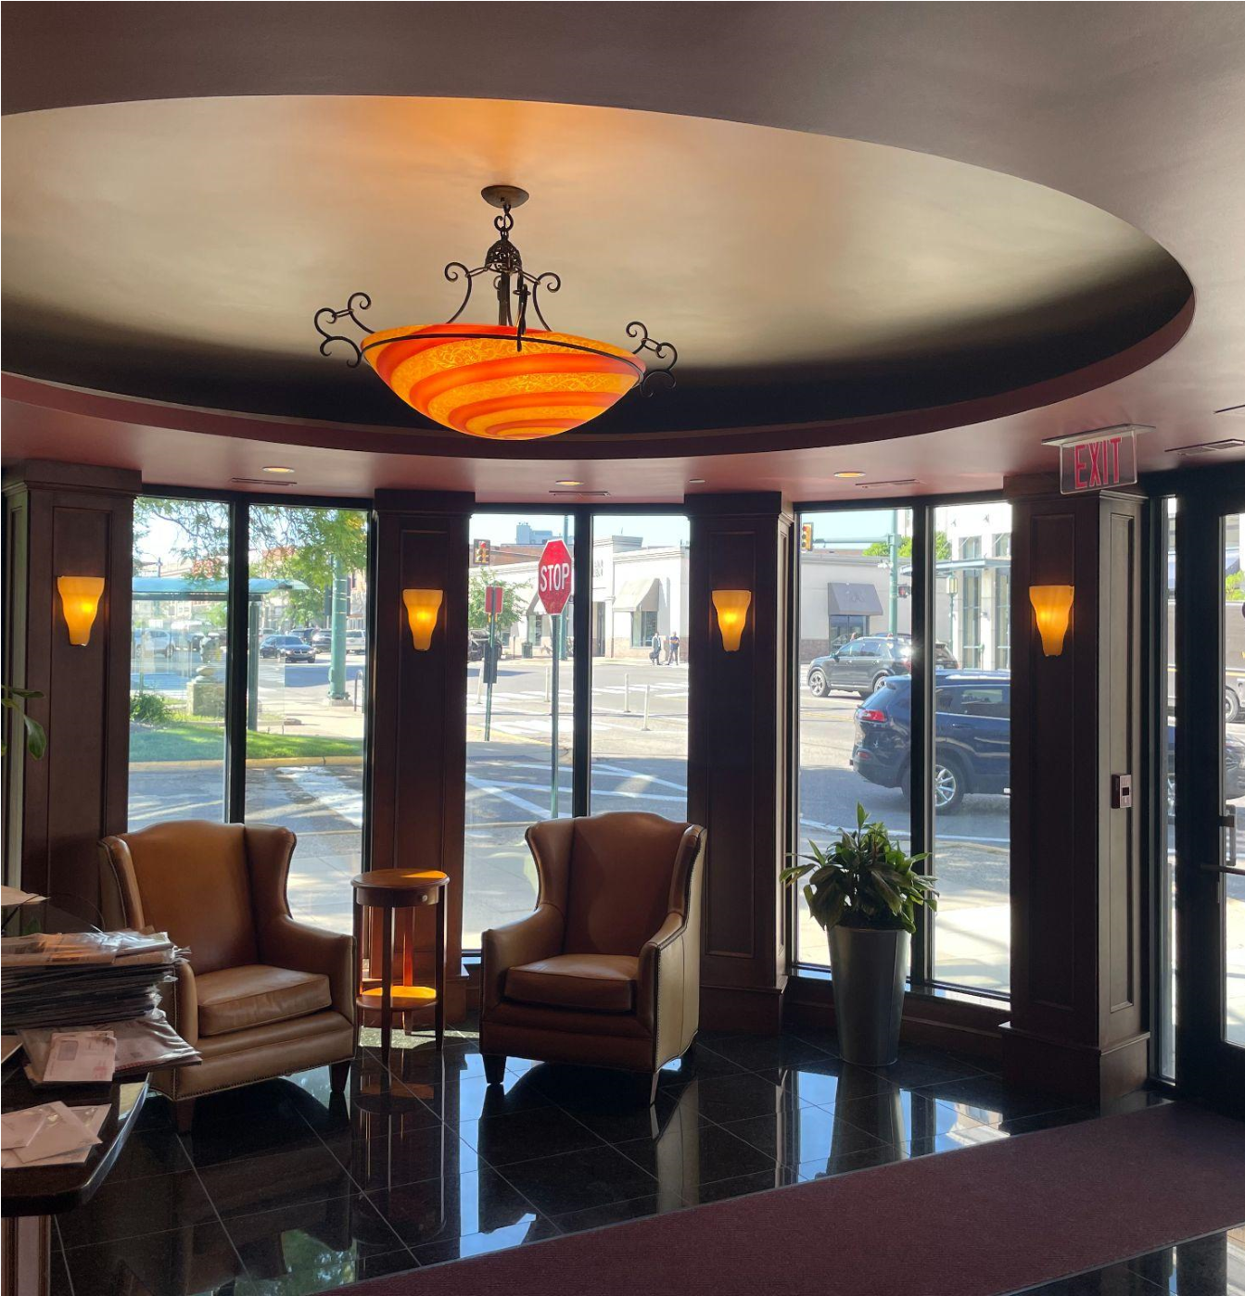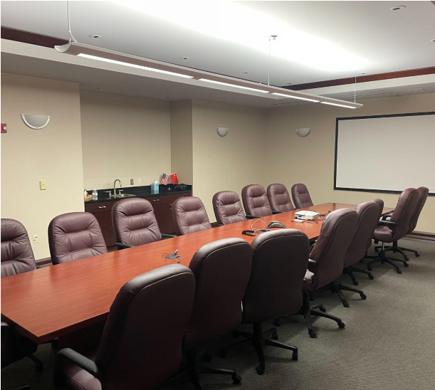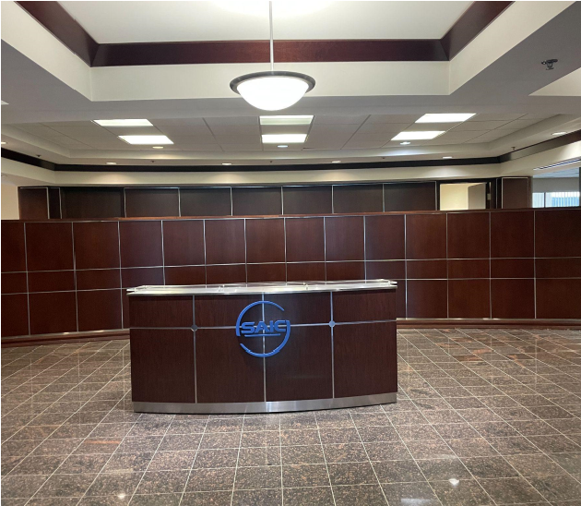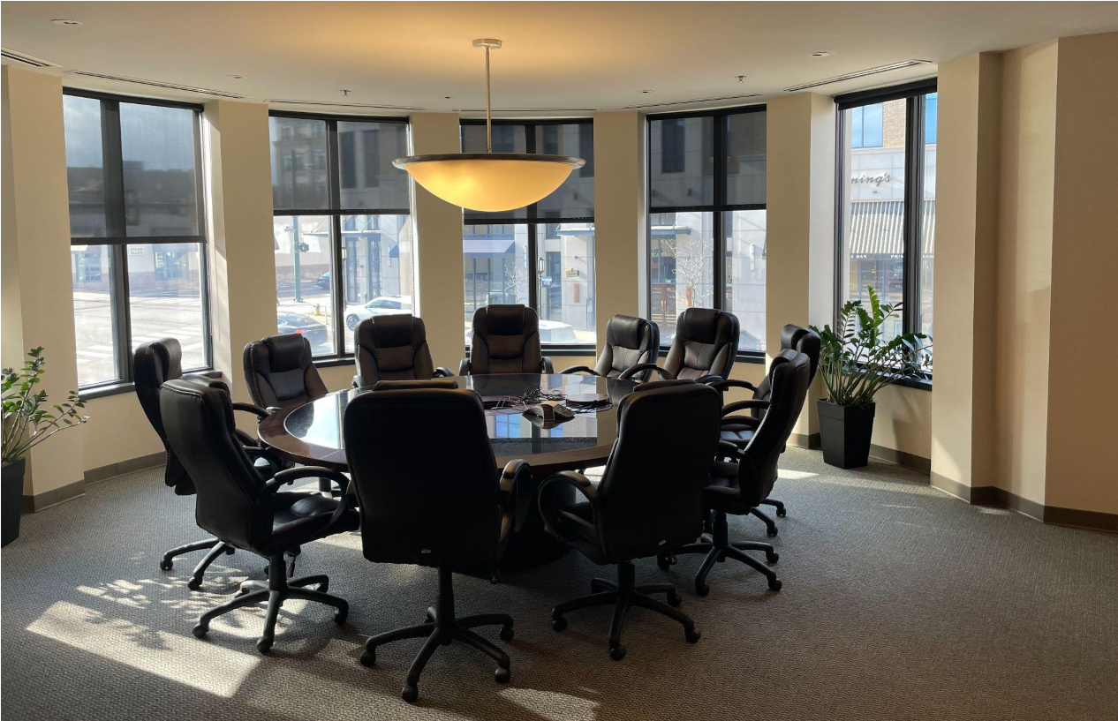
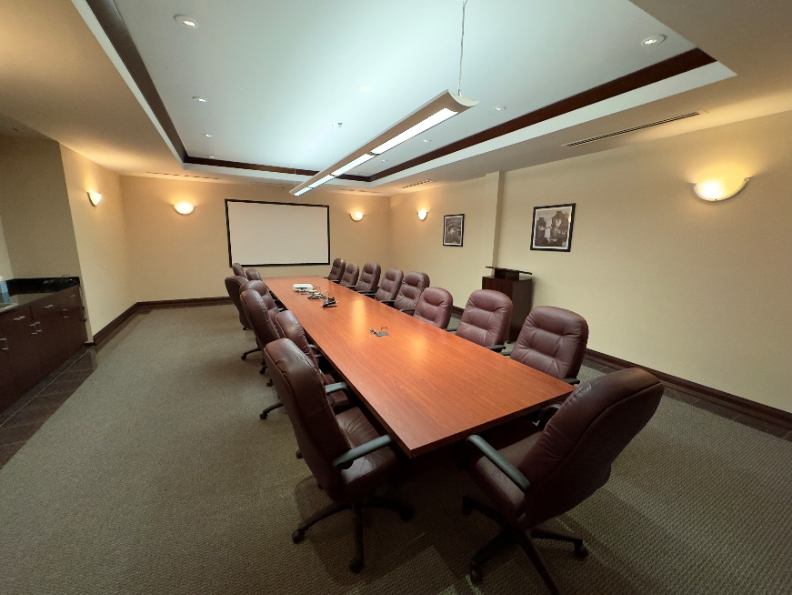

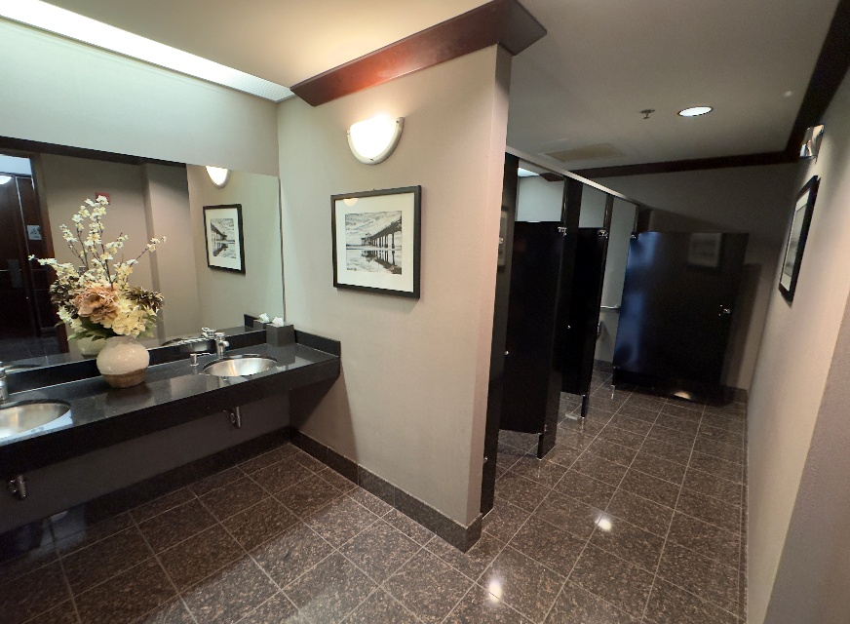
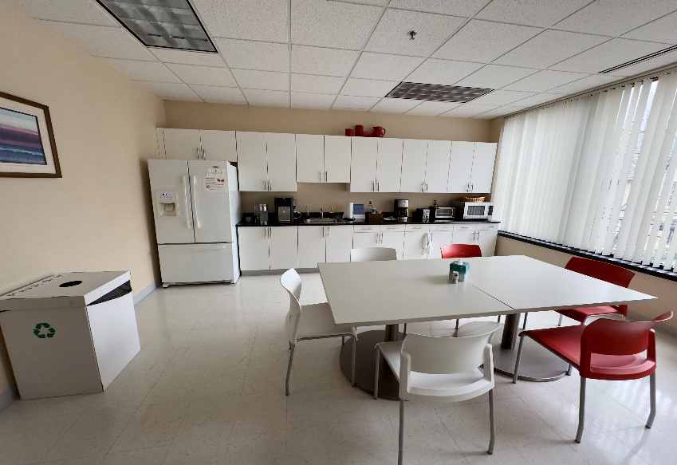
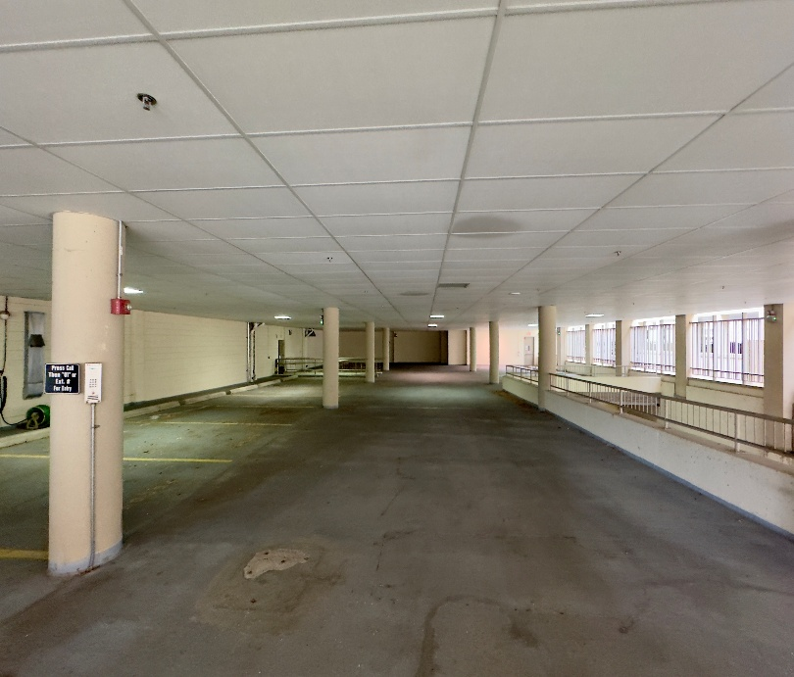
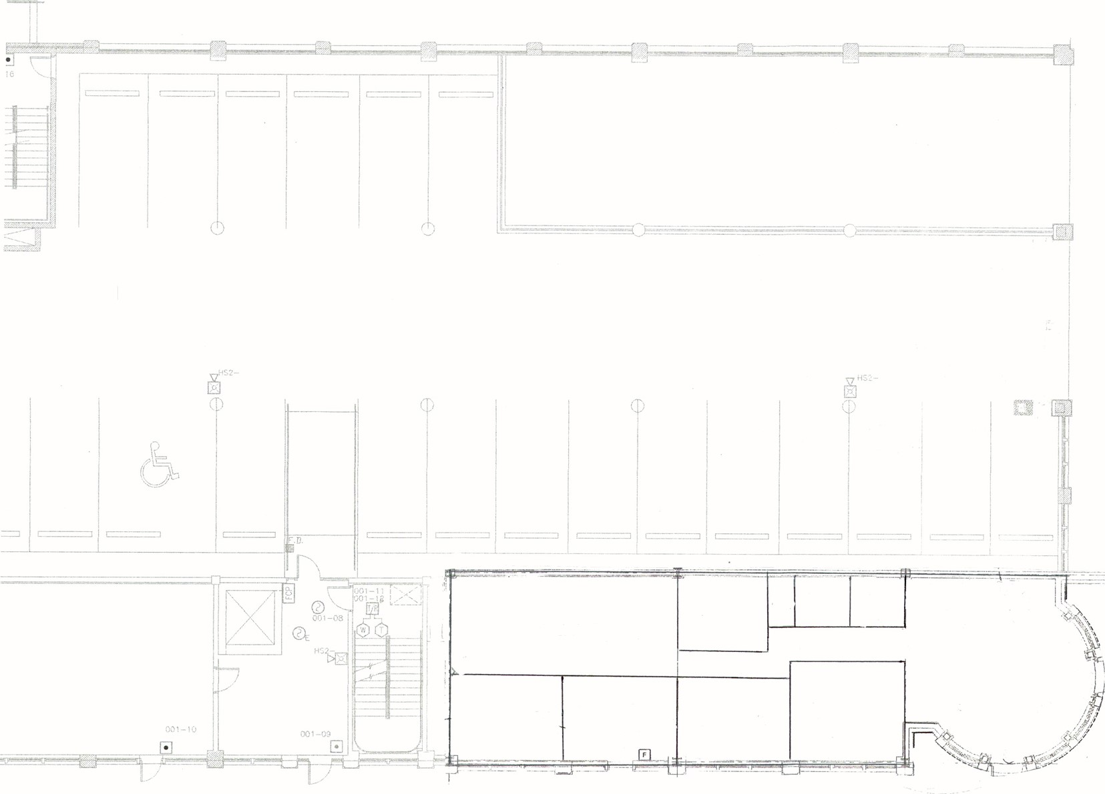
FLOOR 1
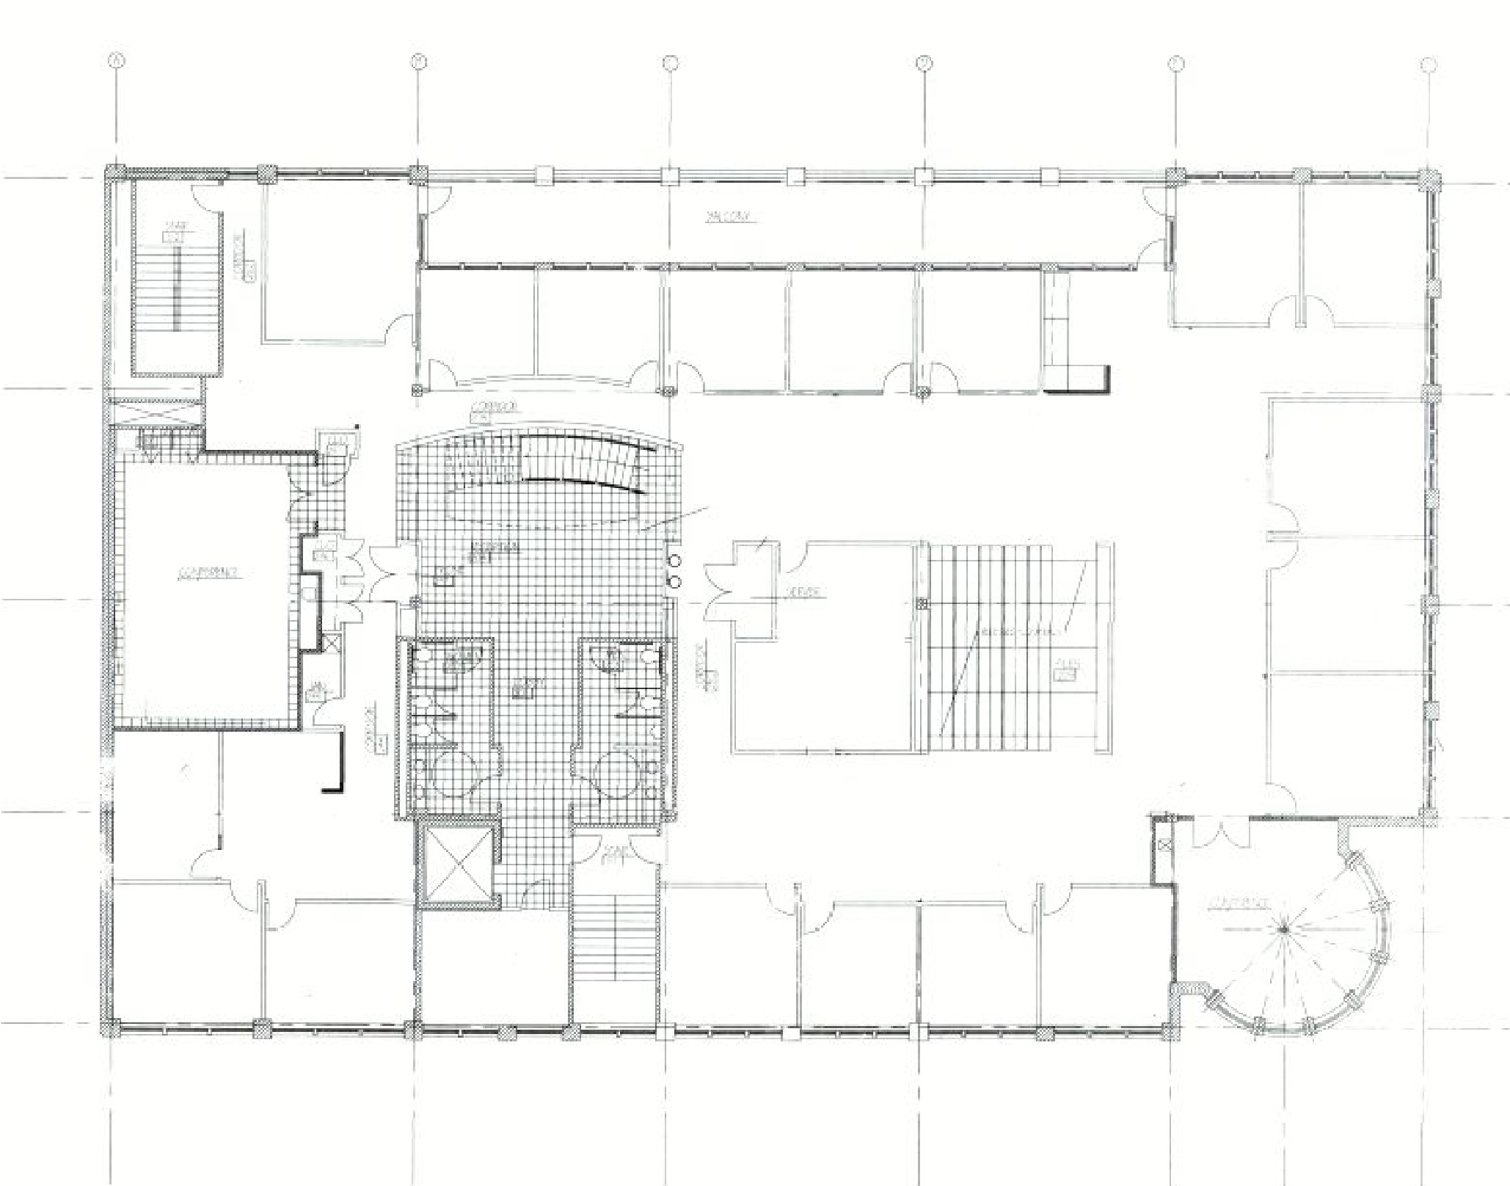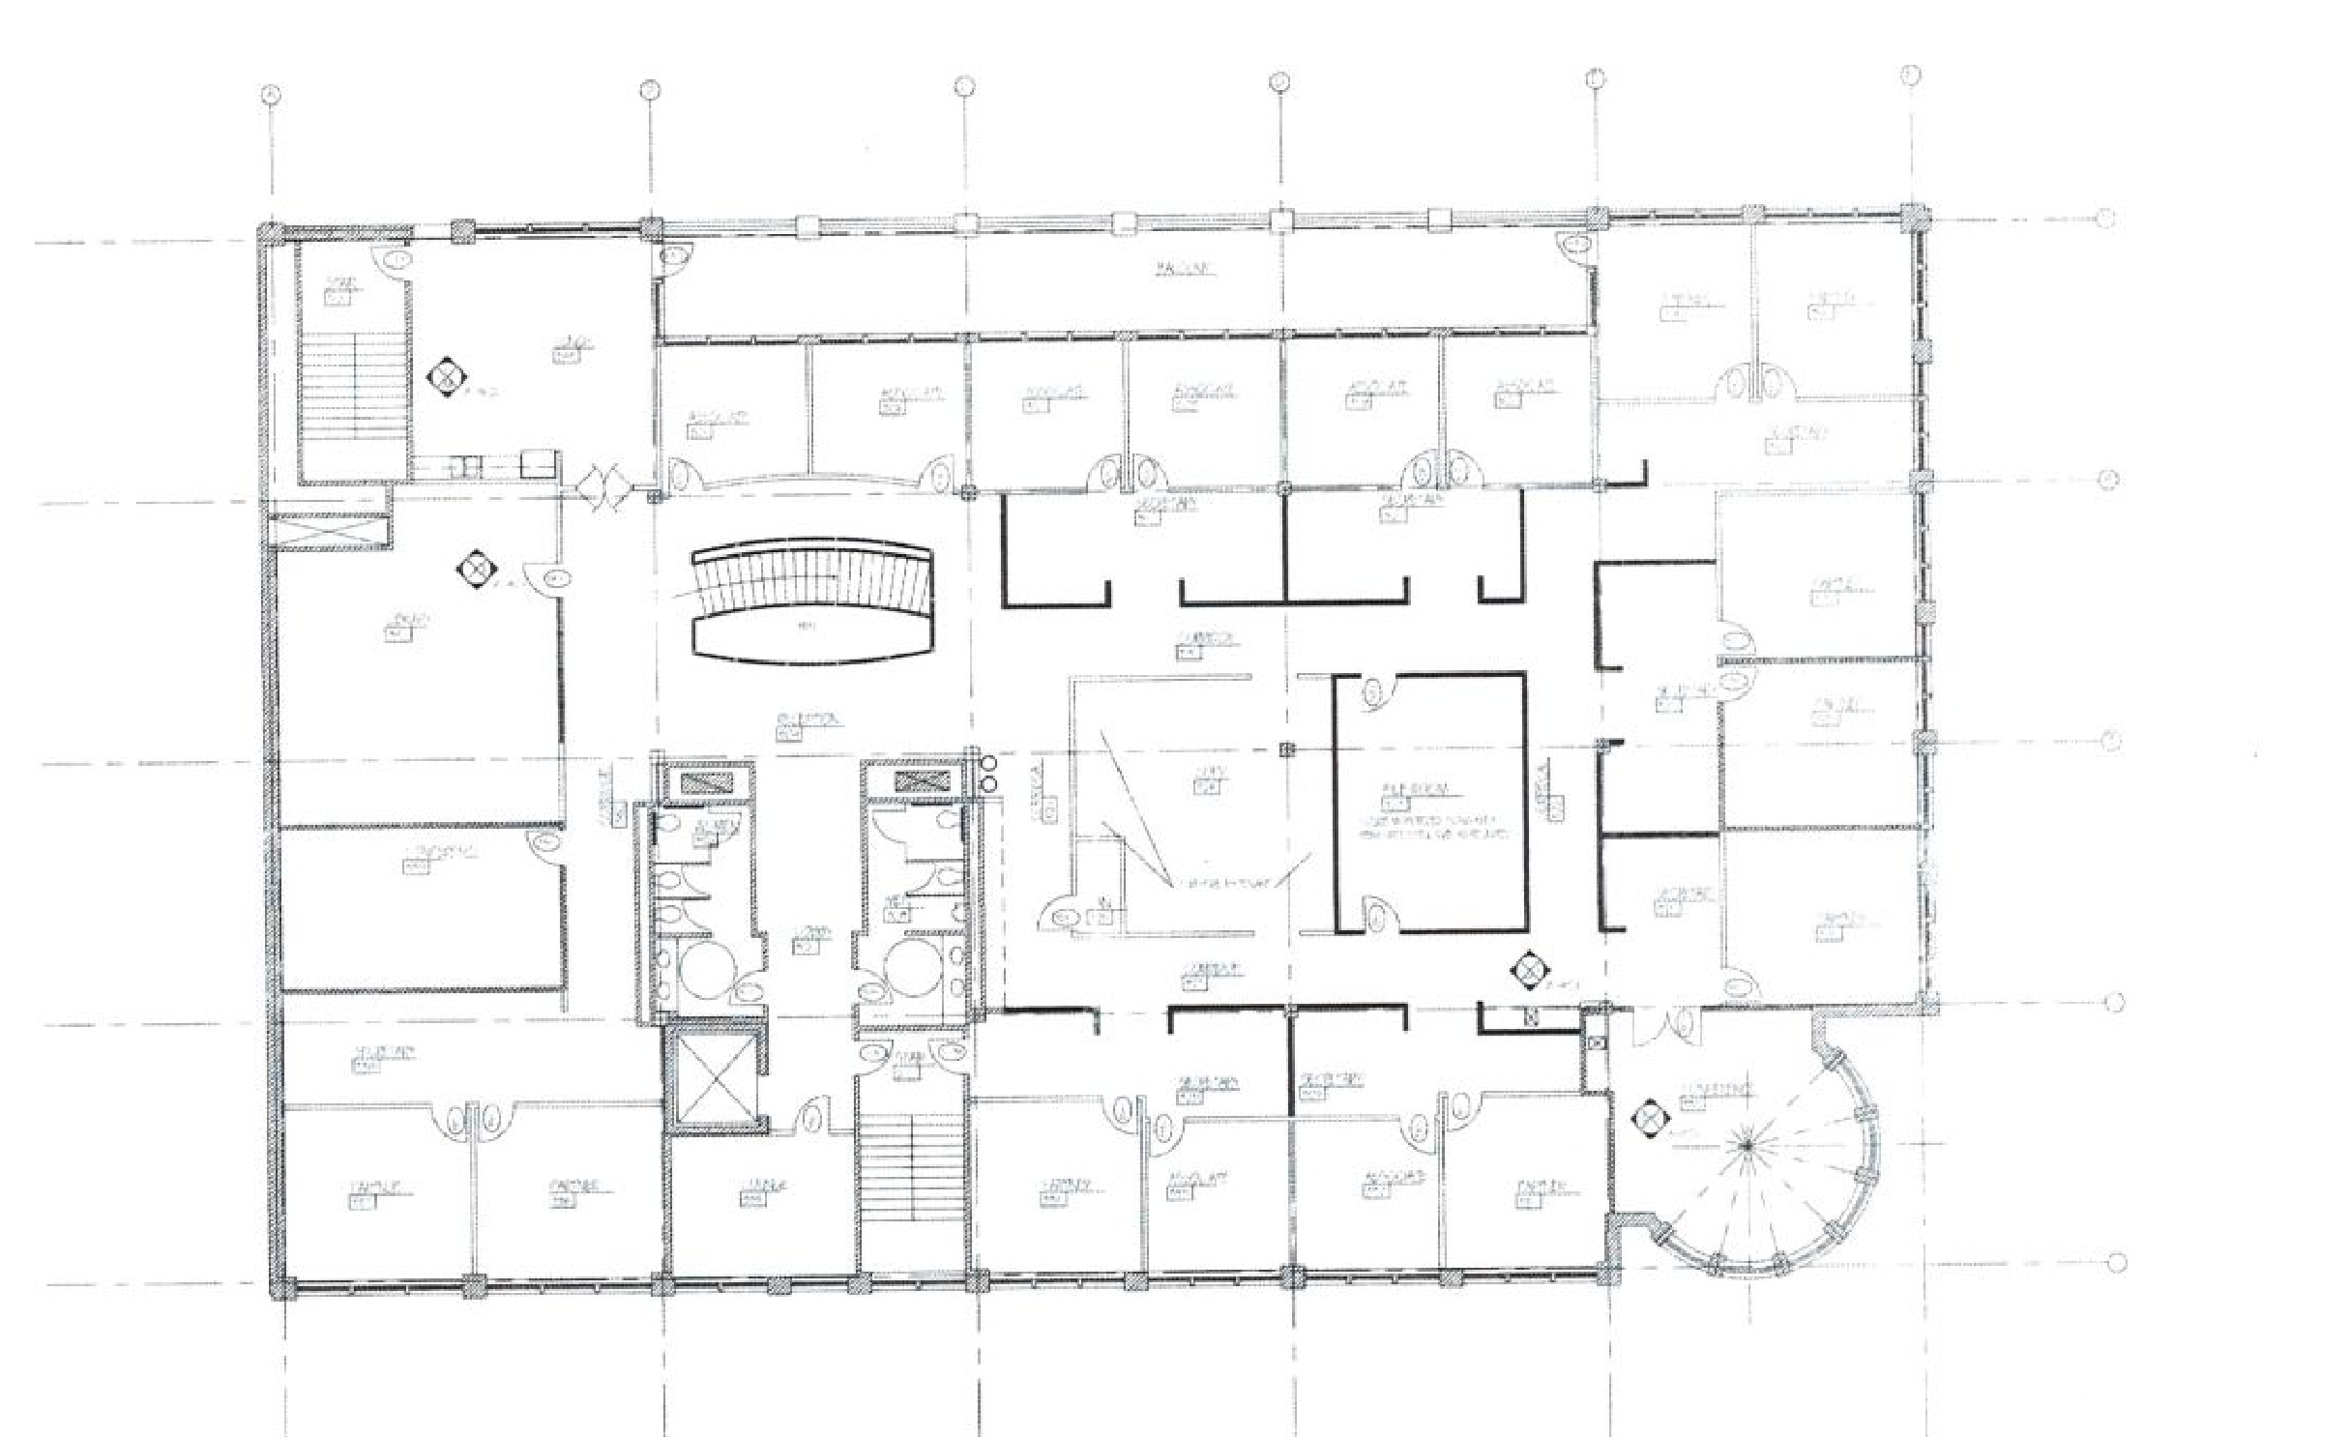
FLOOR 2
FLOOR 3

Deco Real Estate LLC
Bradford Hitch248.321.2400 decobrad@gmail.com


This document has been prepared by Deco Real Estate LLC for advertising and general information only. Deco Real Estate makes no guarantees, representations or warranties of any kind, expressed or implied, regarding the information including but not limited to, warranties of content, accuracy and reliability. Any interested party should undertake their own inquires as to the accuracy of the information. Deco Real Estate excludes unequivocally all inferred or implied terms and conditions and warranties arising out of this document and excludes all liability for loss and damage arising there from.


