EXECUTIVE PROPERTY MANAGEMENT GROUP
_______________________________________________________________________
1751 MOUND STREET, SUITE 206 SARASOTA, FL 34236
OFFICE- 941-365-0200 CELL- 941-809-7027 FAX- 941-365-0290
GARYLANDSMAN@COMCAST.NET

1717-1721 9TH STREET WEST
BRADENTON, FL
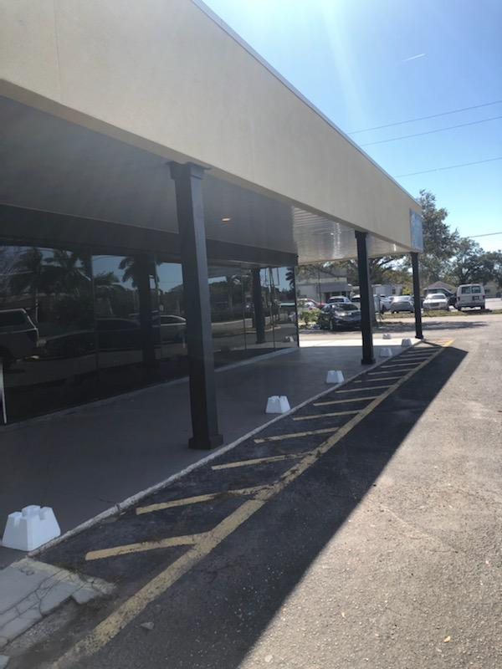

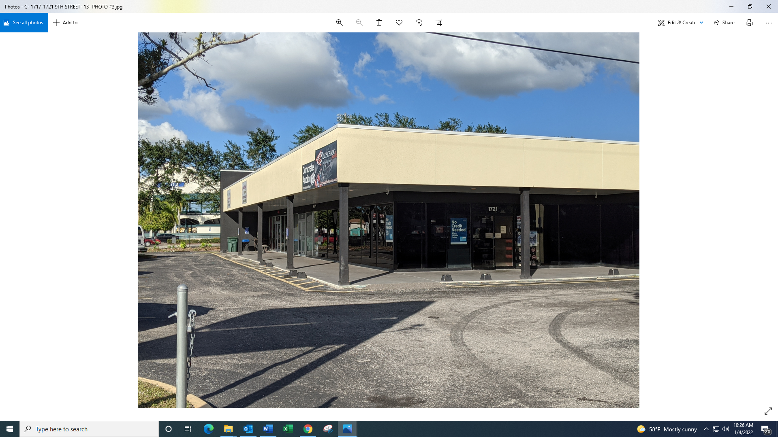

Location- One-half block south of LECOM Park, for 48 years the Southern home of the Pittsburgh Pirates and home to the Bradenton Marauders, who play @ 70 home games annually in the stadium. Formerly McKechnie Field, lovingly called the Fenway Park of Florida for its “old-timey” feel. Takes up most of the blockfront between 17th & 18th Streets. 13,393 sf of retail, directly in front of the new Darwin’s Microbrewery. 175’ of frontage on 9th Street. Good ingress/egress with three entrance/exit driveways. Lot size- 175’ wide by 236’ deep- 41,400 sf
The LECOM Park area is undergoing a strong rebirth, with two microbreweries already in place- Motorworks, at 1014 9th Street, and Darwins, just behind this building at 803 17th Avenue. A new restaurant has leased 1704 9th Street, just across the Street. The City of Bradenton has designated this area for development as an entertainment area, seeking more restaurants, retail shops, clubs, etc..
Building- Largest retail space in the LECOM Park area. Prominent freestanding three-unit corner building- 4,077 sf, 2,595 sf and 6,721 sf. One story concrete and steel building with sprinkler and fire alarm systems. Multiple roll-up doors for units 1717 and 1721 9th Street. Exceptional curb appeal. Located just before signalized intersection at 9th Street and 17th Avenue.
Newly renovated- Improvements include- sprinklers, electric, HVAC system, plumbing, rebuilt front façade, exterior lighting, new HVAC units, new bathrooms, new paint, resealed parking lot, recent landscaping. 10-year old roof recoated in 2018.
Building size- 95.5’ wide by 149’ deep- 41,300 sq. ft. (.95 acre)
Possible uses-Restaurant, microbrewery, fast foods, supermarket, dollar store, drug store, donut shop, pet supermarket, health club, gym, hardware store, etc.
Parking lot holds 28 cars.
Signage- Large existing monument sign with signage space on large façade over each rental unit.
Zoning- C-3, T4-0
Rent- At present, we have one unit available- 1717 9th Street- 6,721 sf @ just $11 psf ($6,161 mo., plus sales tax)

