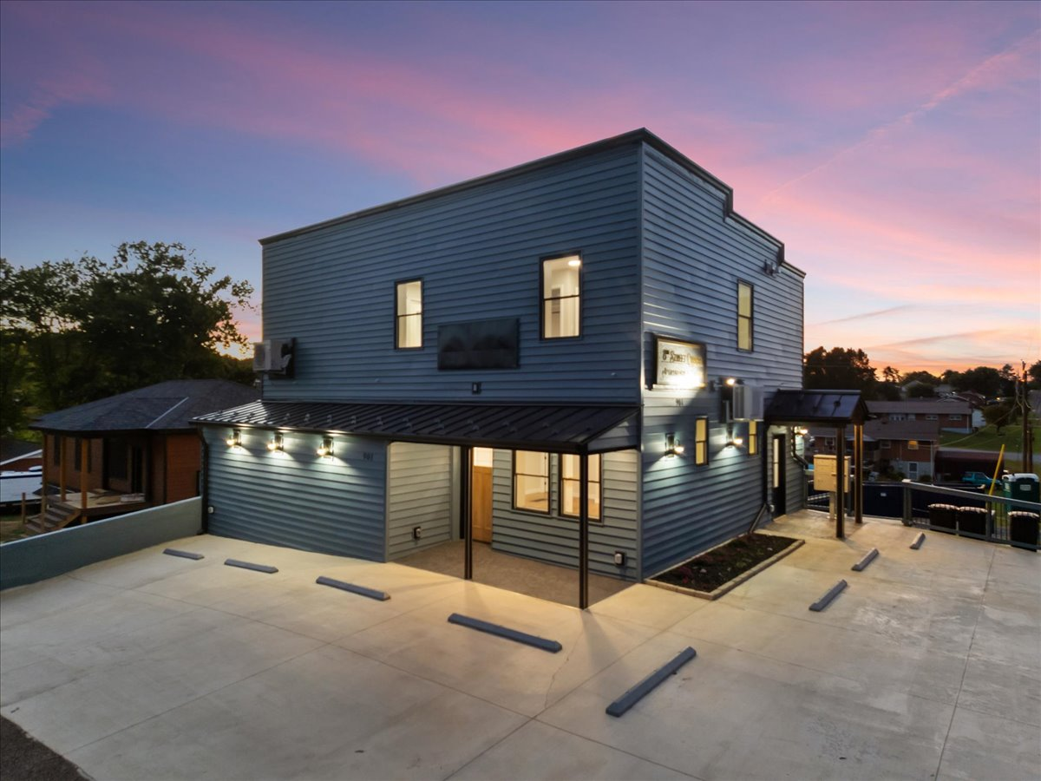

901 8th Street
Radford, Virginia 24141 · Fully Renovated Mixed-Use Investment

$625,000  ASKING PRICE | 7.1%  CAP RATE | 2,970 SF  BUILDING AREA | 4 Units  RESIDENTIAL + RETAIL

Investment Summary
Elliott Inc. is pleased to offer 901 8th Street, a completely renovated mixed-use building in Radford, Virginia, featuring two 2-bedroom apartments, an efficiency unit, and a ground-floor retail storefront — four separately metered income streams in a single, turnkey asset.
Investment Highlights
— Complete 2025 gut renovation — new electrical, plumbing, HVAC, roofing, siding, and windows throughout.
— Four separately metered units minimize landlord-paid utility expense.
— 2-hour fire-rated floor/sound separation between units, plus spray-foam insulation (R-15 walls / R-60 roof) for low long-term operating costs.
— Upgraded utility infrastructure: 6-inch sewer service and 1-inch water service to the building.
— Corner lot with dual street frontage — 66.84 ft on 8th Street and 80 ft on Taylor Street — plus on-site parking.
— Located in Radford, VA, home to Radford University, with walkable access to the downtown corridor.
Property Snapshot
Item | Detail
Address | 901 8th Street, Radford, VA 24141
Building Area | ±2,970 SF
Site Area | 0.123 AC (±5,358 SF)
Zoning | B-1, Limited Business (City of Radford)
Year Renovated | 2025 (complete renovation)
Unit Count | 4 (3 residential + 1 commercial)
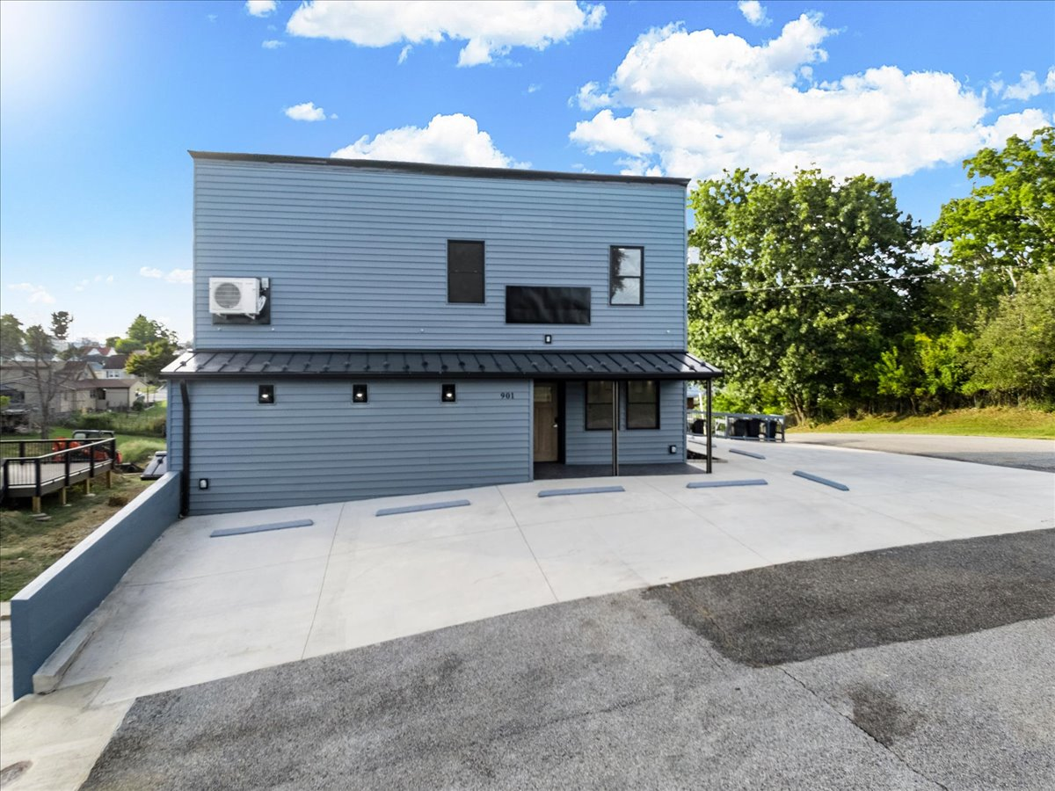
COMPLETED EXTERIOR — SEPTEMBER 2026

Unit Mix & Pro Forma
Unit Mix
Unit | Type | Size | Market Rent | Annual
Apartment A | 2 Bed / 1 Bath | ±570 SF | $1,300 / mo | $15,600
Apartment B | 2 Bed / 1 Bath | ±570 SF | $1,300 / mo | $15,600
Efficiency Unit | Studio | ±400 SF | $1,100 / mo | $13,200
Retail Storefront | Commercial | 1,260 SF | $12.00 / SF / yr | $15,120
Gross Potential Income |  |  |  | $59,520
Pro Forma Operating Statement
Item | Annual
Gross Potential Income | $59,520
Less: Operating Expenses (est. 25% of GPI) | ($14,880)
Net Operating Income (NOI) | $44,640
Return Summary
Item | Value
Asking Price | $625,000
Net Operating Income | $44,640
Cap Rate | 7.1%
Price Per SF (2,970 SF) | $210
Price Per Unit (4 units) | $156,250
Notes
— Rents reflect current market rates for comparable renovated units in the Radford / New River Valley submarket.
— Expense ratio is estimated; a new owner should verify actual insurance, tax, and utility costs at time of offer.
— Property is being offered in fully renovated, move-in-ready condition.

A Comprehensive, Ground-Up Renovation
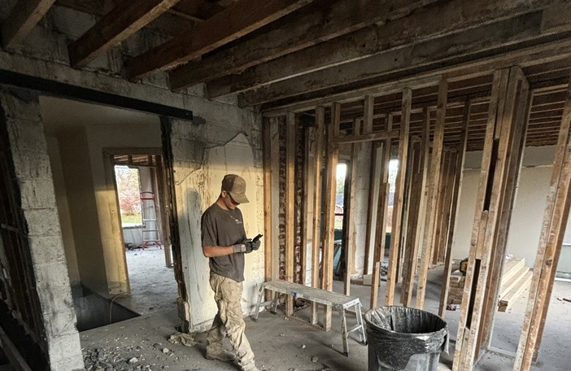
FULL INTERIOR DEMOLITION TO THE STRUCTURAL FRAMING
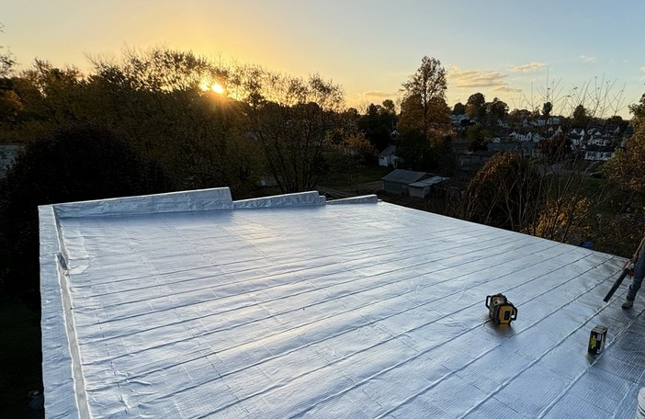 | 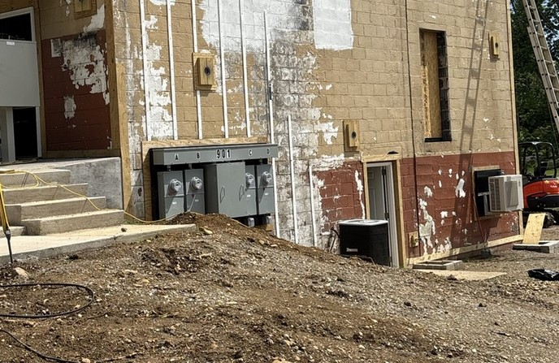
The building was taken down to the structural framing and rebuilt with all-new systems, upgraded utilities, high-performance insulation, and a complete interior and exterior finish package — a renovation that goes well beyond cosmetic updates. Highlights include a new commercial membrane roof (left) and four-meter electrical service serving each income unit independently (right).

Systems & Finish Detail
Structure & Utilities
— Full gut renovation with structural repairs and reframed, reconfigured layouts
— 100% new electrical wiring; metering expanded from two meters to four
— 100% new domestic water and sanitary piping throughout
— Water service upgraded from ½" to 1"; sewer upgraded from 4" to 6" to the city main
— Upgraded HVAC serving all renovated spaces
Fire, Energy & Envelope
— R-15 spray-foam wall insulation and R-60 spray-foam roof insulation
— 2-hour fire-separation assembly: mineral-wool insulation plus double 5/8" gypsum board between floors
— New 40-year insulated vinyl siding over the former cinder-block exterior
— All-new vinyl windows and exterior doors, including keypad entry locks
— New 100-year standing-seam metal roofing on porches and awnings, plus new gutters
Interior Finishes
— Refinished original hardwood flooring; new paint, trim, and lighting throughout
— New solid-plywood kitchen cabinetry, quartz counters, and tile backsplashes
— New appliance packages: washer, dryer, dishwasher, refrigerator, oven, microwave
— All-new tiled bathrooms with tiled shower stalls and glass doors
— Added storage closets and built-in cabinetry in Apartments A and B
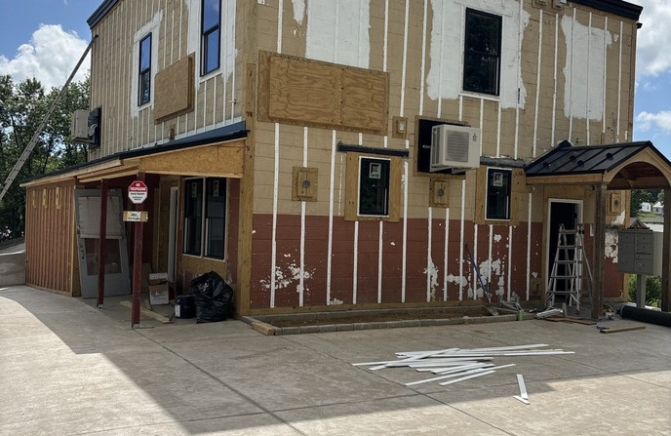
EXTERIOR MID-RENOVATION — NEW FRAMING, WINDOWS & ROOFLINE

Radford, Virginia & the New River Valley
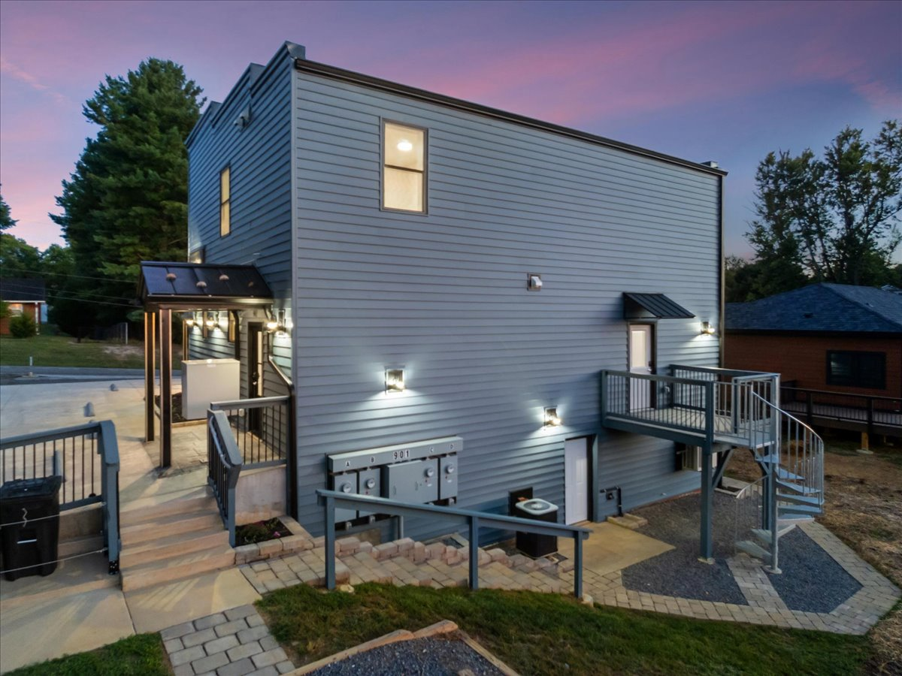
901 8TH STREET — REAR EXTERIOR WITH PRIVATE ENTRANCES AND PARKING
The Market
Radford, Virginia is a small city in the New River Valley region of Southwest Virginia, anchored by Radford University and situated along the New River. The city's compact, walkable core supports a steady base of rental demand from students, university staff, and area employers, while nearby employers in healthcare, manufacturing, and higher education support the broader regional economy.
901 8th Street sits on a corner lot with frontage on both 8th Street and Taylor Street, within walking distance of downtown Radford's commercial corridor.
Why This Asset
— Turnkey, fully renovated condition removes near-term capital expenditure risk for a buyer.
— Diversified income across residential and commercial uses reduces reliance on a single tenant type.
— Individually metered units simplify management and limit landlord-paid utility exposure.
— Corner location with dual frontage offers strong visibility for the ground-floor retail space.

For More Information
Carmen Elliott, CCIM
Founder & CEO — Elliott Inc. | SIOR Member Associate
Elliott Inc. — Commercial Real Estate
New River Valley & Southwest Virginia
Phone: 540-357-2084
Email: carmen@elliottinc.com
www.elliottinc.com

This Offering Memorandum has been prepared by Elliott Inc. for informational purposes only, using information believed to be reliable, including a third-party appraisal and a contractor-prepared renovation summary. It does not constitute an appraisal, and Elliott Inc. makes no warranty or representation as to the accuracy or completeness of the information contained herein. Projected income, expenses, and returns are estimates only and are not guaranteed. Prospective purchasers should conduct their own independent investigation, due diligence, and verification of all information, including property condition, square footage, zoning, income and expenses, permits, and code compliance, prior to making any offer or entering into any agreement. This offering is subject to prior sale, withdrawal, or change in price or terms without notice.

