Wallis Top Pitt Rock Quarry

9286 W Thompson Rd, Rudyard MI
OFFERING PRICE $4,000,000.00
NOT FOR PUBILC OFFERING AT THIS TIME
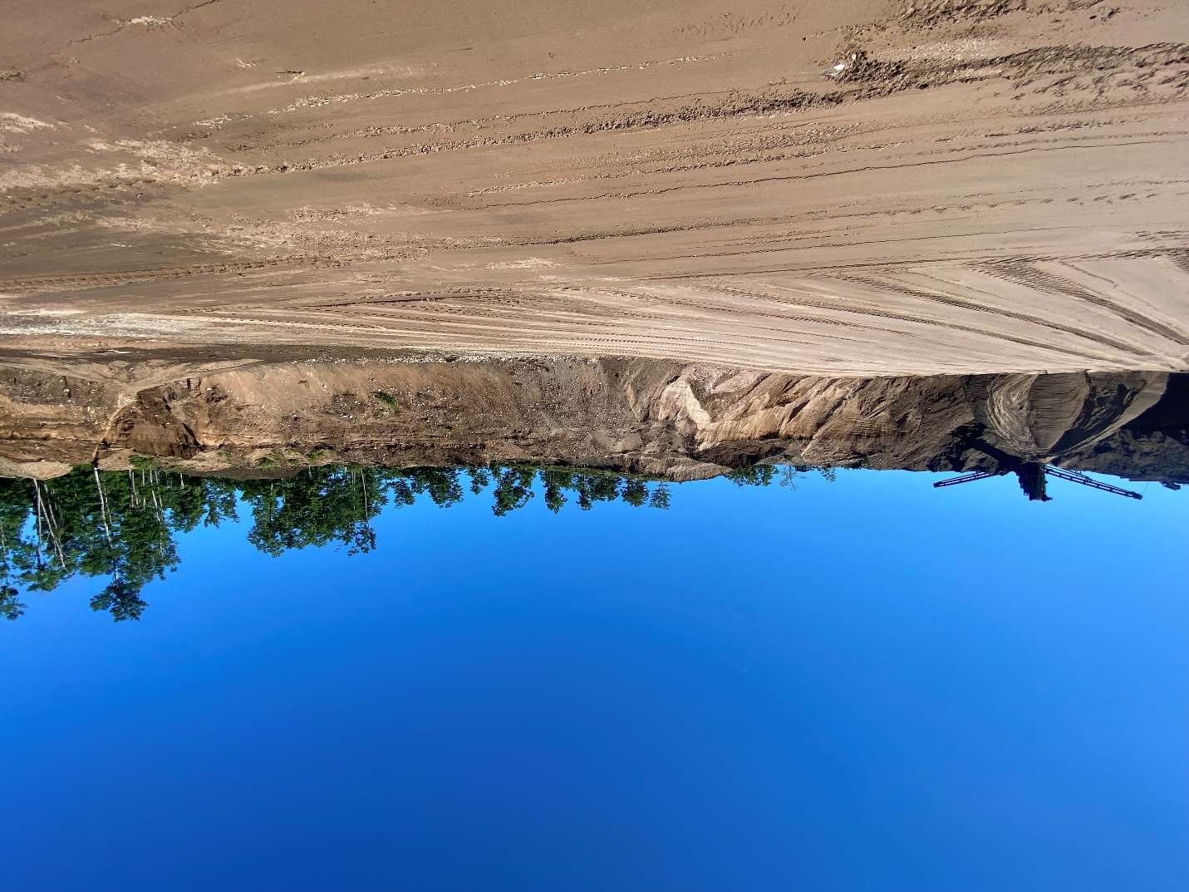

CONTACT TAMMY SHEPARD
(906) 298-0774
Mackinac Properties
Tammyshepard1@gmail.com

This virgin gravel pit was founded 3 years ago and consists of 145 acres. Roughly 30 acres has been cleared to date, the rest is wooded with use and access to small lake.
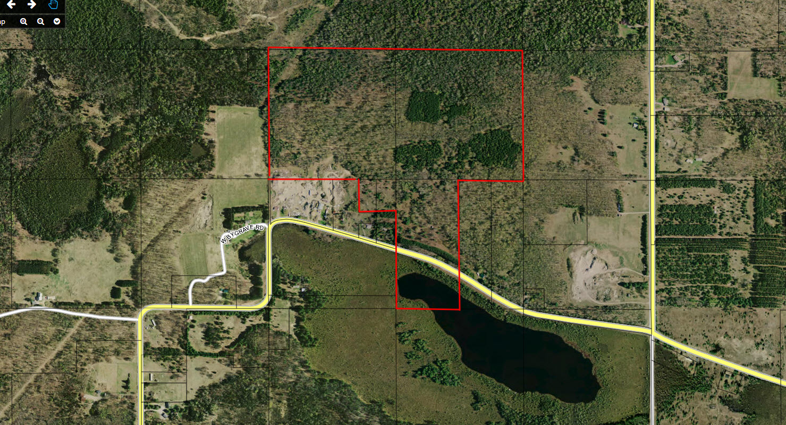
Given the size and quality proven to be present in the quarry it is anticipated to produce for more than 100 years. Material found here consists of the following:
Topsoil, 22A, 23A, Rock, Gravel, Stone, Sand, 2NS, Clay, 6AA and more.

All equipment will be transferred in sale including over $600,000 in equipment, including a 490 Komatsu excavator, 744 end loader,380 Komatsu end loader, bulldozer, screen plant, weight scale and more. Also included is a new building with a garage with well and septic.

