
6 Leigh St. Clinton, NJ 08809
Hunterdon County
EXCLUSIVE FOR SALE
INVESTMENT OPPORTUNITY
PRIME DOWNTOWN CLINTON LOCATION
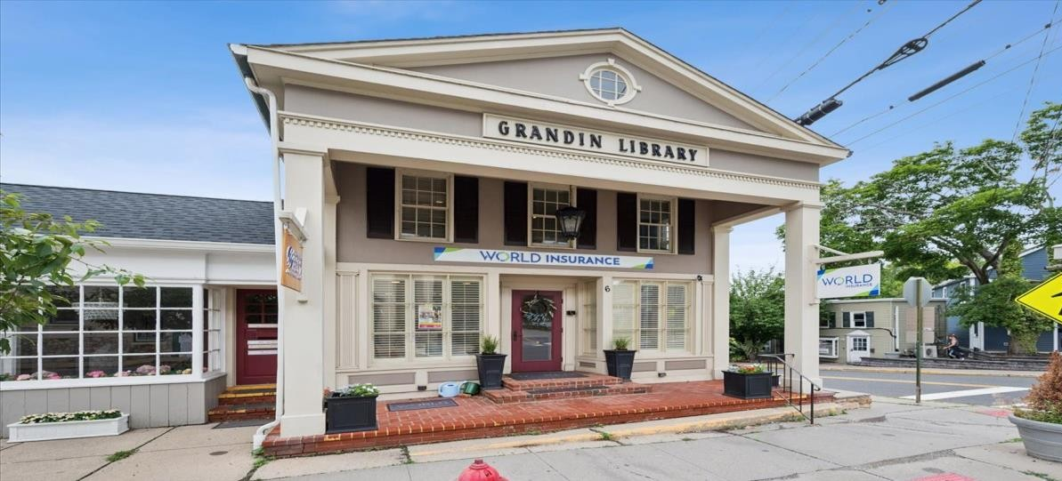
PROPERTY DESCRIPTION
OFFERING SUMMARY

Well-kept Investment opportunity located in
Price for Sale:
$775,000

the heart of historic downtown Clinton one of Hunterdon County’s charming and walkable business districts. Two story free standing six income producing property.
Corner location. Remolded from top to bottom. Upgraded bathrooms, kitchen.
Zoning:
C-1 Downtown
Commercial
Lot Size: .08 acre
Building size:
4,060 SF
Taxes:
$13,159.
Block, Lot:
Blk: 10 Lot: 12

Parking:
On-Street Parking

PROPERTY HIGHLIGHTS
- Flexible C-1 Downtown Commercial Zoning a variety of retail, office, restaurants & service- orientated uses.
- Excellent visibility with strong pedestrian and vehicular traffic.
- Rare opportunity to own in Historic Downtown Clinton.
- Ample public parking directly behind property.
- Minutes from Route 31, 22 & I-78

DEMOGRAPHICS 1 MILE 3 MILES 5 MILES

Total Households | 1,545 | 6,738 | 11,984
Median Age: | 43.1 | 42.5 | 41.5
Total Population | 3,801 | 18,458 | 32,742
Average HH Income | 122,618 | 118,363 | 122,779

Timothy P. Deluccia Broker Associate 908-938-6405
tim@delucciacommercialgroup.com
Deluccia Commercial Group 1996 Washington Valley Rd. PO Box 305
Martinsville, NJ 08836

10 0 10

'2CALE 1" = 10 FT
SURVEY REFERENCE
' ^‘ E6TITI.EO "SURvE r-0R THE ESTATE Or oBCRT TRrI8CK.
* E ATO MCELDOWNEY, OATED JUNE 1, 1965, AND FILEO IN THE

HUNTERDON COUNTY, N.J.”, PREPARED BY CLERK'S OFFICE ON 12—29-65, AS MAP #I9O4.

P.O.B.
HUN1T.pO0N COUNT

GENERAL NOTES:

THIS PLAN REPRESENTS A SLIRVEY MADE ON THE OROUNO.
- THIS SURvEY ¥iAS PROP A9£o US\HC A TITLE couMlTMEH T PREP ARCO BY OLD REPUBuc Nonot AL TITLE
+uSUP,HCE COPP*NT. COC ITVCNT NO. ORH5700 HAvNG
*N EFFECflVC DSTE OF SUGUST 2k 2015.
- IF THIS PLAN DOES NOT COH TAIH M ORIGINAL
5iCH ATURE AND IkIPRESSION SEAL OF THE Uf4DERSIGNED
UCENSED LAND SURVgYOR IT IS NOT AN AUTHEN TSC COPY
AND IN AT HAV£ BCEN ALTEfiEO.
y,o \,/. _i Es AND •DJoINiNG PROPERTY LINES SHo\¥N

N56”S8’00"E — 81.00'
HEREON WERE TAKEN FROkI THE TAX IJAPS FOR THIS

CEN TER STREET
{40' RIGHT-OF— wAY)

- THIS SURVEY IS SUBJECT TO EASWEN TS AND

- sts suRvEx uAi‹E5 fiio REPRESD/TATION TO THE LOCATION OF ANY SUB-SURF*CE UTIUTIES OR STRUCTURES THAT WERE NOT VISIBLE AT THE TIME OF
THIS SURVEY.

- A WRITTENWAIVER AND DIRCC1ON NOT TO SET CORNER ktARXERS HAS BEEN OBTAINED FROM “THE ULT|USTE USER’ PURSUSNT TO P.L200J C.0* M.JS*.
C45: 8—36.3 AND N.J.A.C.13: 40—5.1(D).
- His uO SURvEY IS PREPARED FOR THE BENEFIT OF
THE PARTIES USTEO AND IS NOT PREPARED ron oe
20 CERT\nCO TO SUBSEQUENT P ARSES.

LINE

LOT 11

IRON PIPE 0’
(FOUND A I-IELD) "
BLOCK 10

LOT 12

5,073 S.F.

0.116 AC.

APPROX. WALL
(ON LINE}

8Ul
UT/UjY

)l

140 WEST MAIN STREET HIGH BRIDGE. NJ 0882.9 PH. 908-238-0544 FAX 906-23&9S82
A PROFESSIONAL ASSOCIATION AUTHORIZATIDN CERT 24GA2802 t500 EXP. B31/2016

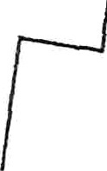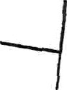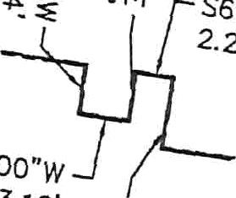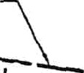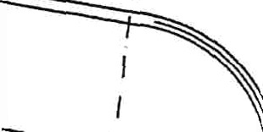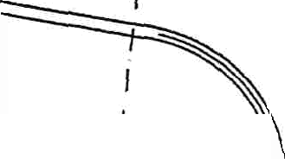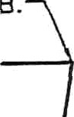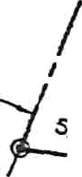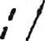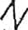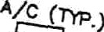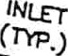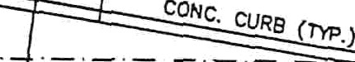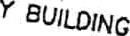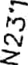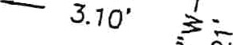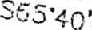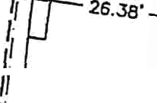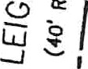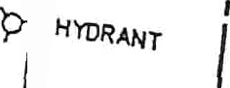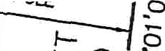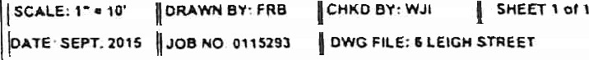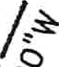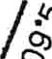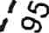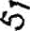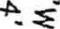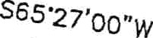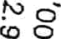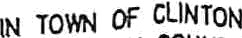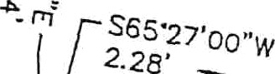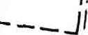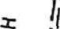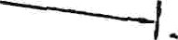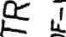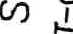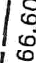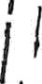/’‘ S6S’/y'
.‘ use

/ LOT 12.01

P*VCD ARE*

” ” J9.kg'

70qy o

00 ¿

19.0

LOT 2 .01
PLAN OF SURVEY

BLOCK 10, LOT 12

TOWN OF CMNTON, HUNTEROON COUNTY NEW JERSEY

WAYNE J. INGRAM PROFESSIONAL LAND SURVEYOR

9 18/15

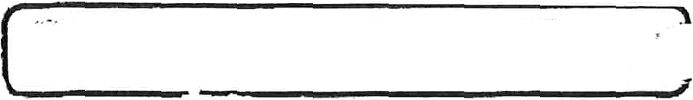
Tax Map Location

UTIL

1.01
.STATE OF

) NEW JERSEY
I EXEMPT

Q.03

3.01

MEMPT

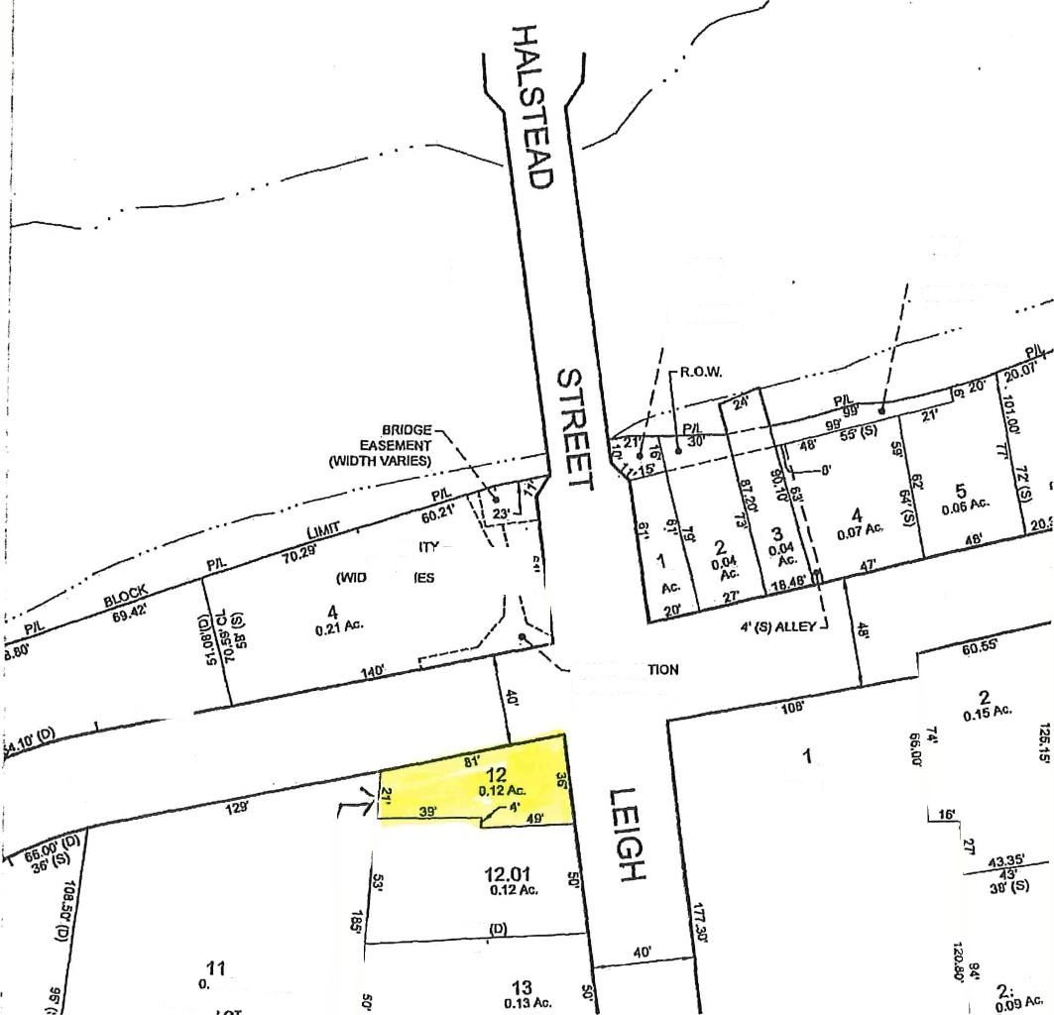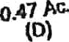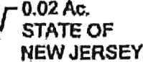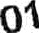

COfJSTRUC EASEMENT

03 Ac MUNIOIPAL PARXIN

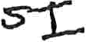

E>‹ISTING OFFICE „ NO. I

ED<I5TING OFFICE
•” NO. 2 - '
9

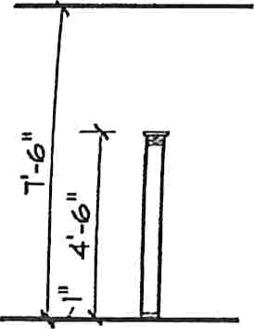

HALF MALL PARTITION DETAIL

"‹
'-!O" %

EXISTING STAIR

EXISTING ACCESSIBLE B M

12'-B“
E D'¢ISTING BREAK AREA

2'-IO"
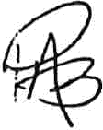

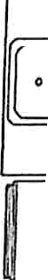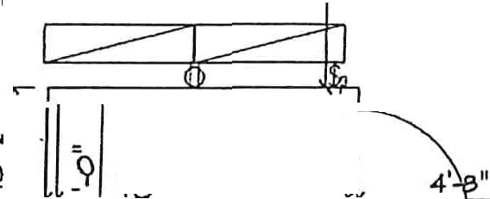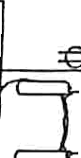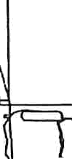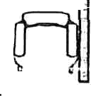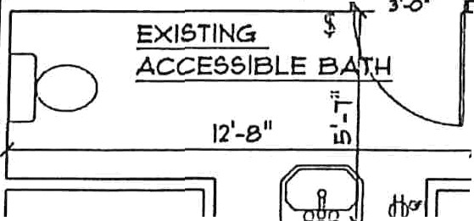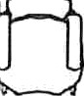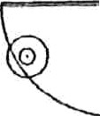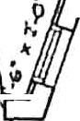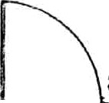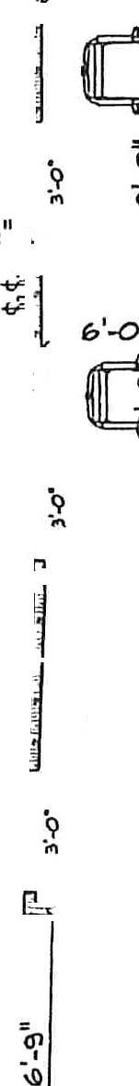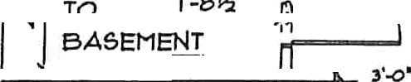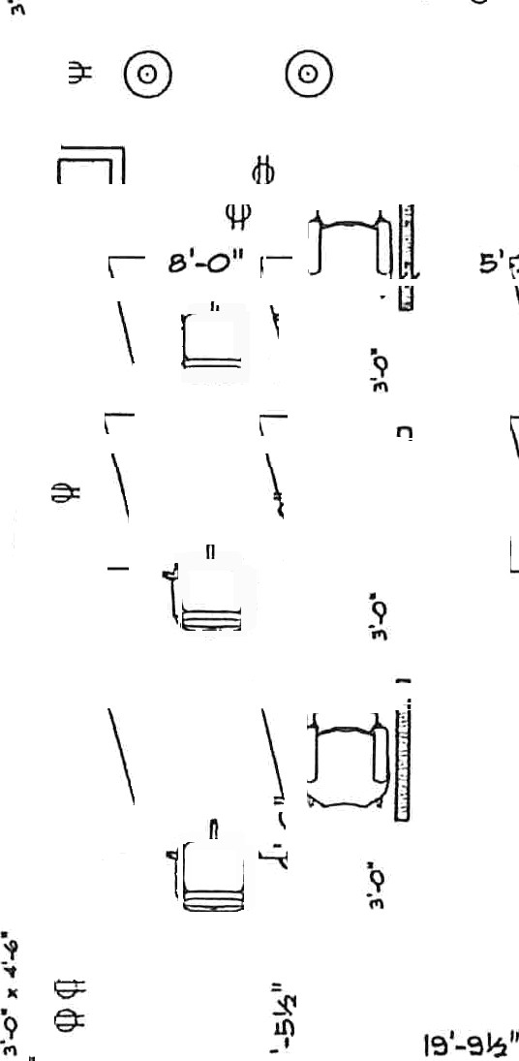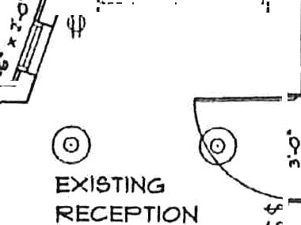TRUE INSURANCE
RENOVATED FIRST

FLOOR I"’LAN

1M2U.5.Hipfn y22


6 Leigh St. Clinton NJ
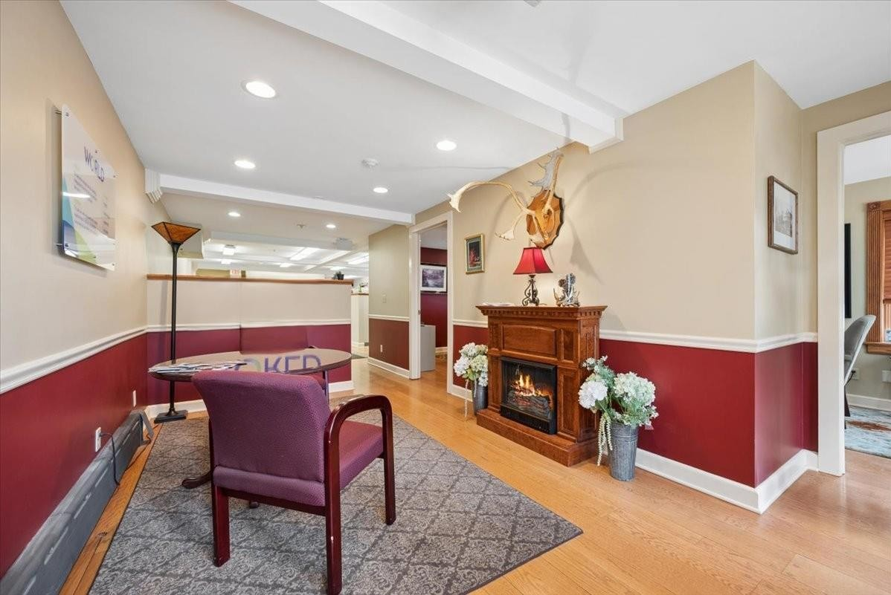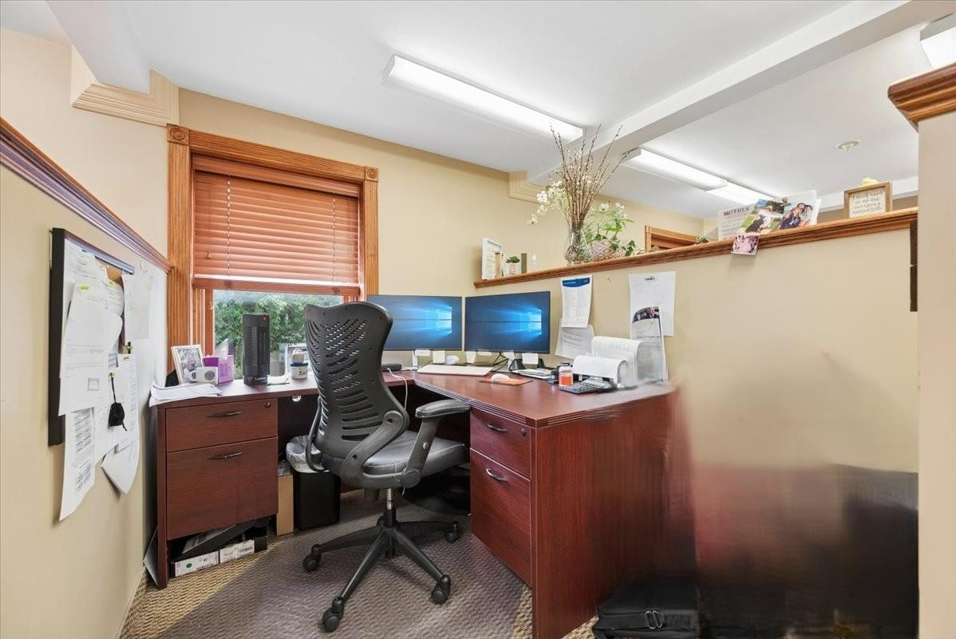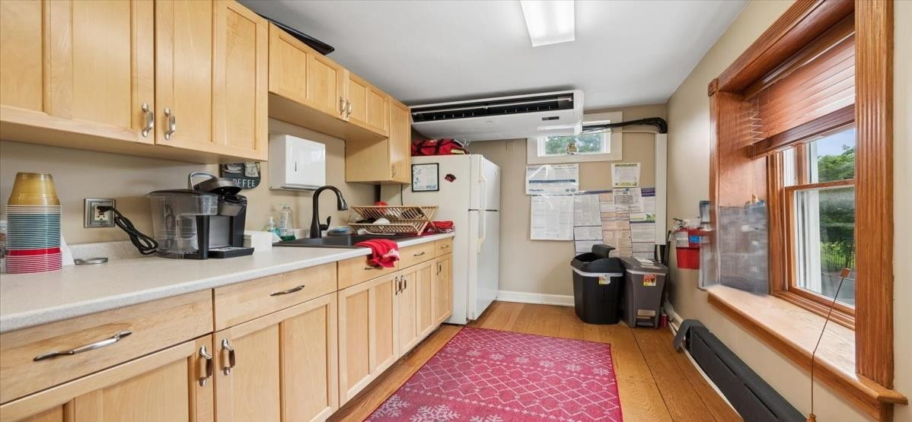

6 Leigh St. Clinton NJ
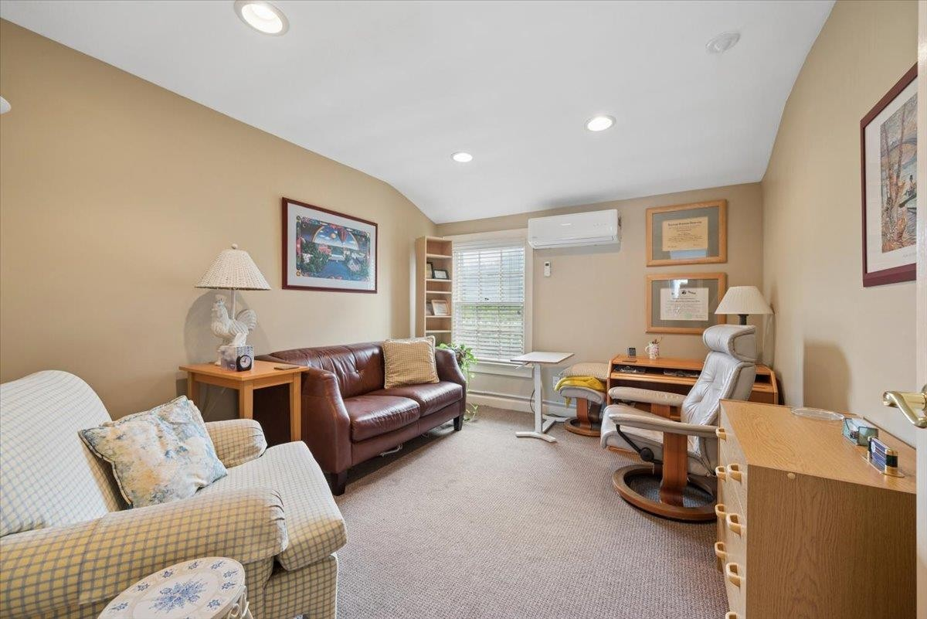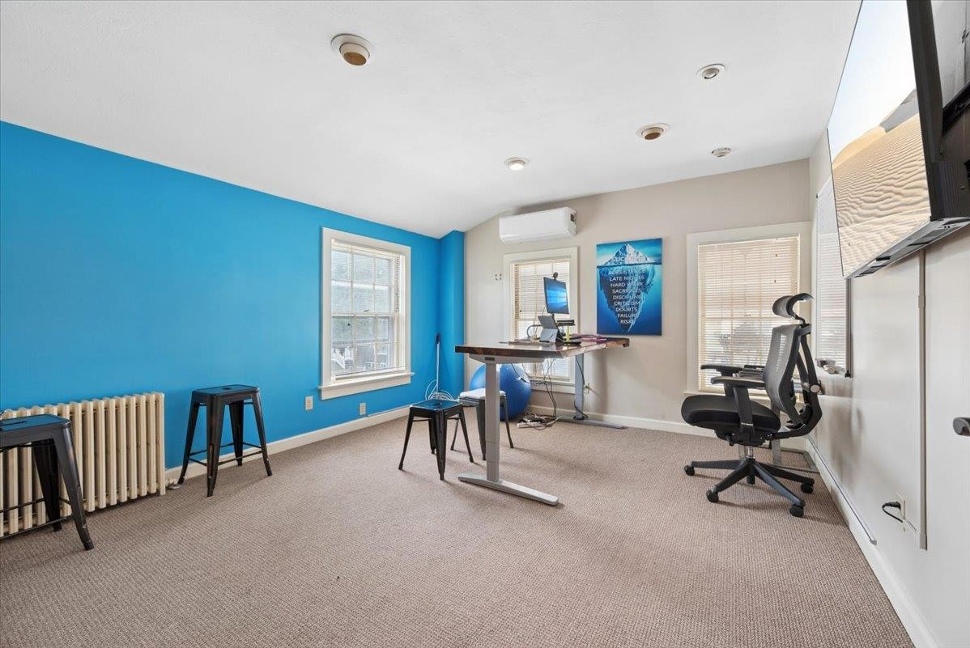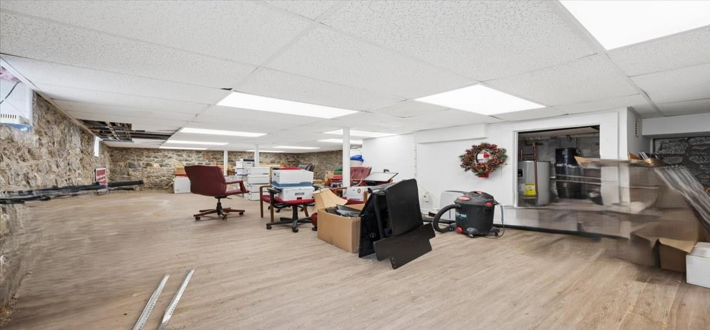

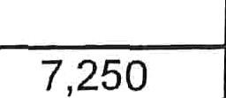
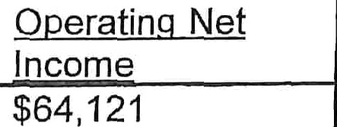
Income & Expense Statement 6 Leigh St. Clinton, NJ 08809 Office Building CompleN

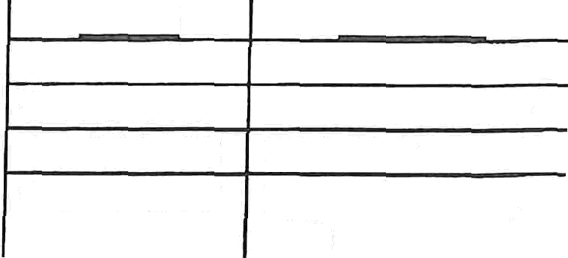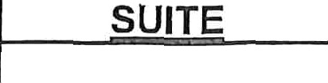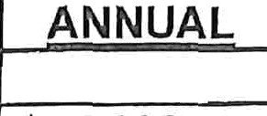Rent roll:

DATE TENANT  4-1-26 to 28 World Insurance  4-1-26 to 29 IHM, LLC  6-1-26 to 27 Ron Schroeder,  PhD |  | SUITE | MONTH | ANNUAL  $45,000  26,400
 |  | 1°t Floor | $3,750 | ANNUAL  $45,000  26,400
 |  | 2B, 2D, 2F  2E | 2,200 | ANNUAL  $45,000  26,400
 |  | 2B, 2D, 2F  2E | 700 | 8,400
4-1-26 to Dr. David Bock 27 |  | 2C | 600 | 7,200
Open Open for Rent |  | 2A | 700 | 8,400
Open | Open for Rent | Basement  Storage | 500 | 6,000
 | 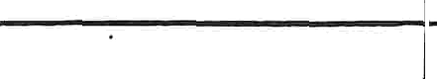 | Total 100% | $8,450  7,250 | $101,400 | O erat n Net Income  $64,121
 |  | Present 86% | $8,450  7,250 | 87,000 | O erat n Net Income  $64,121

Expenses 2025:
TPr peart xes  Electric | $13,168  4,645
Oil | 3,586
Water | 380
Sewer | 528
Garbage | 1,445
Pest Control | 1,092
Property Insurance | 4,520
Flood Insurance | 6,341
Maintenance | 1,573
Total | $37,279

GOI: | $101,400.00
TOE: | $37,279.00
NOI: | $64,121.00

