PEOPLES ROAD BUSINESS PARK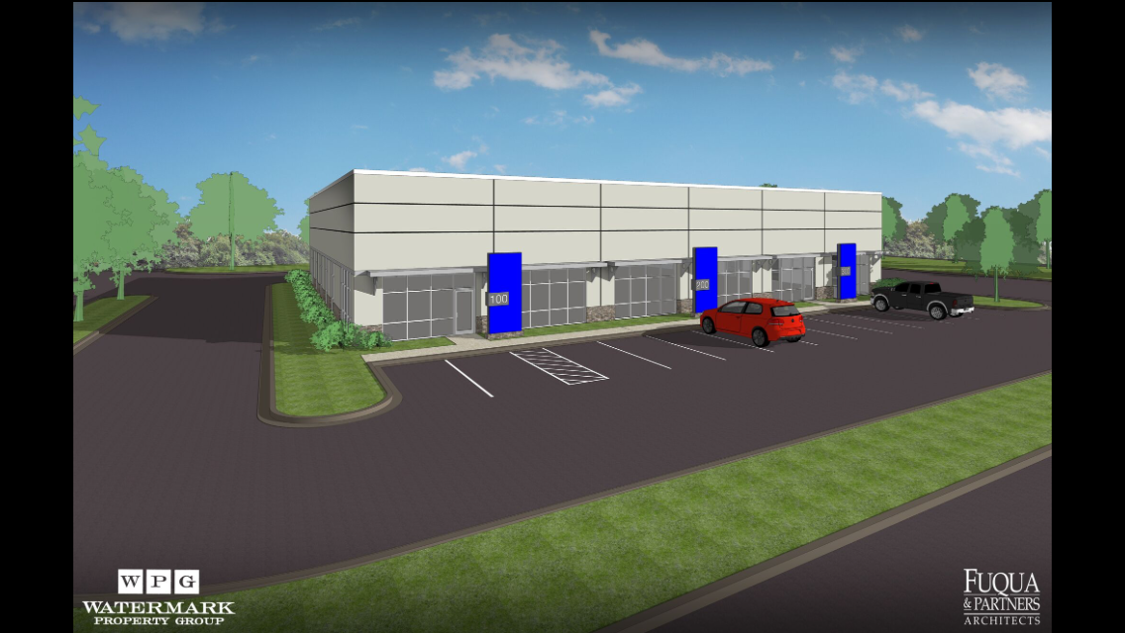
PEOPLES ROAD

Proposed Building-Leasing Now
  - Located in the heart of the vibrant Greenbrier industrial area
  - 5 minutes from the new Mazda Toyota plant, Polaris, GE Aerospace and Huntsville International Airport
  - Over 60,000 vehicles per day passing just north of the site, providing excellent access to and from I-565, the main east-west corridor through north Alabama
  - Strategically located between I-65 and the Huntsville International Airport
  - Building 100 is to be a 12,000 SF building, potentially divisible into three 4,000 SF units
  - Each unit can have warehouse space in the back and an office/showroom area in the front, making this an ideal location between Decatur and Huntsville for contractors, light manufacturers and distribution/logistics companies


JOHN C. EYSTER, JR.
WATERMARK PROPERTY GROUP, LLC
300 MARKET STREET NE, SUITE B-1
P. O. BOX 1189
DECATUR, AL 35602
256-426-1165 OWNER/AGENT

