
2325 Verlin Rd, Green Bay, WI 54311
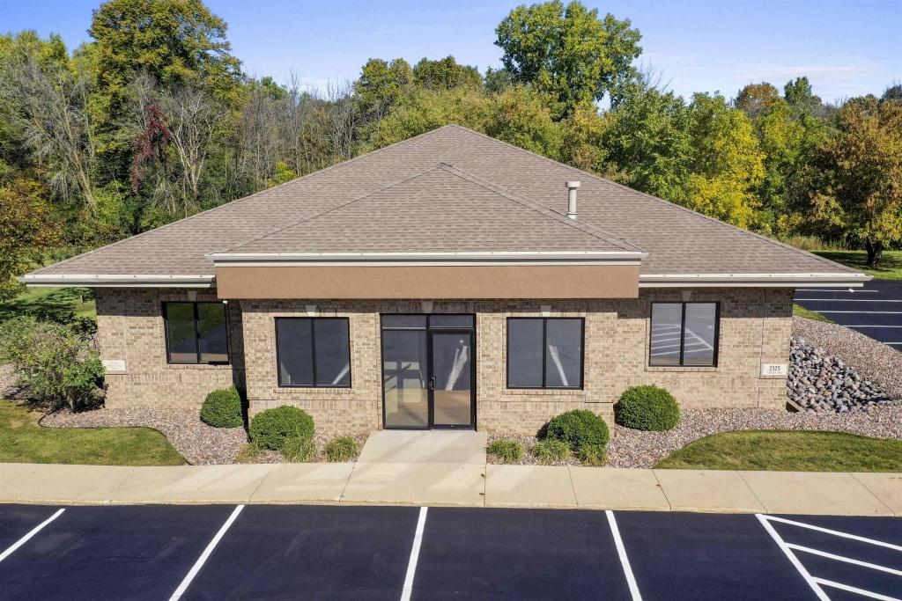
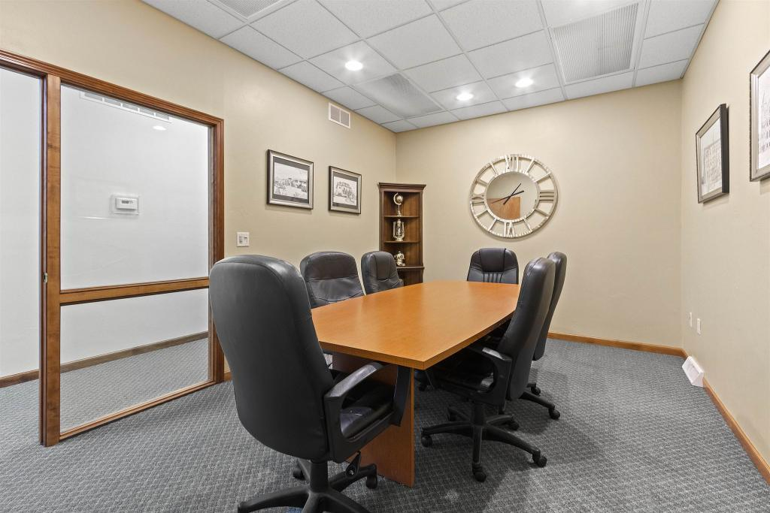
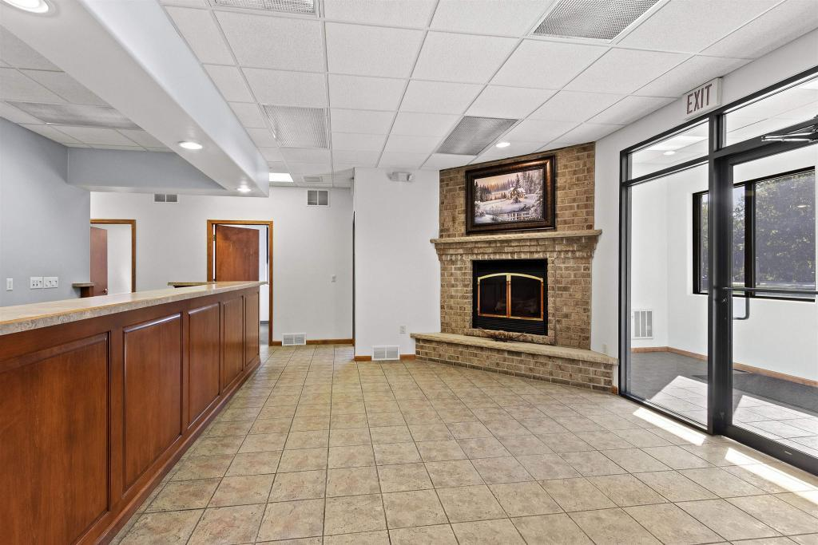
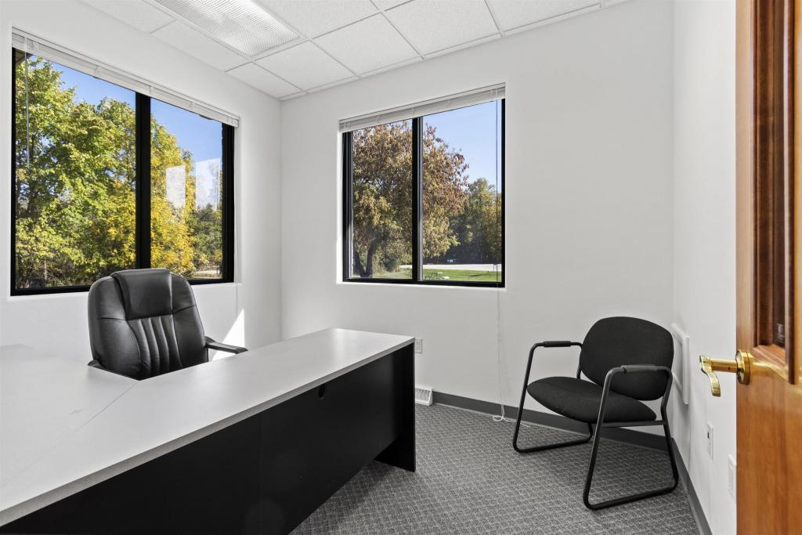
New Location! Including the following features:
• A receptionist who will welcome your guests from 8am to 5pm Monday through Friday (A $30,000 value per year!)
• Fully furnished offices with executive desks ($2000 value per office)
• Complimentary coffee for you and your guests
• Mail & package distribution (Free service included with reception)
• Copier/printer and fax provided with 200 free B&W copies each month (A $24.00 + value per month)
• Spacious conference rooms with flexible scheduling
• Janitorial service and supplies
• Lawn care and snow removal
• Free parking (Compared to $160 per month for downtown parking)
• Kitchenette with full size refrigerator & microwave
• Utilities Included (Heat, Air Conditioning, Water and Electric)
•Optional Low cost High Speed Internet ($25 per month per user versus $175 for dedicated service)
•Optional Phone Service (Only $40 per phone line including receptionist service and voice mail)

Rental Information:

Office Suite # _______________

Rental Rate ___________/ month

For More information contact:

Mike Gehm 920-559-0956 mike@eosuites.com

Executive Office Suites Riverside 920-569-1899 riverside@eosuites.com

