OFFICE SUITES FOR LEASE
CONTACT AGENT FOR VIEWING
AVAILABLE IMMEDIATELY · 8 PRIVATE SUITES · FROM $310/MONTH
Private, lockable offices in a professional executive suite on a high-traffic stretch of Horizon Drive — anchored by Southern Nevada Health District, Allstate Insurance, a dental office, and a medical office. Ideal for therapists, massage & wellness practitioners, real estate and loan professionals, small medical or retail businesses, startups, and independent professionals of nearly any kind.
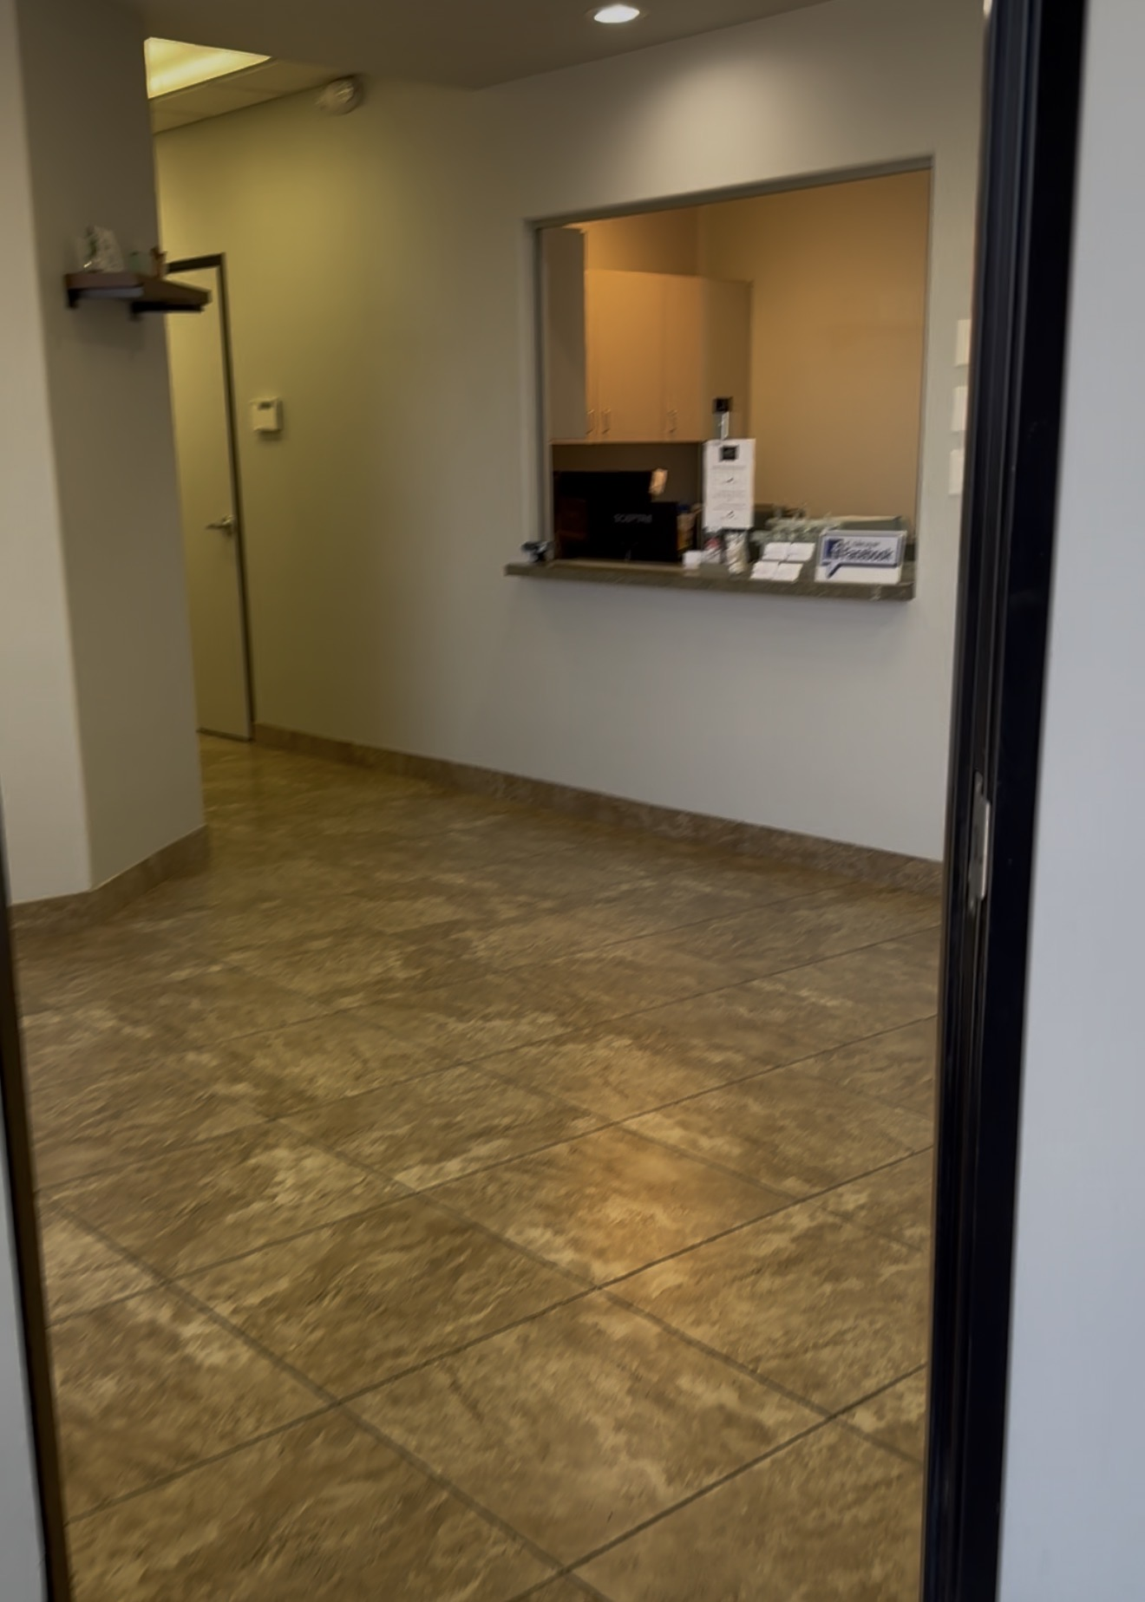 | 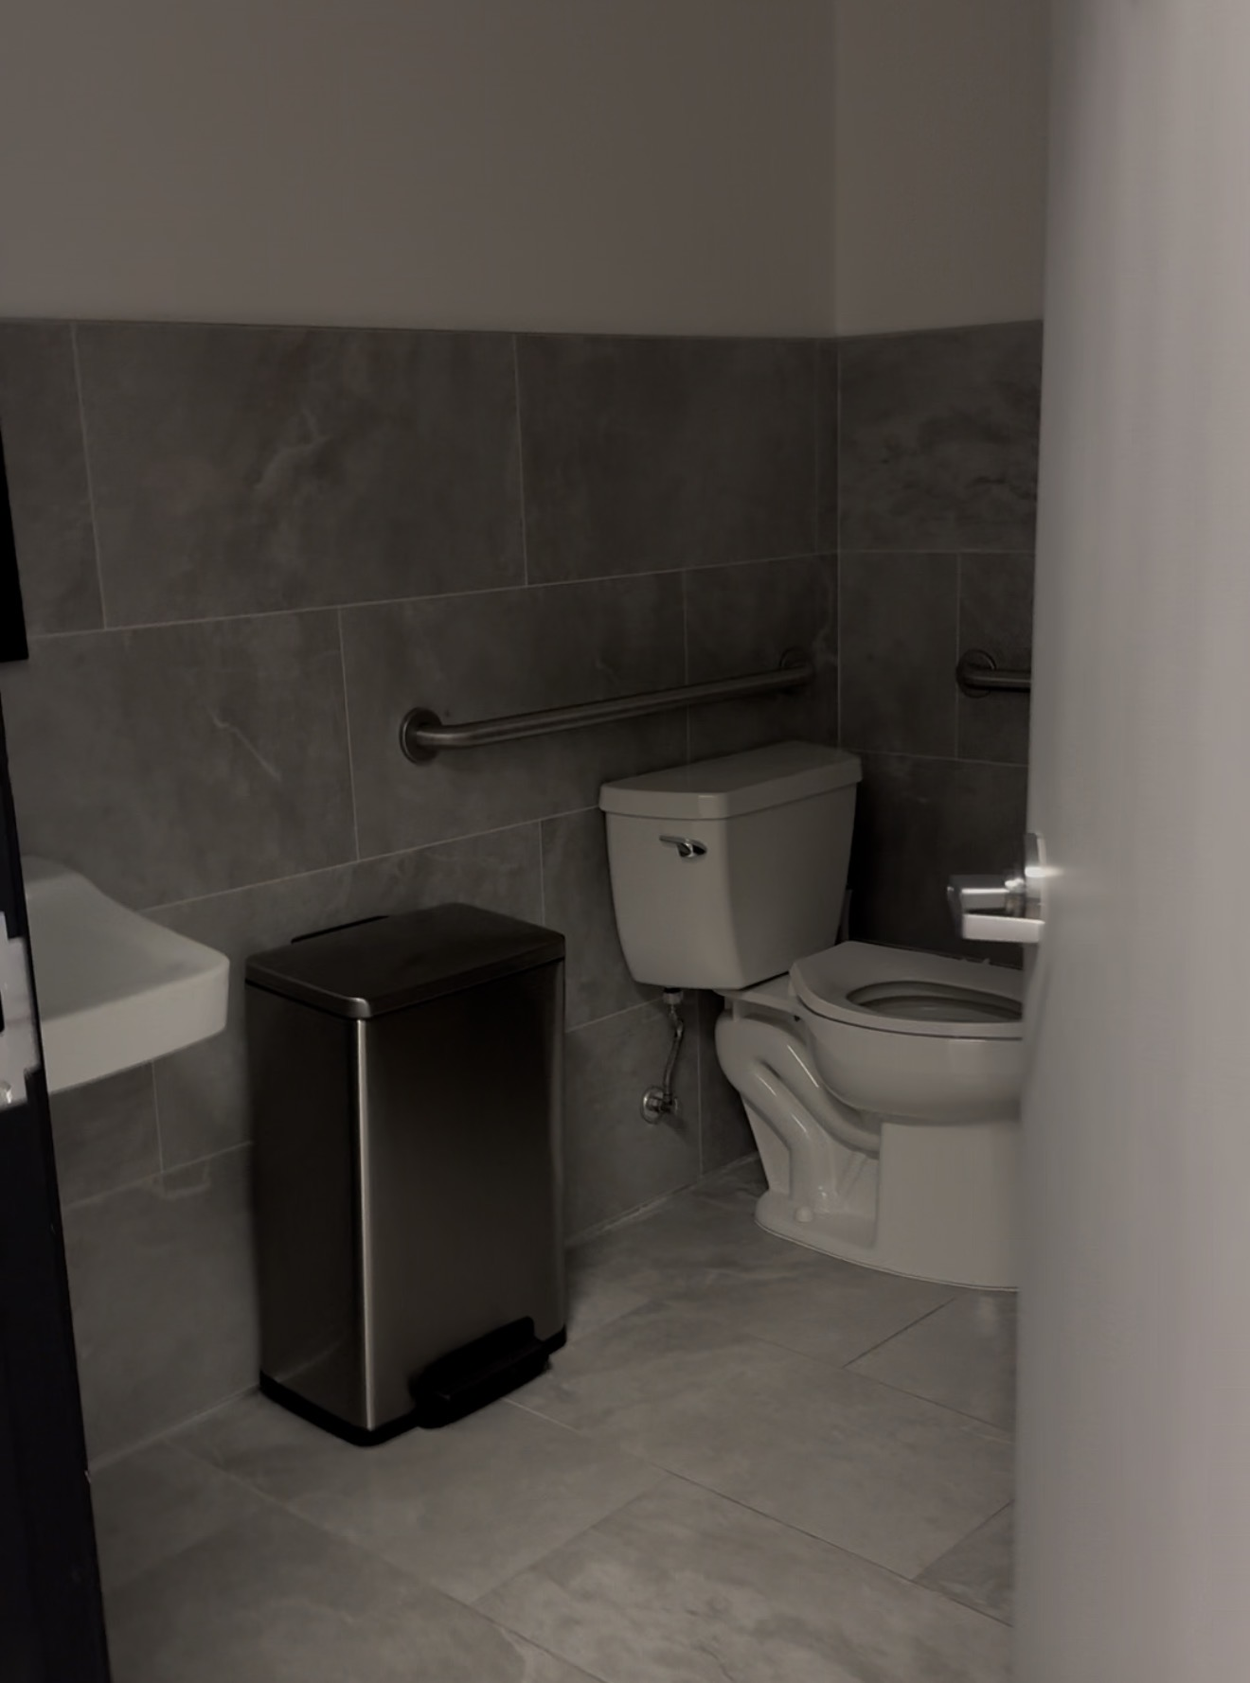
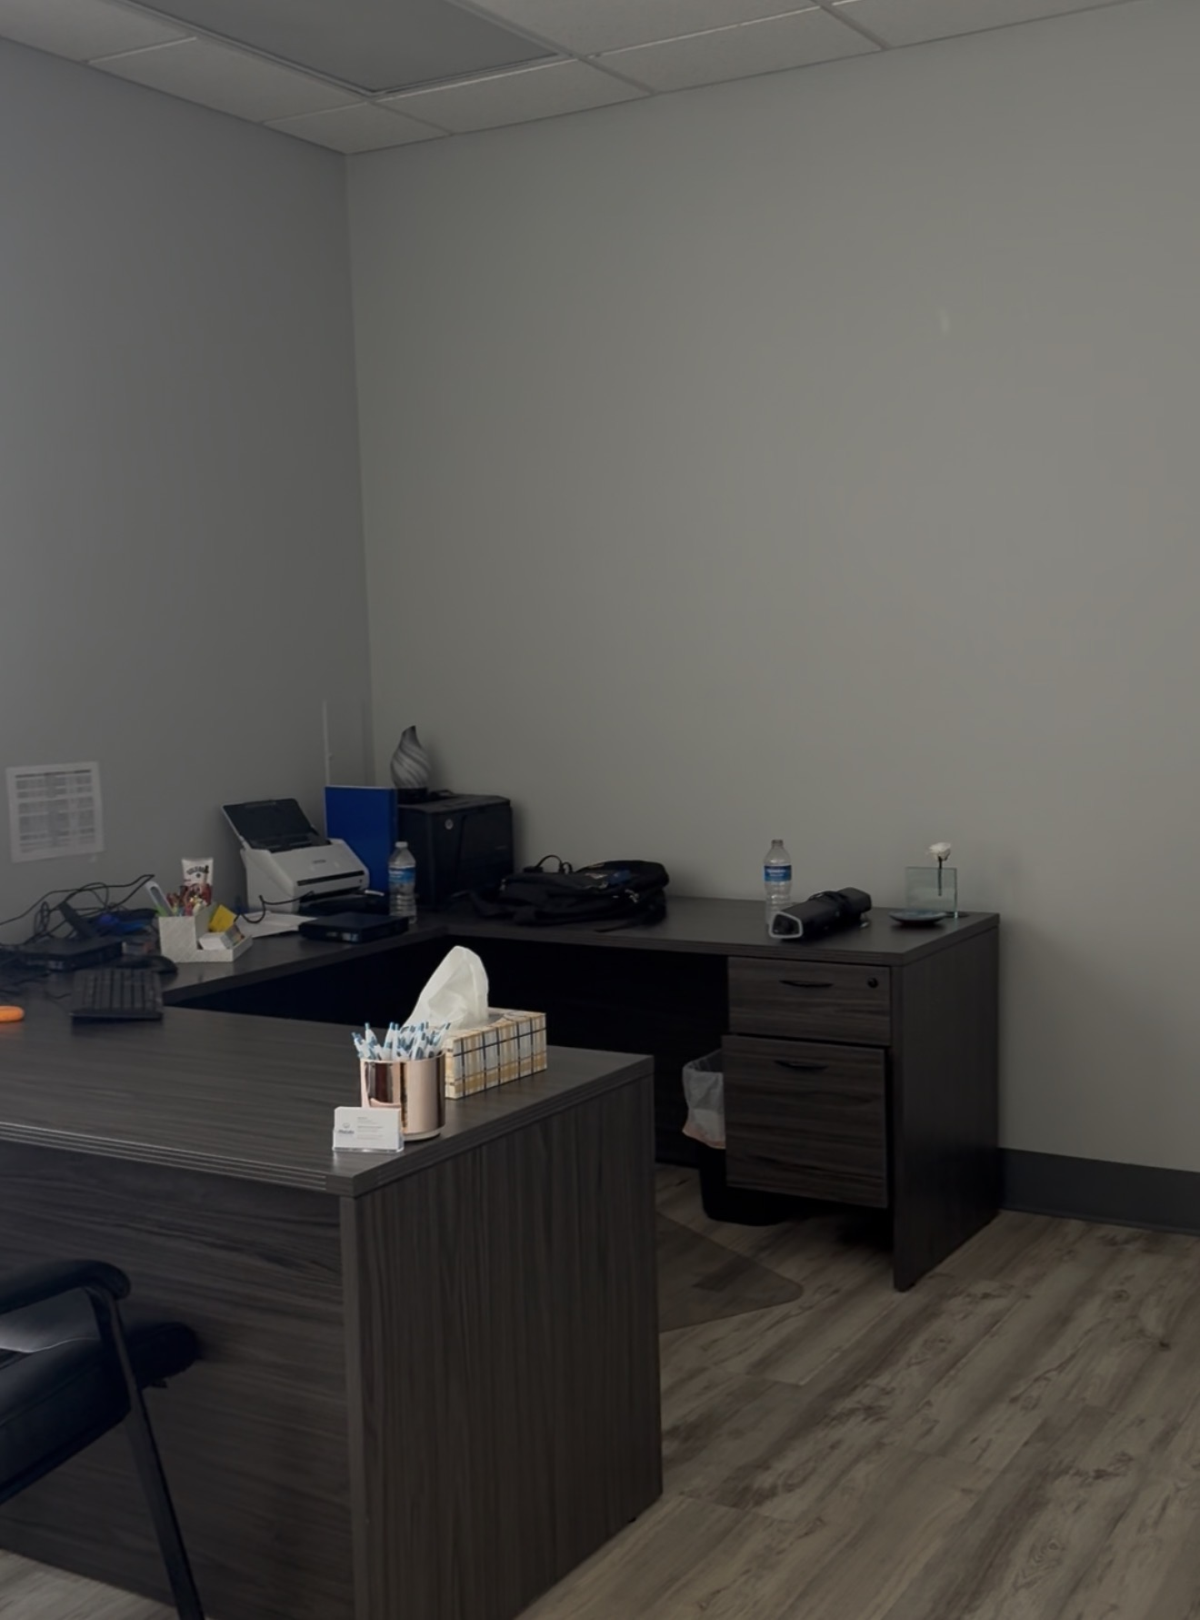 | 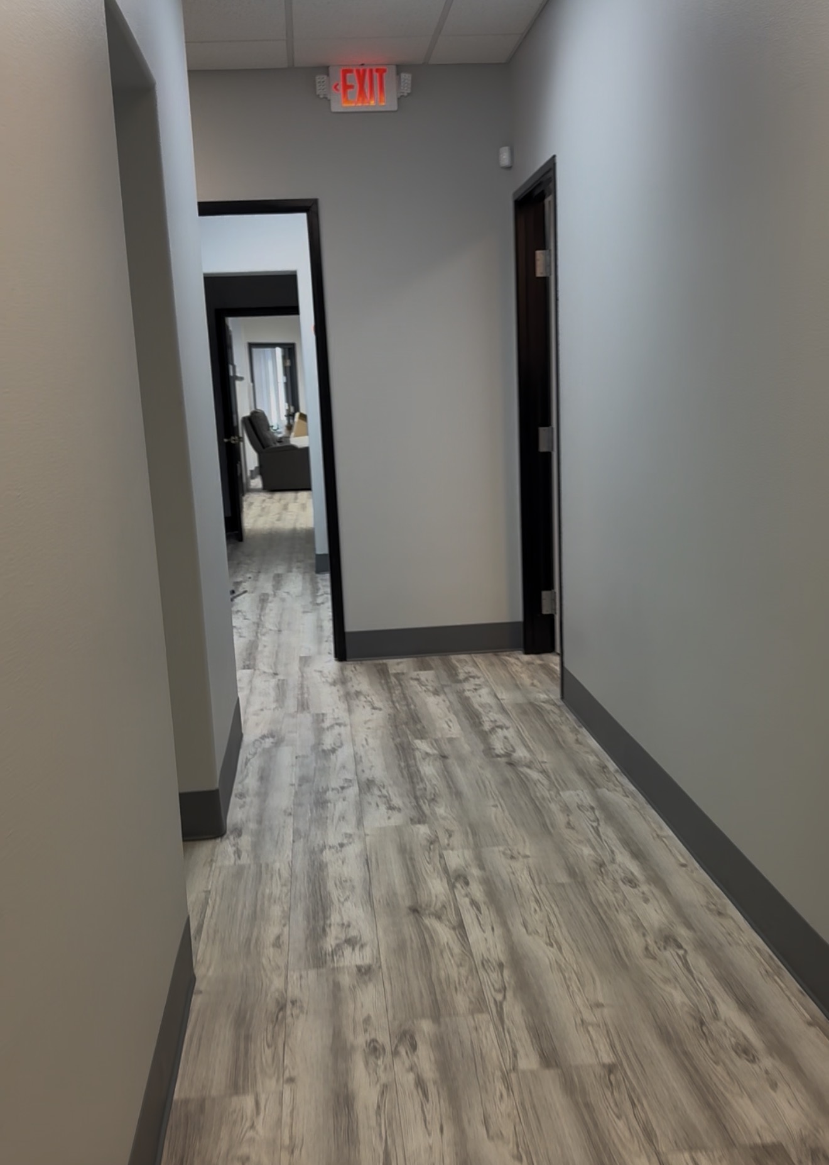

Suite | Size | Description | Monthly
1 | 120 sf | Private office, no window | $600/mo
2 | 199.5 sf | 2 windows, ceiling fan | $970/mo
3 | 152.25 sf | 1 window | $775/mo
4 | 90 sf | Private office, no window | $450/mo
5 | 90 sf | Private office, no window | $450/mo
6 | 150 sf | 1 window, street view | $765/mo
7 | 120 sf | 1 window, street view | $630/mo
8 | 96 sf | Reception, built-ins | $310/mo
EVERY SUITE INCLUDES
- Open, on-site parking  - 24/7 key-coded building access  - Power, water, trash, sewer & internet included  - Shared A/C & heating | - Weekly-cleaned shared restroom & kitchenette  - Mail & package acceptance, M–F 8–5  - Flexible lease terms — annual or month-to-month  - 1 month free on a 12-month lease
CONTACT TO SCHEDULE A TOUR
Melissa Hudson
iProperties International
NV License # BS.0146059
702-769-1399
successrealestatenv@gmail.com

