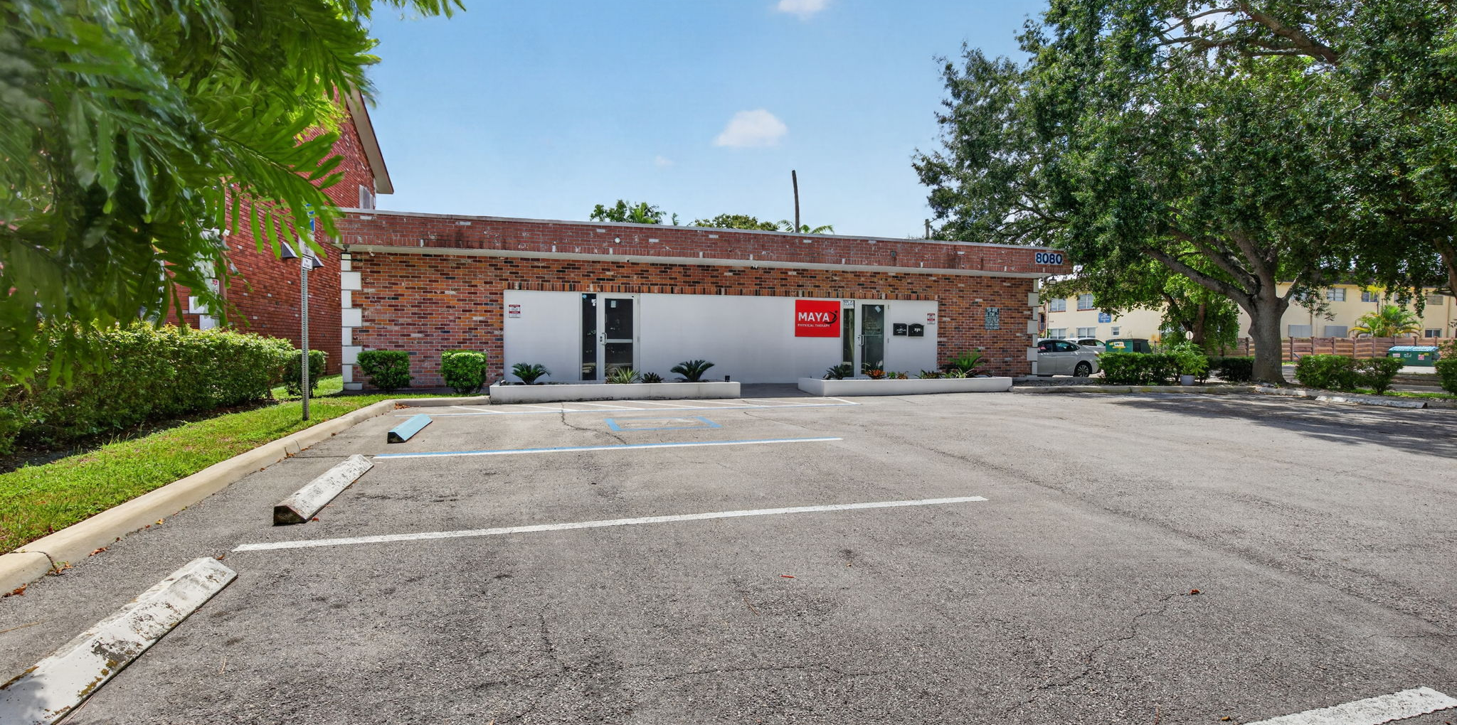
FOR LEASE | MEDICAL · PROFESSIONAL OFFICE
8080 Pasadena Blvd
PEMBROKE PINES, FLORIDA 33024
A turnkey ±1,100 SF suite with six treatment rooms, a private office, reception and waiting — steps from Memorial Hospital Pembroke and minutes from the beaches, airports and courts of South Florida.
±1,100 SF  AVAILABLE | 6 + 1  ROOMS + OFFICE | TURNKEY  MOVE-IN READY | B-3  ZONING

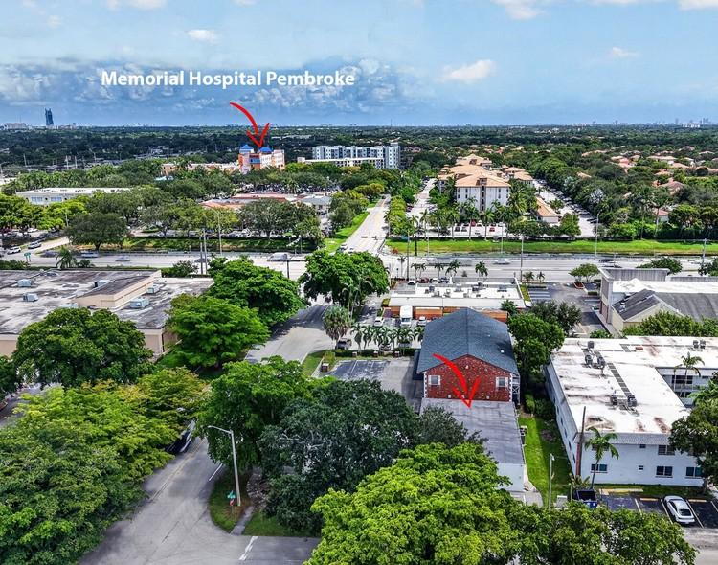 | 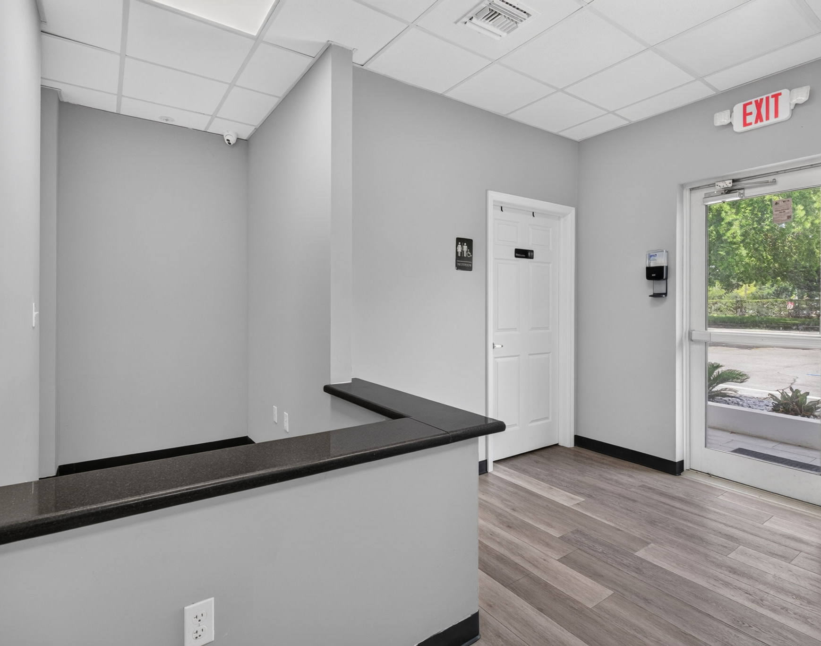 | 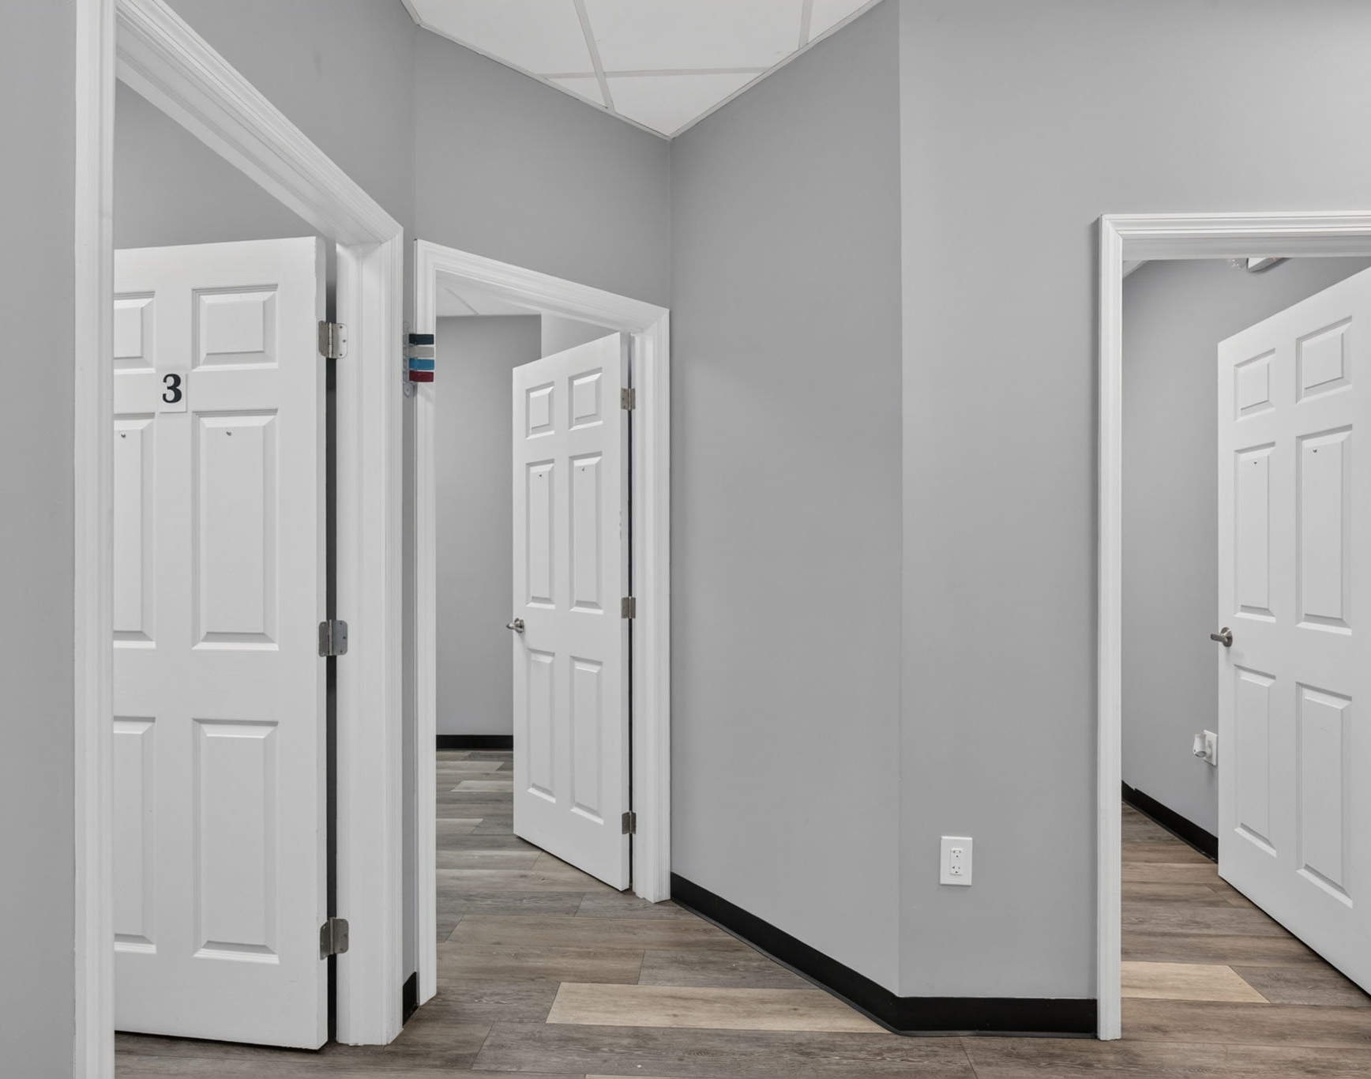 | 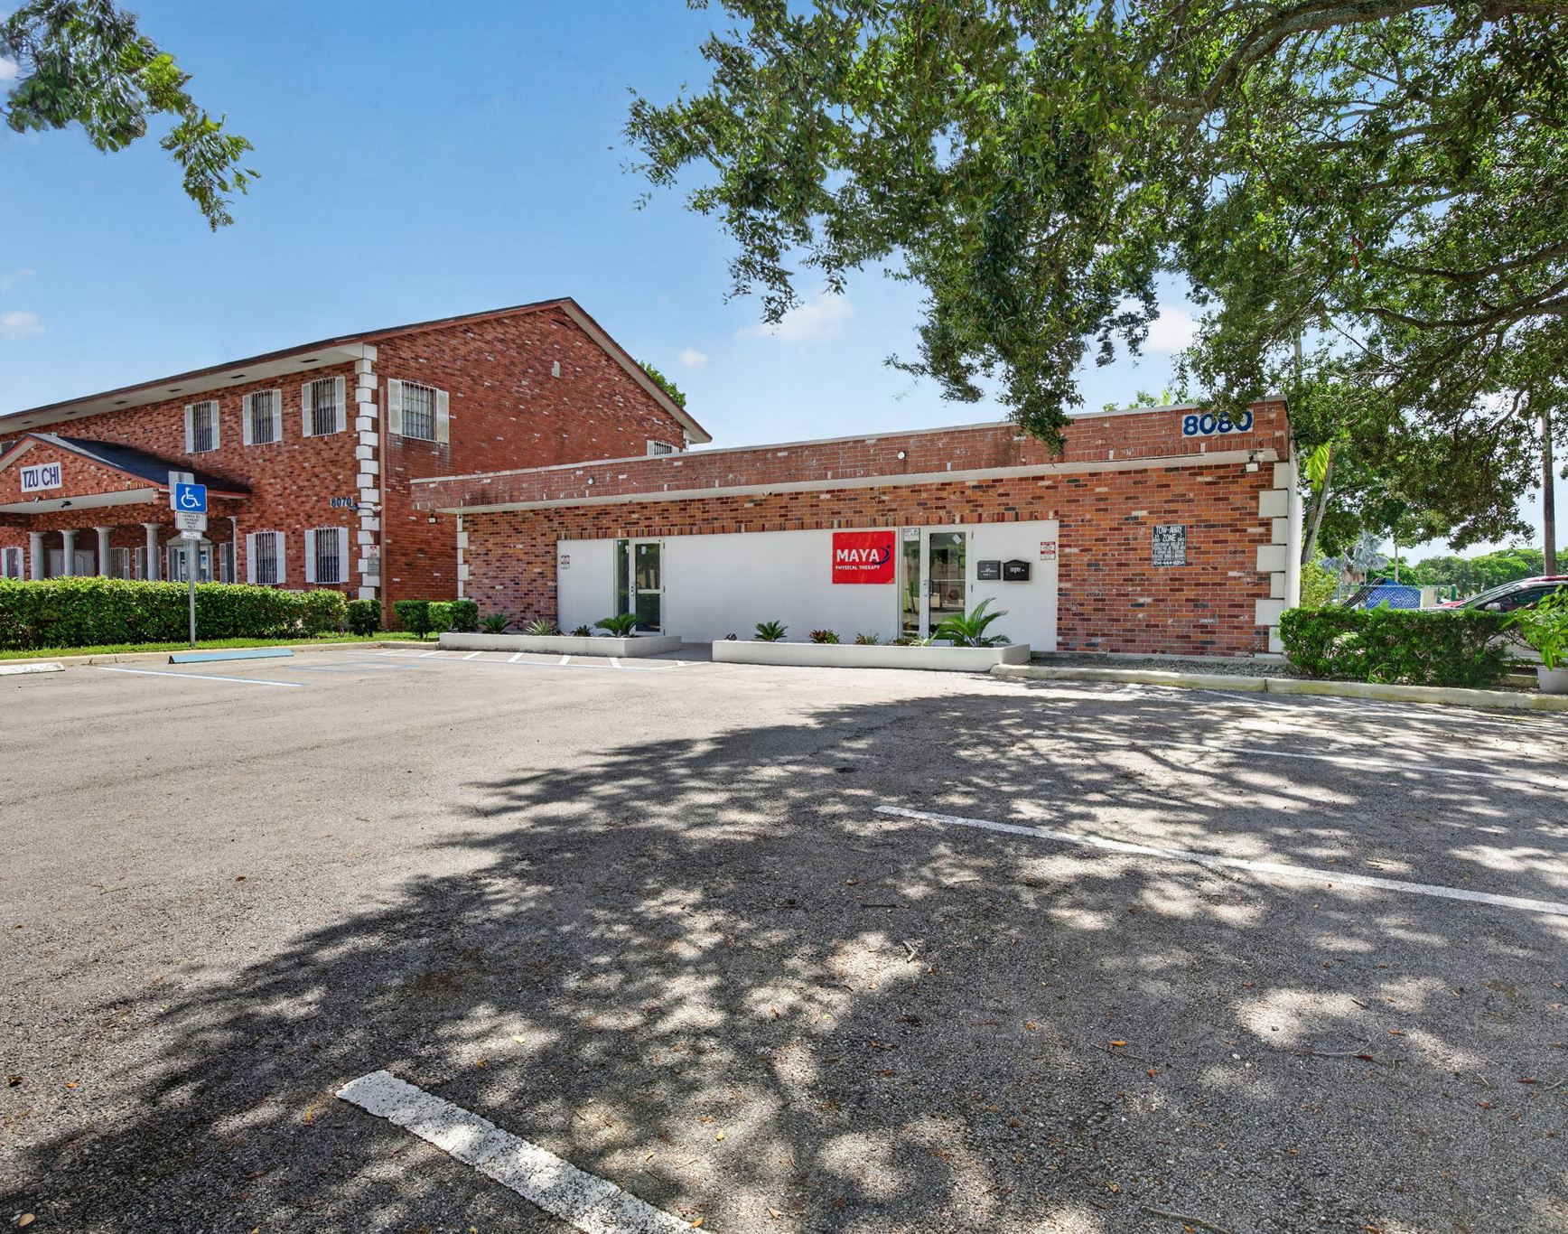
AERIAL VIEW | RECEPTION | PRIVATE ROOMS | PRIVATE ENTRANCE

 | Raissa Restivo  Medical Real Estate & Business Brokerage Specialist  THE KEYES COMPANY · COMMERCIAL DIVISION | 561-676-8814  RaissaRestivo@keyes.com  MedOfficeSpaces.com

Property Overview
A fully built-out, move-in-ready suite in a low-rise, owner-occupied medical/professional building near Memorial Hospital Pembroke — without the restrictions of a hospital-grounds ground lease. The suite offers six treatment rooms, a private office, a separate waiting room, and a reception area with a built-in reception desk, plus a shared staff breakroom and two shared restrooms. Designed for patient care, the same layout works equally well for a law firm, CPA practice, financial advisor, or other professional office — treatment rooms become private offices, and the reception and waiting areas welcome clients. With the build-out complete, a new tenant can open with minimal construction cost and downtime.
The building presents as a professional, standalone-feeling medical office with its own dedicated parking, covered walkway entrance, and mature landscaping, set in one of Pembroke Pines' busiest medical corridors. The owner runs his own practice in the other half of the building (Suite B), so tenants deal directly with ownership — no property-management layers — and enjoy a well-maintained, owner-occupied property.

Suite Features
✓ Ideal for medical or professional office users
✓ Six (6) private treatment rooms
✓ Private office
✓ Separate waiting room & reception with built-in desk
✓ Shared staff breakroom
✓ Two shared restrooms (staff & patient)
✓ Network / Wi-Fi closet
✓ Private front entrance to Suite A with covered walkway
✓ Dedicated on-site parking
✓ Near Memorial Hospital Pembroke
✓ Owner-occupied building — direct, responsive ownership

Asking Rate & Terms
The suite is offered at $35.00 per SF per year on a triple net (NNN) basis, with the tenant responsible for its pro-rata share of property taxes, insurance, and common area maintenance. Ownership is seeking a minimum 5-year term with 3.5% annual escalations — a stable, long-term home for a growing practice, priced competitively against on-campus medical space nearby. With the medical build-out already in place, a new tenant avoids the upfront cost and delay of building out raw space.

Designed for Medical. Ready for Professional.
Few suites are this versatile. The six private rooms and private office serve a medical practice as treatment rooms — or a professional firm as private offices and conference space. Reception, a separate waiting room, and a dedicated network closet support either use, and the location puts clients and patients within easy reach.
Medical & Healthcare | Professional Office
Primary care & family medicine | Law firms & solo attorneys
Specialists & satellite offices | CPA, bookkeeping & tax practices
Chiropractic | Financial & wealth advisors
Behavioral health & counseling | Insurance agencies
Wellness, aesthetics & med spa | Title, mortgage & real estate firms
Home-health & care coordination | Consultants & professional services
Tenant to verify intended use with the City of Pembroke Pines (B-3 General Business zoning).

Property Facts
Available Space | ±1,100 SF (within a 2,108 SF building)
Suite Layout | 6 treatment rooms, 1 private office, waiting room & reception
Lease Rate | $35.00 / SF / YR, Triple Net (NNN)
Lease Term | 5-Year Minimum
Escalation | 3.5% Annually
Zoning | B-3
Lot Size | 0.19 Acres (8,196 SF)
Year Built | 1972 (Renovated 1995)

Floor Plan
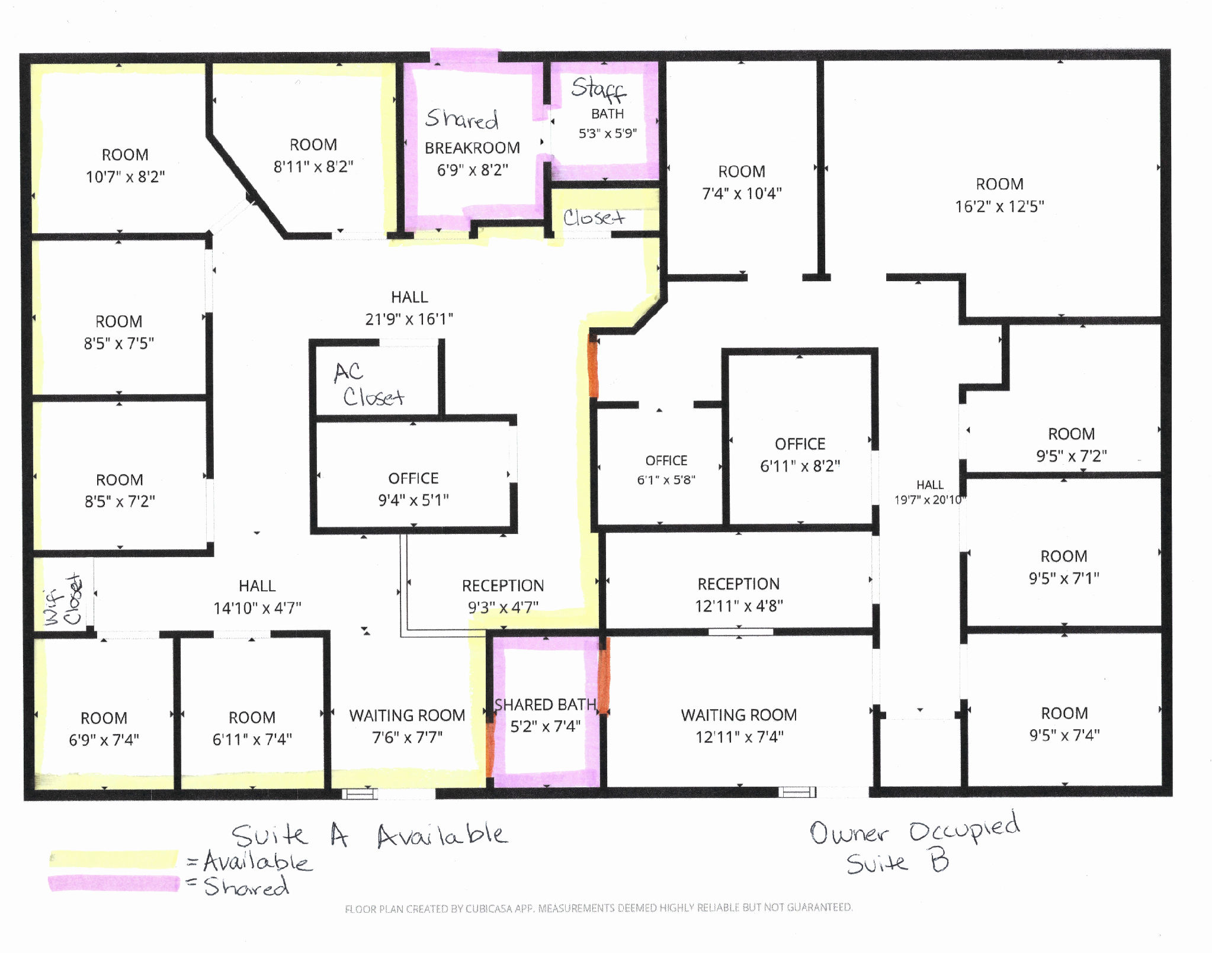
Suite A (available) highlighted in yellow · shared areas highlighted in pink · Suite B owner-occupied

Room Dimensions
Treatment Room 1 | 10'7" x 8'2"
Treatment Room 2 | 8'11" x 8'2"
Treatment Room 3 | 8'5" x 7'5"
Treatment Room 4 | 8'5" x 7'2"
Treatment Room 5 | 6'11" x 7'4"
Treatment Room 6 | 6'9" x 7'4"
Private Office | 9'4" x 5'1"
Reception | 9'3" x 4'7"
Waiting Room | 7'6" x 7'7"
Shared Breakroom | 6'9" x 8'2"
Shared Restroom (Patient) | 5'2" x 7'4"
Shared Restroom (Staff) | 5'3" x 5'9"
Measurements per floor plan; deemed reliable but not guaranteed.

Photo Gallery
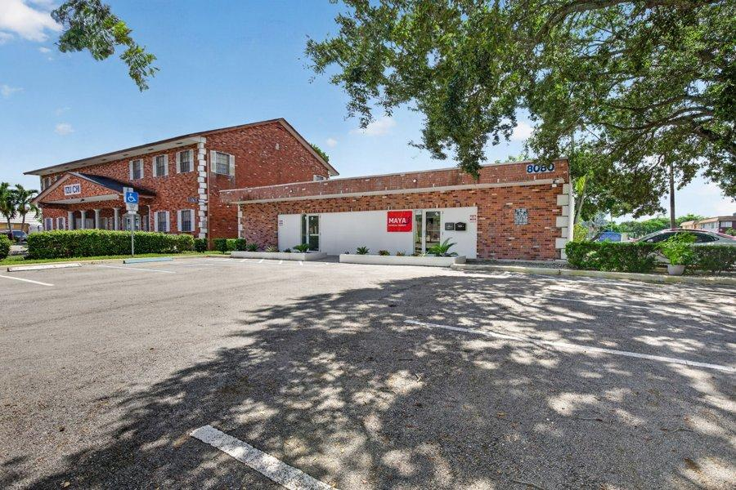  Building Exterior & Parking | 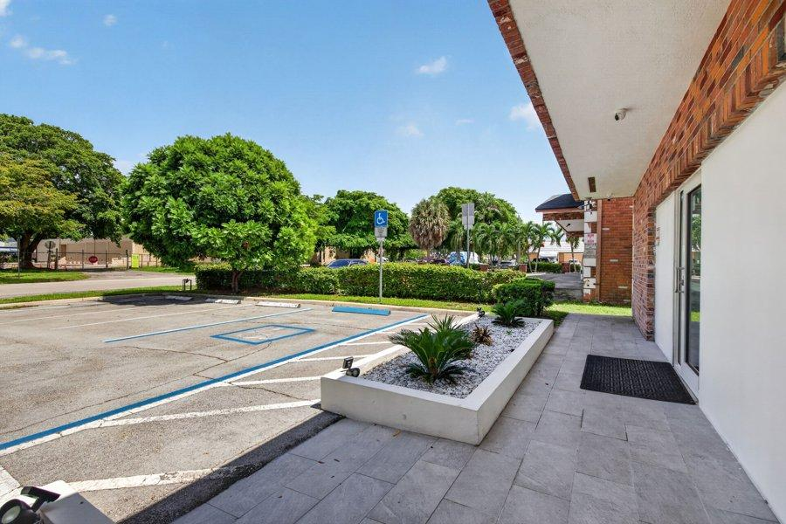  Private Entrance & Walkway | 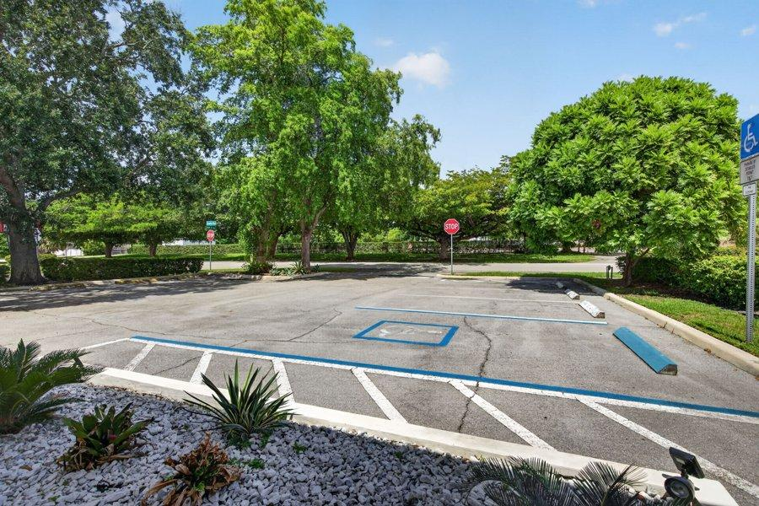  Parking & Entry
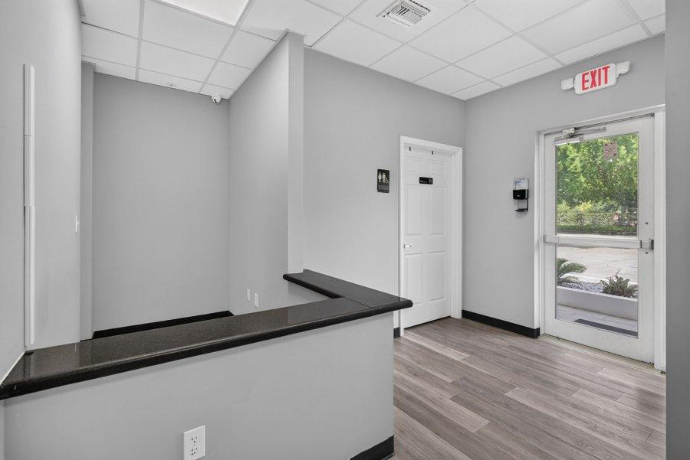  Reception with Built-In Desk | 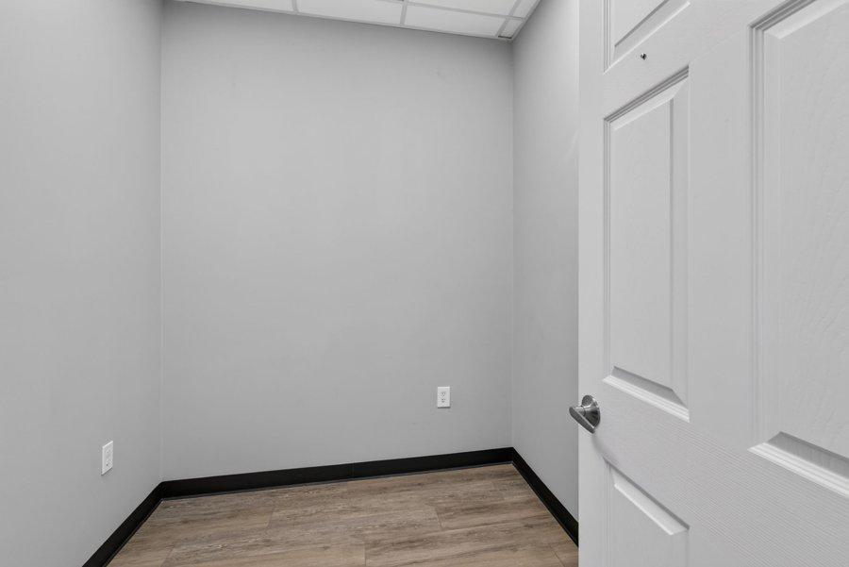  Several Private Treatment Rooms | 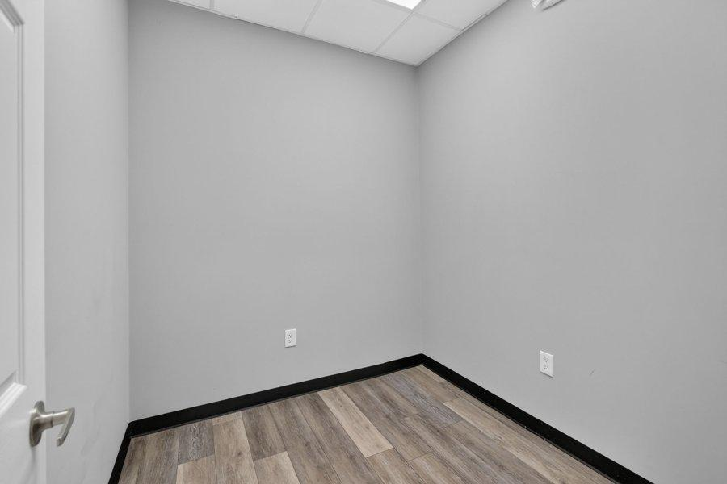  Private Treatment Room
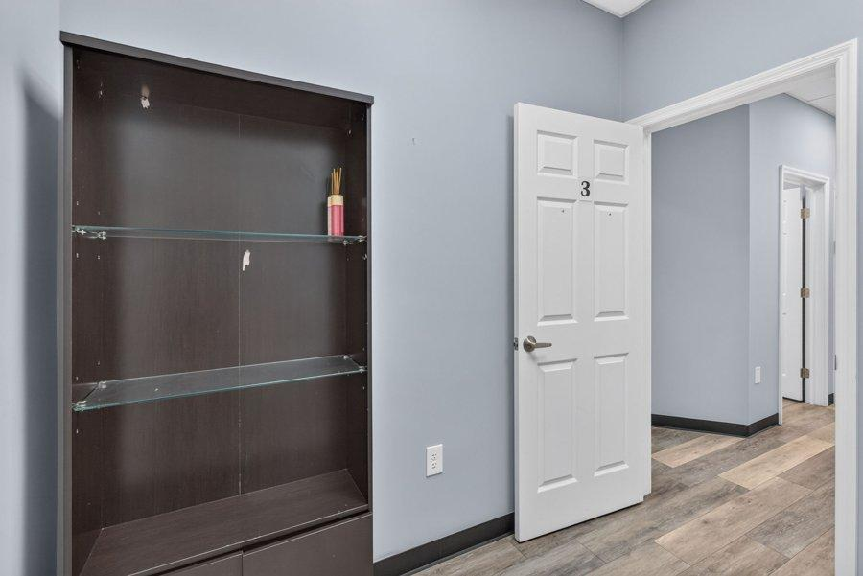  Treatment Room with Built-In Cabinetry | 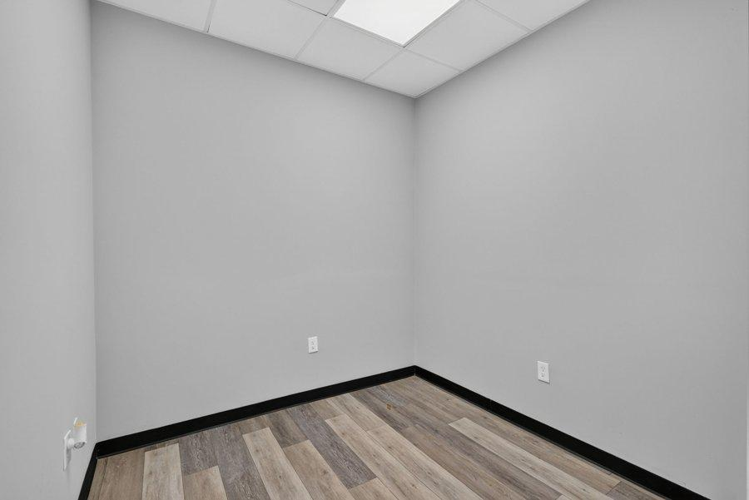  Private Treatment Room | 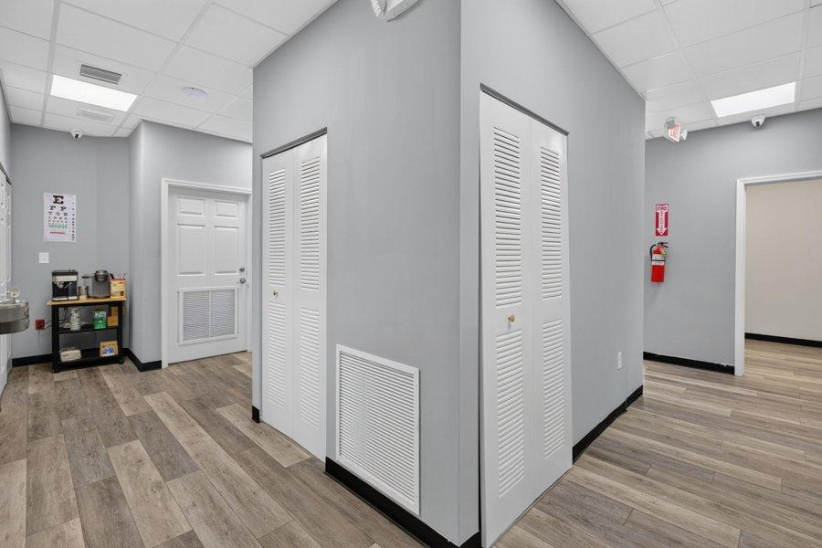  Interior Suite Corridor
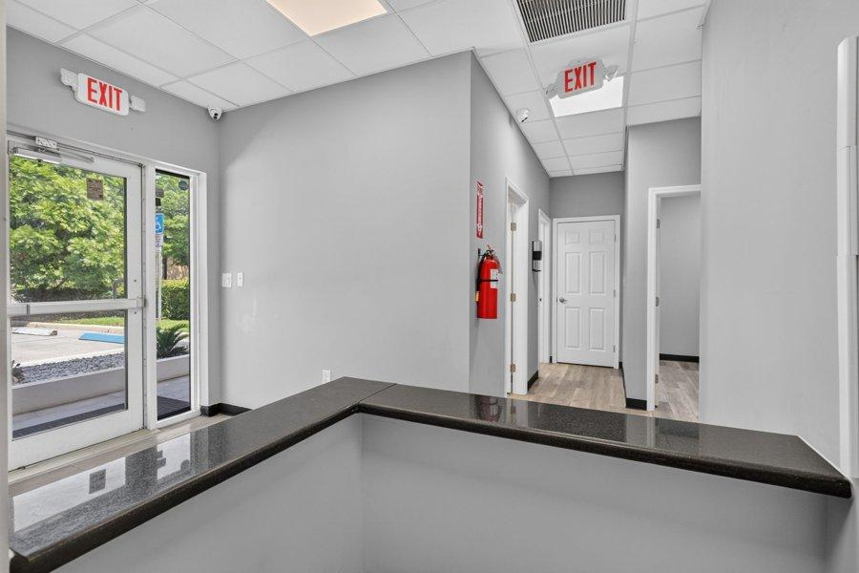  Corridor to Front Entrance | 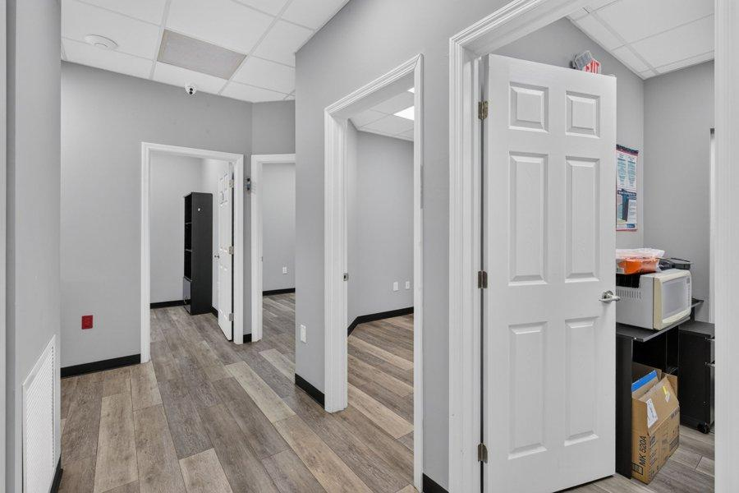  Utility / Break Area | 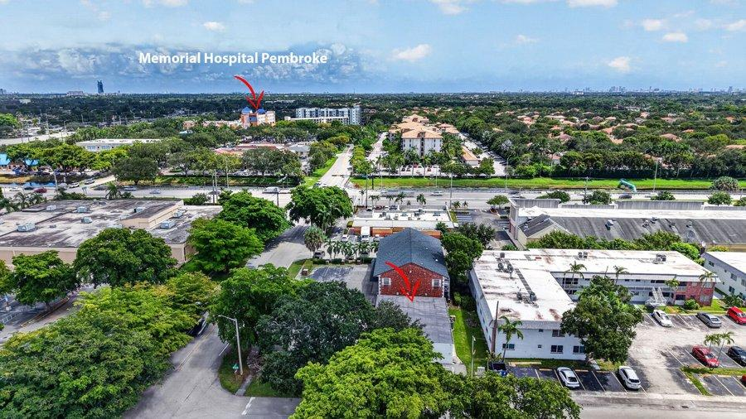  Aerial — Memorial Hospital Pembroke Nearby

Location & Proximity
8080 Pasadena Blvd sits along the University Dr & Pasadena Blvd corridor, one of southwest Broward's busiest medical corridors. The property is near Memorial Hospital Pembroke, a full-service hospital in the Memorial Healthcare System, but not on hospital grounds — so the lease carries none of the ground-lease restrictions, use limitations, or hospital approvals that come with an on-campus medical building. Tenants gain the convenience and referral proximity of a hospital neighbor with the independence of a private building.
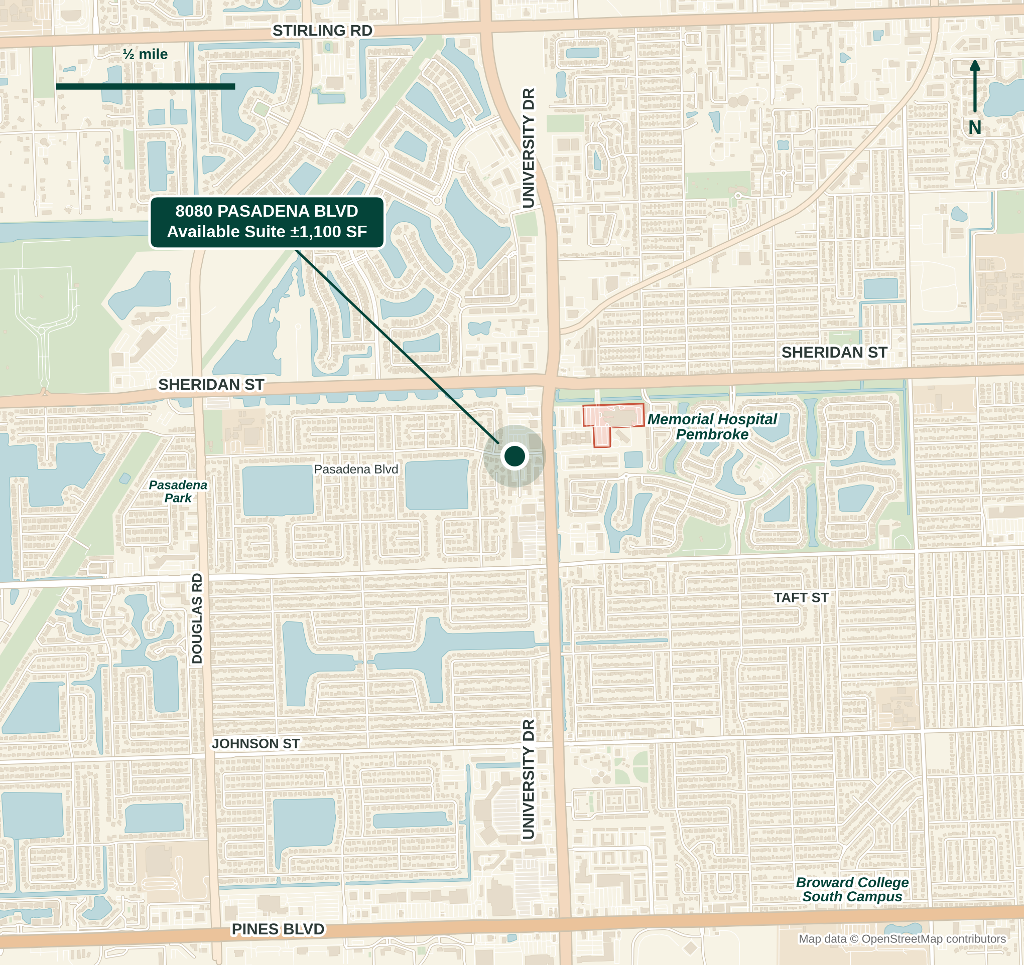
Neighborhood map — University Dr & Pasadena Blvd, Pembroke Pines. Map data © OpenStreetMap contributors.

Minutes from Everything
Destination | Distance · Drive Time
Memorial Hospital Pembroke | < 0.5 mi · ~2 min
Broward College South Campus | 2.5 mi · ~7 min
Seminole Hard Rock Hotel & Casino | 4 mi · ~10 min
South Regional Courthouse (Hollywood) | 6 mi · ~12 min
C.B. Smith Park | 6 mi · ~11 min
Fort Lauderdale-Hollywood Int'l Airport (FLL) | 8 mi · ~17 min
Hollywood Beach & Broadwalk | 10 mi · ~20 min
Port Everglades Cruise Port | 12 mi · ~24 min
Aventura Mall | 12 mi · ~22 min
Las Olas Blvd / Downtown Fort Lauderdale | 13 mi · ~23 min
Wynwood, Miami | 18 mi · ~29 min
Brickell, Miami | 21 mi · ~32 min
Miami International Airport (MIA) | 23 mi · ~38 min
Approximate driving distance and off-peak drive time; actual times vary with traffic.

Pembroke Pines at a Glance
176,714  POPULATION (2025 EST.) | $85,104  MEDIAN HH INCOME | 39.7%  BACHELOR'S DEGREE + | 69.6%  HOMEOWNERSHIP

Pembroke Pines is one of Broward County's largest cities — an established, family-oriented community with a strong base of homeowners, a well-educated workforce, and one in five residents aged 65 or older. That mix drives steady demand for healthcare and for the attorneys, accountants and advisors who serve local families and businesses.
Source: U.S. Census Bureau QuickFacts, Pembroke Pines city, Florida.

The South Florida Lifestyle
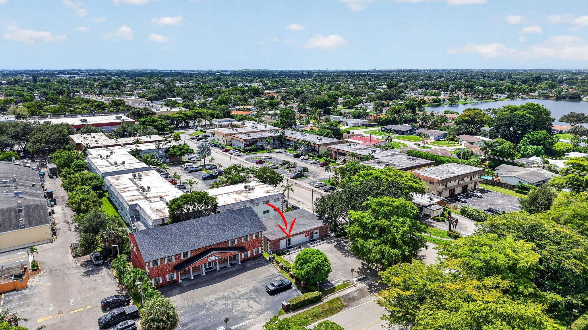
Work where others vacation. South Florida pairs a year-round subtropical climate — roughly 3,000 hours of sunshine a year and an average temperature in the mid-70s — with a business environment that continues to draw professionals, families and companies from across the country. From 8080 Pasadena Blvd, the Atlantic beaches of Hollywood and Fort Lauderdale are about 20 minutes east, and the wide-open wilderness of the Everglades lies just to the west.
3,000  HOURS OF SUNSHINE / YR | 23 MI  ATLANTIC BEACHES | 300+ MI  NAVIGABLE WATERWAYS | 0%  STATE INCOME TAX

Greater Fort Lauderdale offers 23 miles of beaches, more than 300 miles of navigable waterways that earned it the nickname “Venice of America,” 50-plus golf courses and more than 4,000 restaurants. Las Olas Boulevard's dining and boutiques, Hollywood's oceanfront Broadwalk, the Seminole Hard Rock Hotel & Casino and Miami's arts and culinary scene in Wynwood and Brickell are all an easy drive — making it easier to recruit and retain great staff, and to enjoy life after hours.
Florida levies no state personal income tax — a meaningful advantage for practice owners, partners and employees alike. Add steady population growth and a deep base of families and retirees, and it's a market where both a business and the people behind it can thrive.
Sources: Visit Lauderdale (Greater Fort Lauderdale fact sheet); Florida Department of Revenue.

At the Heart of South Florida
Pembroke Pines sits at the center of the Miami–Fort Lauderdale–West Palm Beach metro, home to more than 6 million people, with Broward County alone topping 2 million residents. Fort Lauderdale-Hollywood International Airport, the beaches of Hollywood and the South Regional Courthouse are all within about 10 miles, while downtown Fort Lauderdale, Aventura, Brickell and Miami International Airport fall within 25 — with I-75, I-595, Florida's Turnpike and I-95 all close at hand.
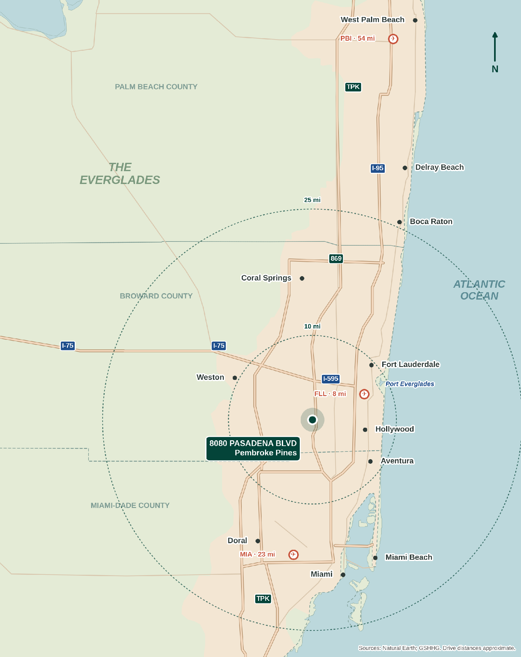
South Florida regional map with 10- and 25-mile rings from the property.

Highway Access
Getting in and out is easy. Seven major highways are within about 15 minutes of the property — US-441, Florida's Turnpike, I-595, the Homestead Extension, I-95, I-75 and the Palmetto Expressway — with the Sawgrass Expressway and US-27 about 20 minutes away, connecting patients, clients and staff to all of Broward, Miami-Dade and Palm Beach counties.
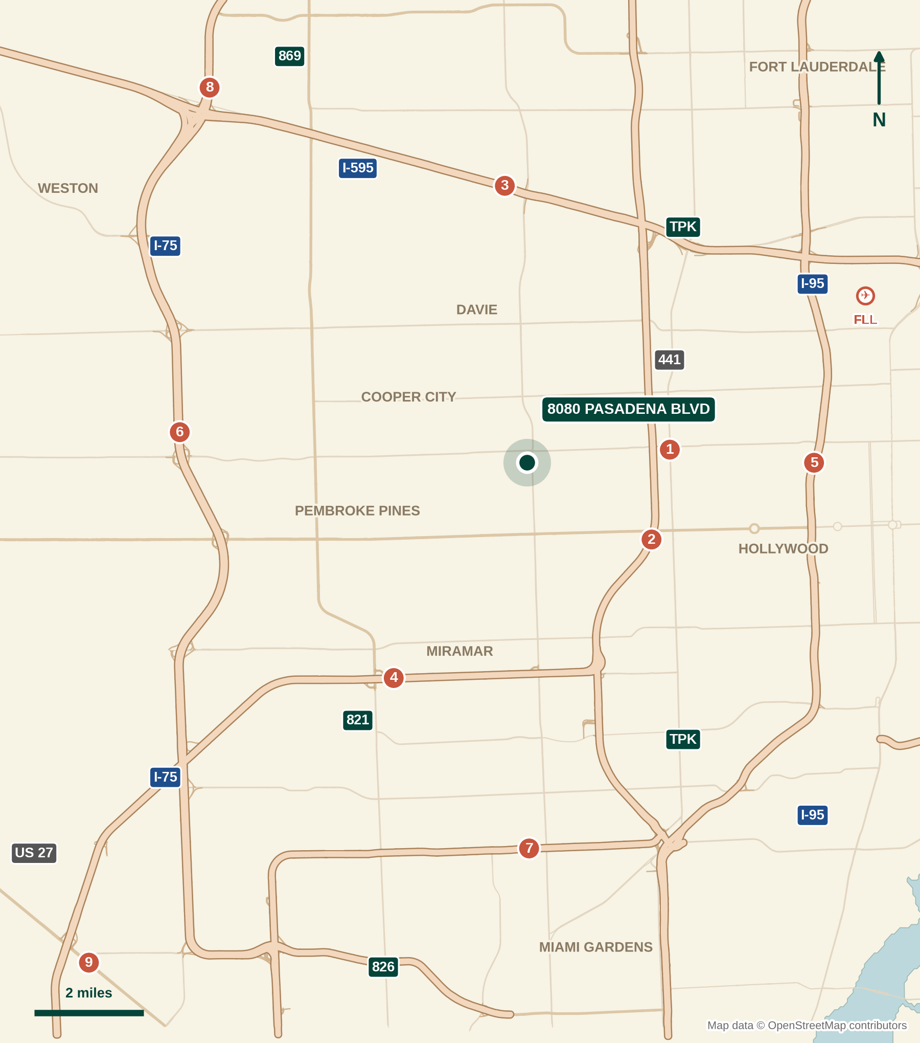
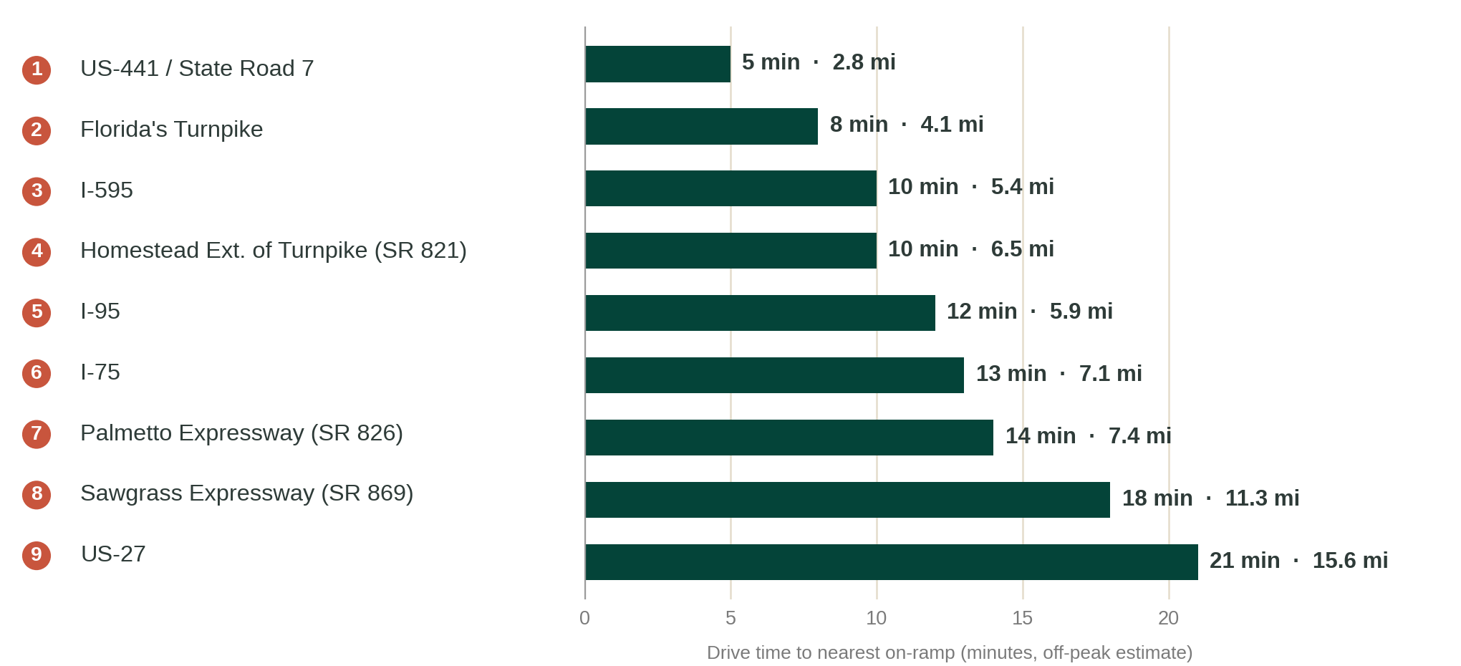
Numbers on the map match the chart. Distance and drive time to the nearest on-ramp, off-peak estimates; actual times vary with traffic. Map data © OpenStreetMap contributors.

Get To Know Me:
Raissa Restivo | Medical Real Estate & Business Brokerage Specialist
Raissa Restivo is a Commercial Real Estate and Business Brokerage specialist with The Keyes Company, serving physicians, medical groups, practice owners, investors, and business owners throughout South Florida, including Broward, Palm Beach, Miami-Dade, and the Treasure Coast.
With a specialized focus on healthcare real estate, Raissa helps medical professionals navigate medical office leasing, acquisitions, sales, investments, and practice transactions. As a licensed business broker, she also assists business and practice owners with valuations, sales, acquisitions, and strategic exit planning.
With a strong background in marketing and pricing strategy, Raissa takes a hands-on approach throughout every transaction—from valuation and positioning to marketing, negotiation, and closing. Her combined expertise in commercial real estate and business brokerage allows her to provide clients with a comprehensive perspective when real estate and business ownership intersect.
Raissa is a member of the Business Brokers of Florida (BBF), International Business Brokers Association (IBBA), and Realtor Commercial Alliance (RCA). Known for her relationship-driven approach, she has built a strong network of medical professionals, business owners, investors, and commercial property owners, providing clients with access to both on-market and off-market opportunities.
Outside of work, Raissa enjoys raising her two children, fishing, spending time on the water, and reading her latest book club book pick.

Raissa Restivo
Medical Real Estate & Business Brokerage Specialist
THE KEYES COMPANY · COMMERCIAL DIVISION
561-676-8814
RaissaRestivo@keyes.com
MedOfficeSpaces.com

