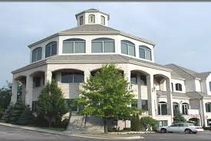
Office space (nice window views) for rent/sublet/coworking/shared space in Bloomingdale, IL (1100 Sq ft)
Price $12 + Utilities
Location: Downtown Bloomingdale
Condition
Used - like new

Details

Office Space for Lease or Shared Use! Spacious offices available (4 rooms — 1100 Sq ft) perfect for doctors, insurance agents, CPAs, estheticians, or any other professionals looking for a comfortable and convenient work environment.
✅ Executive suite with nice window views
✅ Access to water in one of the rooms
✅ Multiple rooms available
✅ Comes with furniture
✅ Included conference/training room
✅ Flexible lease terms
✅ Great location
✅ Proximity to loop (I 290)
✅ fully furnished
✅ Plenty of parking space

Message me for details or to schedule a viewing @6307649091



