LEASING NOW
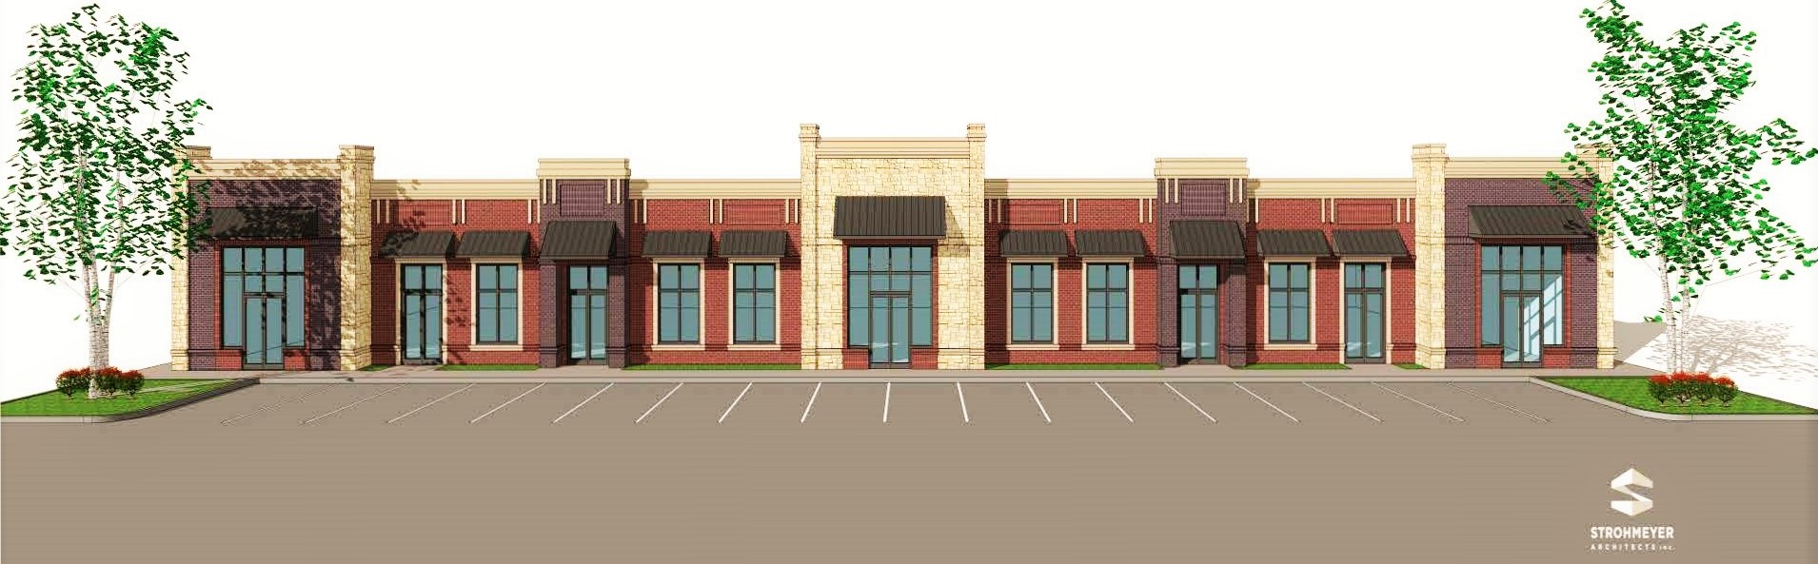

Heath Buffalo Plaza |  | Property Information:
Heath Buffalo Plaza is newest addition to the retail shopping experience in Heath. This center features great parking, city facilities and Lake Ray Hubbard. By offering 13,800 SF it is the largest retail center in this exclusive and dynamic community who is experiencing strong growth. |  | - Total space available: 1,104+/- SF  - Minimum Divisible: 1,104+/- SF  - Maximum Contiguous: 1,104+/- SF  - Lease Type: Modified Gross  - Space is 70 feet deep x length of frontage  - This is 2nd generation space so the suite infrastructure is complete. Tenant Finish out to your specifications.  - The mix of Current Tenants offers an awesome draw for shopper traffic.
For More Information Contact:
Gary Vice gary@srp-careers.com (469) 402-4008

