For Sale

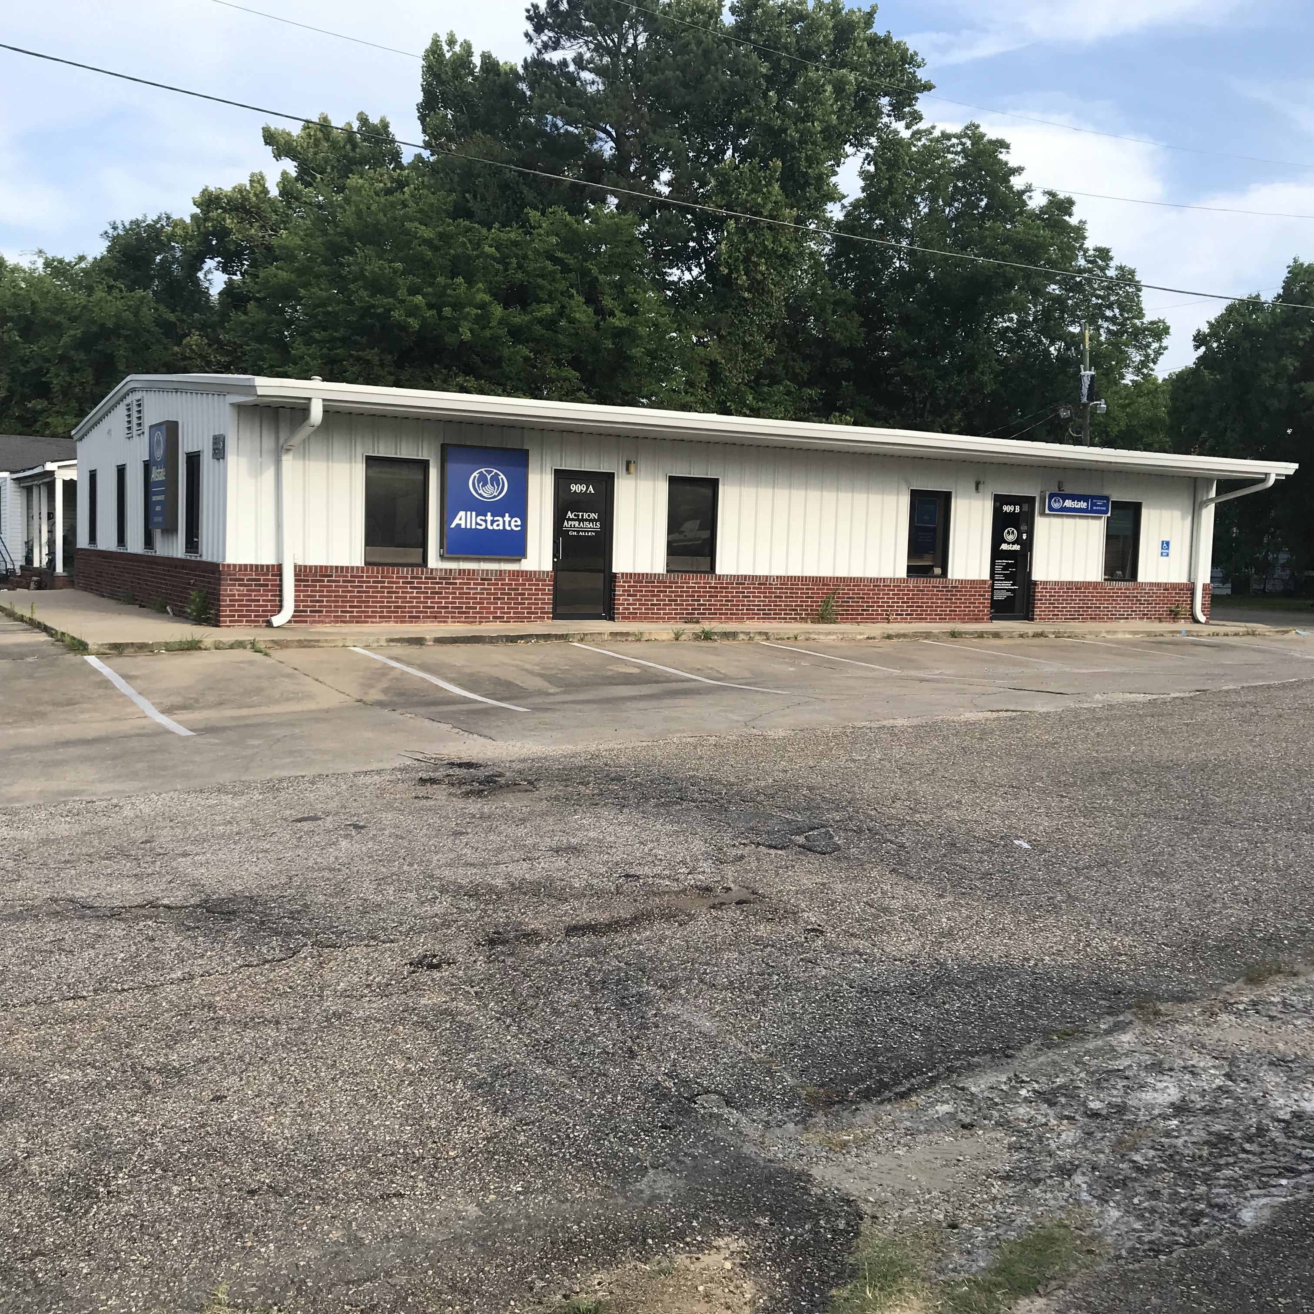

909 HIGHLAND AVE
SELMA, AL 36701

Offered at $225,000
- Multi-tenant
- Office Space
- 2400 SQ. FT.
- Adequate Parking
- Great Location
- 8% Cap Rate

contact:
Deans Barber, Broker
334-872-0478
Office
33-412-7879
Cell

