Bill Brown Building – Second Floor Office – 7826 Leary Way, Redmond, WA 98052

SUITE 201

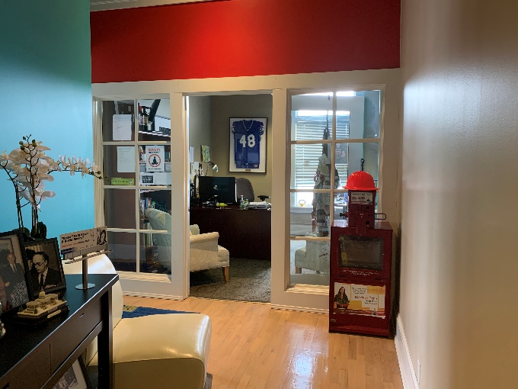
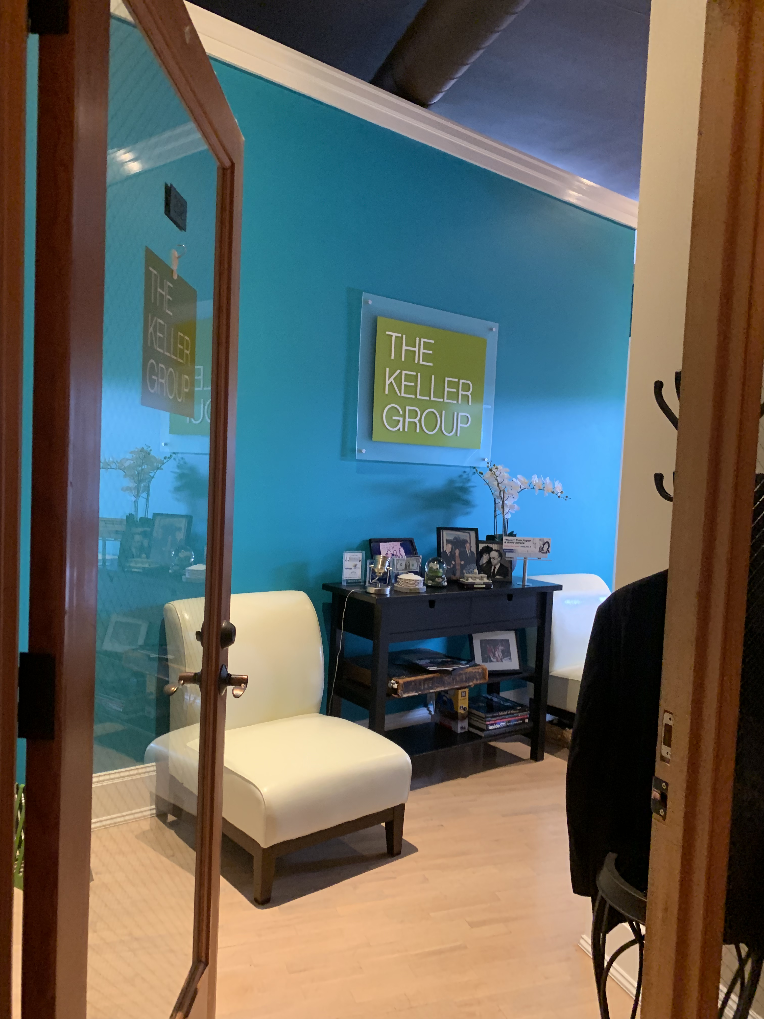
RECEPTION AREA

ENTRANCE TO SUITE 201
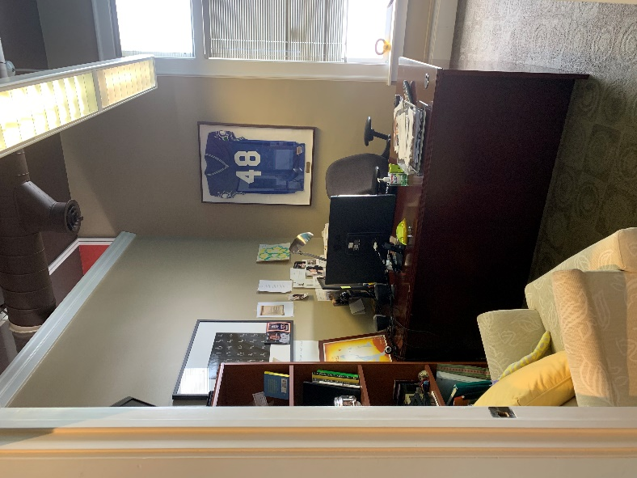
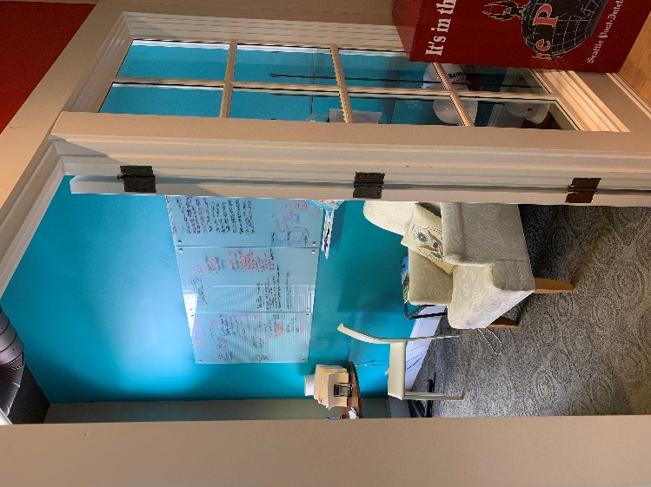
OFFICE / CONFERENCE AREA
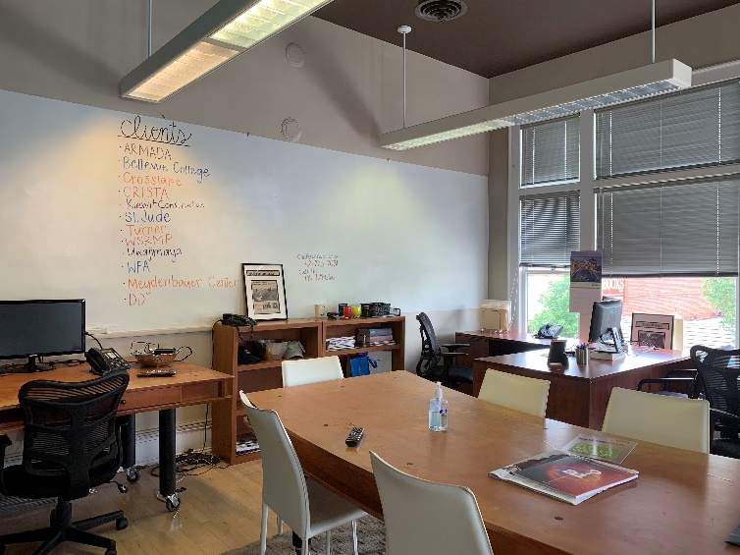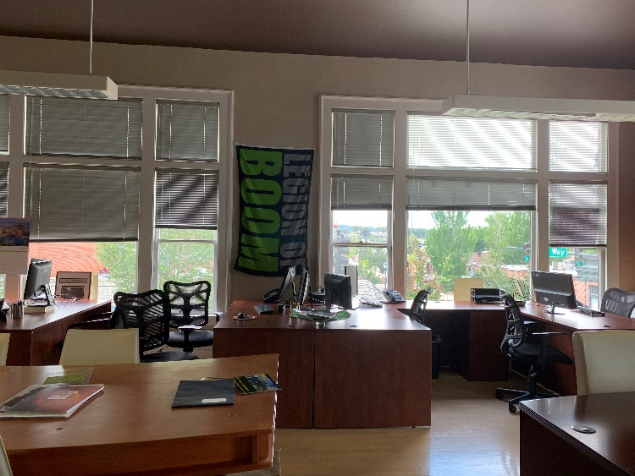
OPEN WORK SPACE – LOOKING AT NORTH WINDOWS

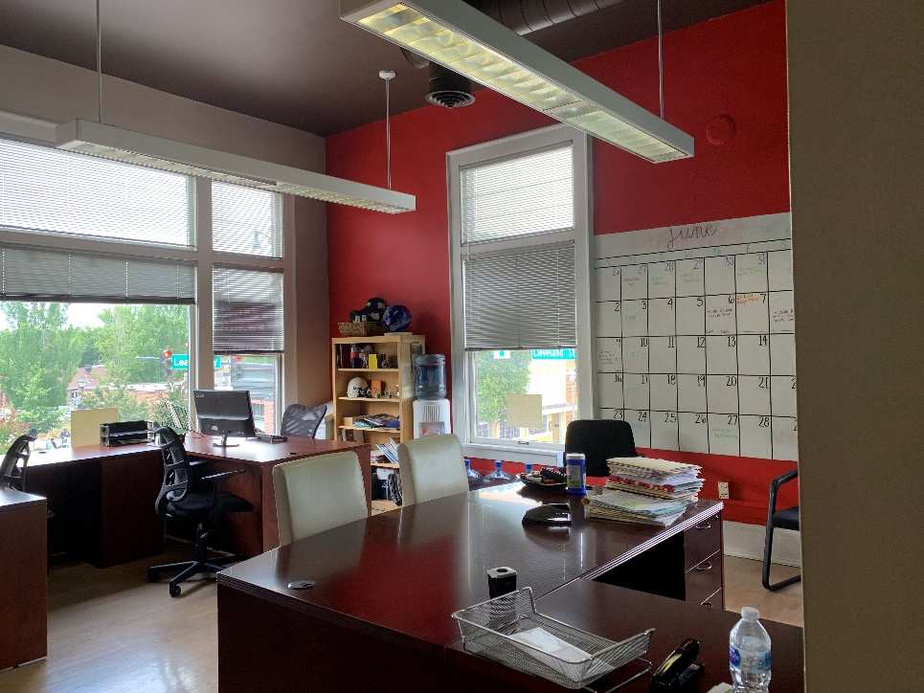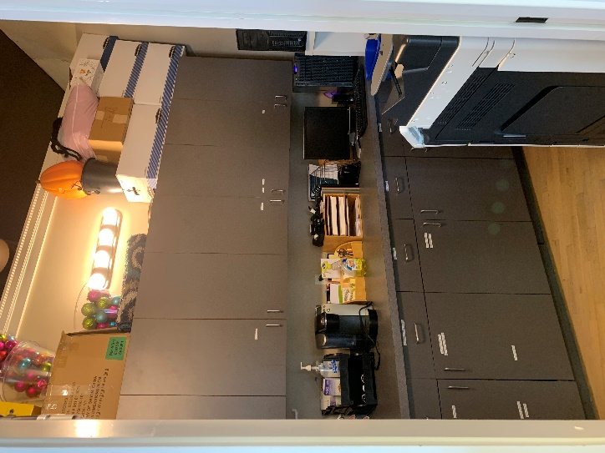
OPEN WORKSPACE – N. AND EAST WINDOWS STORAGE/COFFEE/REFRIGERATOR

