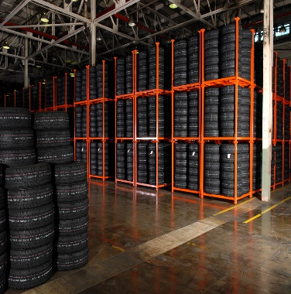
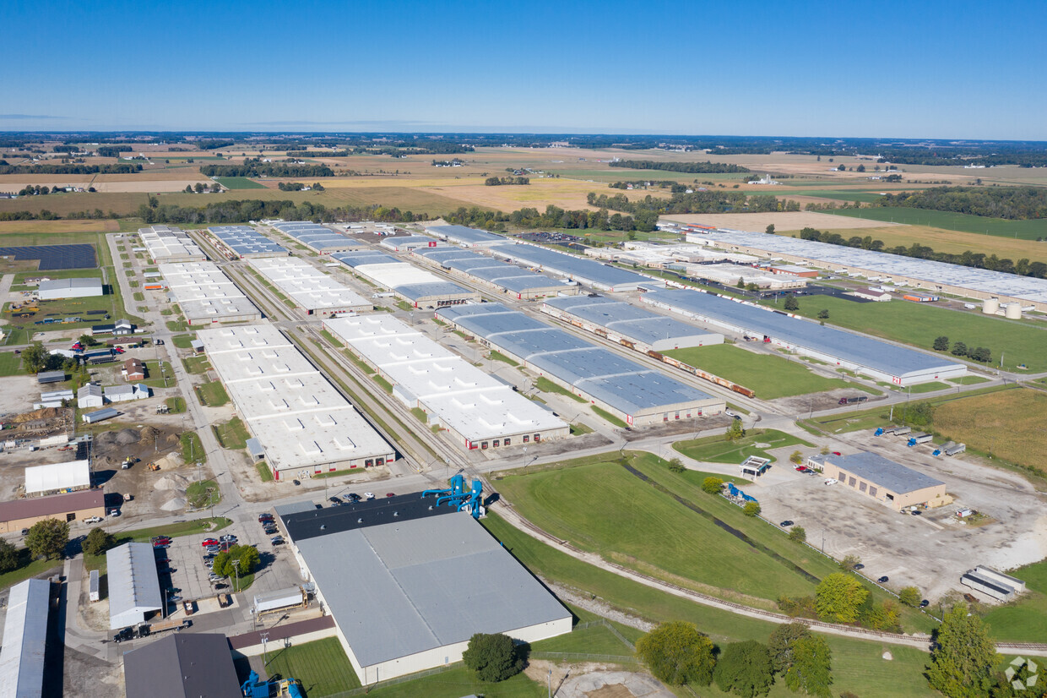
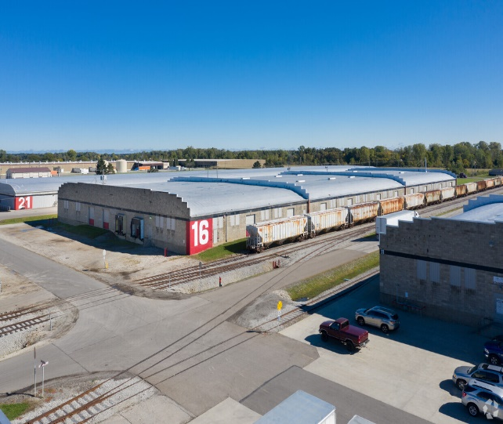
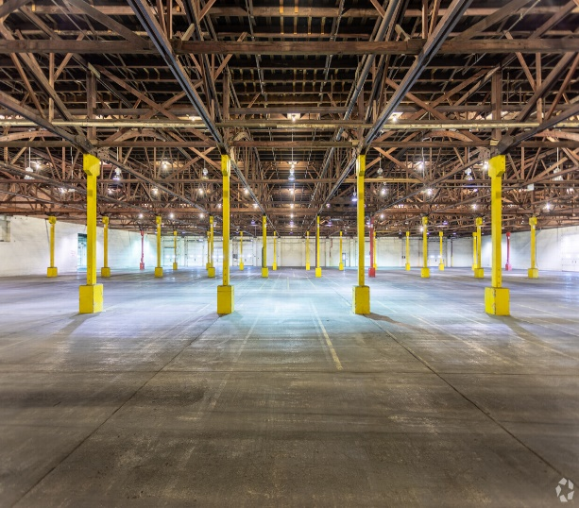
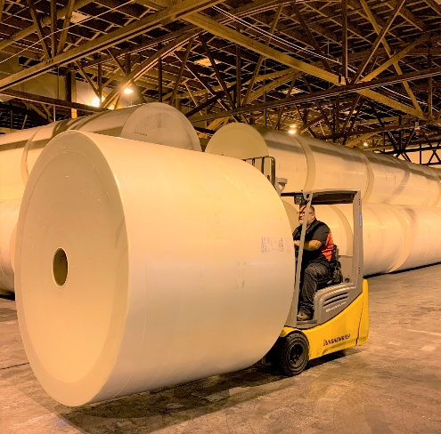
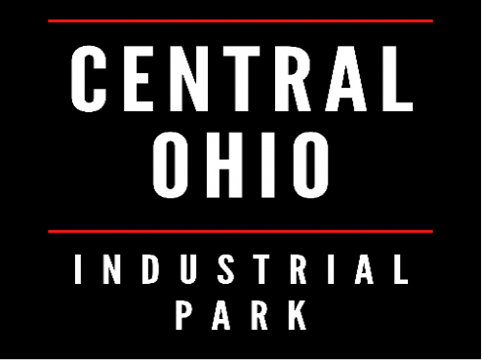
For
LEASE
Long or Short Term
Industrial Space Available
in Central Ohio

For more information contact Taylor Parnell at (419) 961-5318 www.centralohiowarehouse.com
Central Ohio Industrial Park (COIP) has been in business since 1985. We have over a century of cumulative experience in our management department alone. COIP is known for low cost leasing and flexible solutions to meet your needs. Whether your need is space to manage with your team or a full third-party logistics service to provide handling and inventory control, we are the answer. Our experienced warehouse professionals can provide solutions that allow you to expand your business without the burden of labor cost and overhead of owning a building. We believe in excellent service and treat our customers’ products with the same care as if they were our own.

Located in Shelby, OH
Lease Space
- Perfect for manufacturing, assembly, warehousing, and distribution
- High-quality, low-cost space
- Below market lease rates
- Customized space to meet your requirements
- 14’ to 23’ ceilings
- Separately metered utilities
- Rail service
- Fully sprinklered dry system
- Heated space available
- 20,000 – 1,000,000 sq. ft. available
- 24-hour on-site security
- Outside storage available
- Located centrally between Cleveland and Columbus

Public Warehouse Services
- Affordable storage, distribution & handling
- Customizable solutions to meet your needs & budget
- Truck and rail accessible
- Quick & effective response
- Flexibility to adapt to challenging needs and urgent requests
- Industry leading inventory tracking capabilities

