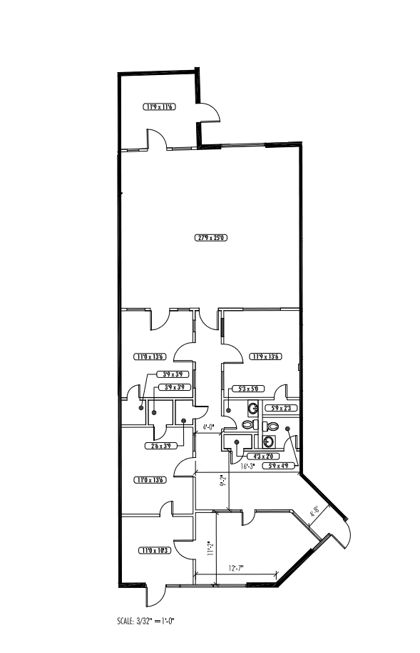
103’-8’
108’-2”
29’-1”
Base Rent: $1897.00 ($10.96/ sf)
NNN: $439.63 ($2.54/ sf)
Total $2336.63 ($13.50/ sf)
JB Dallas LLC • (214)854-0338
Center Point • Suite 17 • 2077 SF
78’-0”
27’-9”

