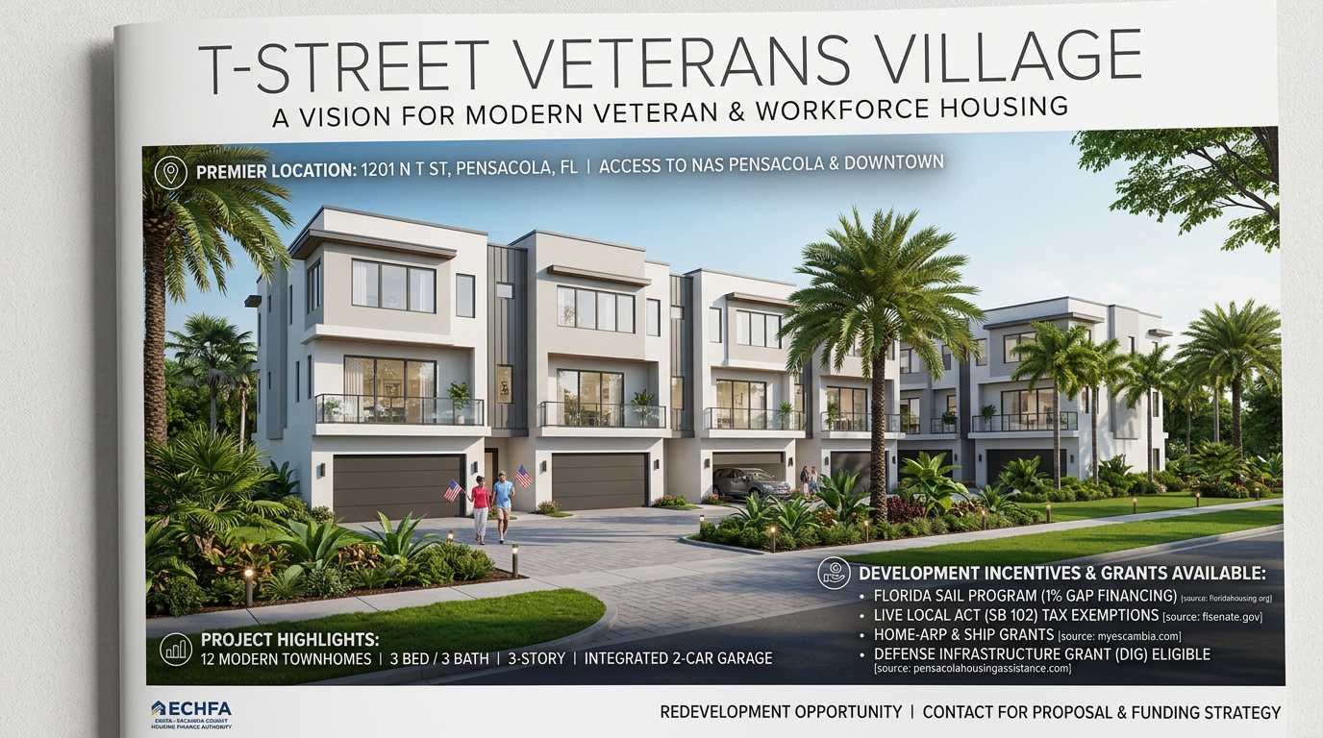
T STREET VETERANS VILLAGE
1201 N T Street | Pensacola, FL 32505
A High-Yield Redevelopment Opportunity for Affordable & Veteran Housing

THE VISION
DEVELOPMENT OVERVIEW
Transform a prime corner lot into a mission-driven community. This shovel-ready site is optimized for a high-density townhome project designed to meet the growing demand for quality veteran housing in Escambia County.

THE CONCEPT:
10-12 Modern Townhomes
3 Story Vertical Living
3 Bedrooms / 3 Bathrooms
Integrated 2 Car Garages

STRATEGIC LOCATION
Situated in the heart of Pensacola, this location offers unparalleled proximity to critical infrastructure and military support networks.

BY RIGHT DENSITY: Leverage the Florida Live Local Act to maximize unit count on the 20843 sq ft footprint.
MISSION ALIGNMENT: Designed specifically to support the 'Homes for Veterans' initiative and NAS Pensacola personnel.

THE CAPITAL STACK
MAXIMIZE YOUR ROI WITH 2026 INCENTIVES
This project is positioned at the intersection of record-breaking state and local funding cycles.

LOCAL & STATE GRANTS:
SAIL VETERANS PRIORITY: 0-1% interest gap financing for up to 35% of costs.
DEFENSE INFRASTRUCTURE GRANT: Part of Pensacola's $600k+ allocation for military housing.
SHIP/HOME-ARP: Forgivable developer loans for affordable unit production.

FINANCIAL REWARDS:
100% PROPERTY TAX ABATEMENT: Permanent exemption for units serving <80% AMI.
ECHFA BOND FINANCING: Tax-exempt mortgage revenue bonds for construction.
SALES TAX SAVINGS: 100% exemption on all construction materials.

PARTNERSHIP & CONTACT
We are seeking visionary developers and non-profit partners to lead this legacy project.

CURRENT STATUS:
Existing steel structure ready for salvage/removal.
Utility infrastructure present.
Statement of Interest prepared for ECHFA.

DISCLAIMER
All information gathered from public records and online resources. Buyers must independently verify all zoning, density, and funding eligibility. No warranties expressed or implied.

