FOR LEASE
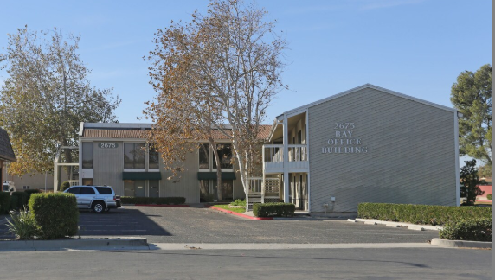
SUITES 102 & 103
2675 N. VENTURA ROAD
PORT HUENEME, CA 93041

Professional Retail / Office Space • Approx. 600 SF Per Suite
$21/SF annually – 1-month free rent per year

Investment Highlights
• Individual suites available immediately
• Flexible retail, office, service, wellness, or professional use
• Excellent visibility along Ventura Road corridor
• Convenient access to nearby residential and commercial districts

Ideal Uses
Professional Office • Insurance • Real Estate • Accounting • Technology Services • Medical/Wellness • Boutique Retail • Consulting • Administrative Operations

Why Port Hueneme?
Position your business in a growing coastal community serving residents, nearby employers, and military-related activity. These efficient suites offer a cost-effective location for customer-facing and professional businesses.

CONTACT FOR LEASING INFORMATION
Michael LoBasso
323-828-2828
mlobasso@mailboxes.com

