LAND FOR SALE – MARYSVILLE, OHIO
(Last remaining parcel – 2.752 acres)
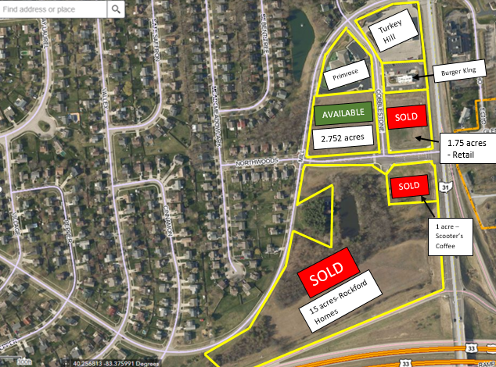
REDUCED PRICE!
- Located near State Route 33 and 31.
- Located at a signalized intersection.
- Zoned Marysville Suburban Commercial.
- All utilities to the site.
- Ideal for medical/professional/retail uses.
- Fast developing retail/commuter corridor.
- $950,000 ($345,203 per acre) $825,000 ($299,782 per acre).
The John Roesch Company (Broker)
614-395-1598

