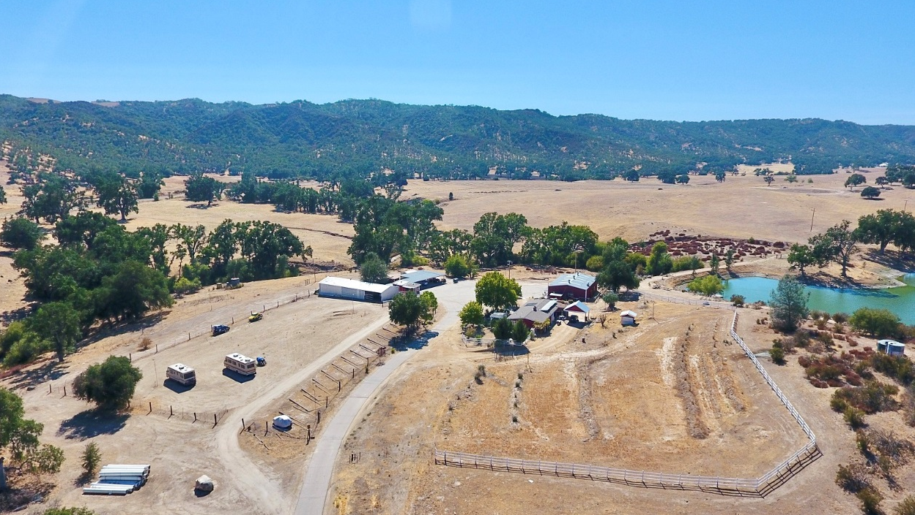
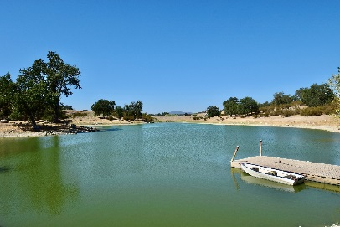
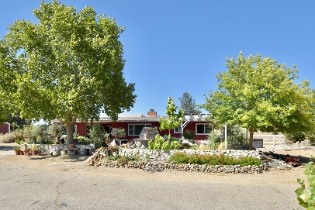
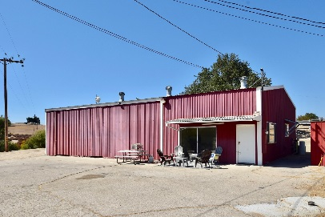
76980 SAN ANTONIO ROAD, BRADLEY


Size: Main House: 4 Bedrooms, 2 Baths
Apartment: 2 Bedrooms, 1 Bath
6± Acres

APN: 424-071-025-000

Price: $799,900

LIVE, WORK AND PLAY! The possibilities are endless on this sustainable ranch with heavy commercial zoning! Charming 4 bedrooms, 2 bath home on 6 acres. Includes 3,200± sq. ft. insulated warehouse with apartment and mezzanine. Commercial greenhouse with power and water plus solar. 2nd greenhouse with work stations creates the perfect environment for delicate plants and processing produce. Oversized pole barn and open bay garage with lighted unpaved lot designed for RV and Boat parking. This would also make a great horse facility with plenty of flat ground. There is an additional 1,200± sq. ft. of covered parking/work bays with concrete slab plus a small barn and chicken coop. (OVER)

25,000 ± sq. ft. of asphalt plus untouched land remaining for more ventures. The Kubota tractor is included! Catch bass, crappie, carp, blue gill & shad from your own dock or take the boat out on the large pond while sharing space with resident blue heron, snowy egret & bald eagles.

The home is 1,856± sq. ft. with a covered porch entry and a nostalgic Dutch door. Features new hardwood floors and dual pane windows, wood beamed and vaulted ceilings, numerous French doors with covered patios to bring the outdoors in. Mini-split A/C system with ceiling fans throughout and wonderful wood burning fireplace. Homey kitchen with oversized pantry and formal dining room. Large master bedroom with walk-in closet and spacious new bathroom. Stack washer dryer, water softener and solar panels are all included. Sturdy carport accommodates personal vehicles. This is a Shangri-La with lush landscape lined with rustic Carmel stone walls and a soothing waterfall into the shaded koi pond. Home for many mature koi fish and Rosie, the turtle. Relax in this natural bird sanctuary or cozy up to the outdoor fireplace on the brick patio enveloped by bamboo and oak trees. Soak in the peaceful setting of the Jacuzzi with unobstructed views of mountains, sunrises, sunsets and the big night sky.

The self-contained two-bedroom apartment situated inside the warehouse has its own electric meter, propane tank and HVAC system. It includes a living room, galley kitchen with pantry, two large bedrooms with walk-in closets and a full bathroom.

On the path to south shore entrance for Lake San Antonio with paved road and electronic entry gate. Good well with large water storage tanks. Lots of history; once known as Al's Marine Service and mini-mart, currently Sugar Mountain Ranch Boat and RV Storage. Unique commercial land surrounded by larger ranches just waiting for your new entrepreneurial ideas. Zoning allows for a wide variety of uses including hotel, motel, restaurant, church, kennels, automotive repair, trucking operations, contractor’s yards, cannabis activities and more. A good candidate for vacation rentals, glamp camp and event center. Check with Monterey County for specific regulations.
