JUST 3 DAYS
Commercial Investment Opportunity
219 N Main Street & 222 York Avenue
Weatherford, Texas
Investor / Owner-User Opportunity
Historic Downtown Through-Building
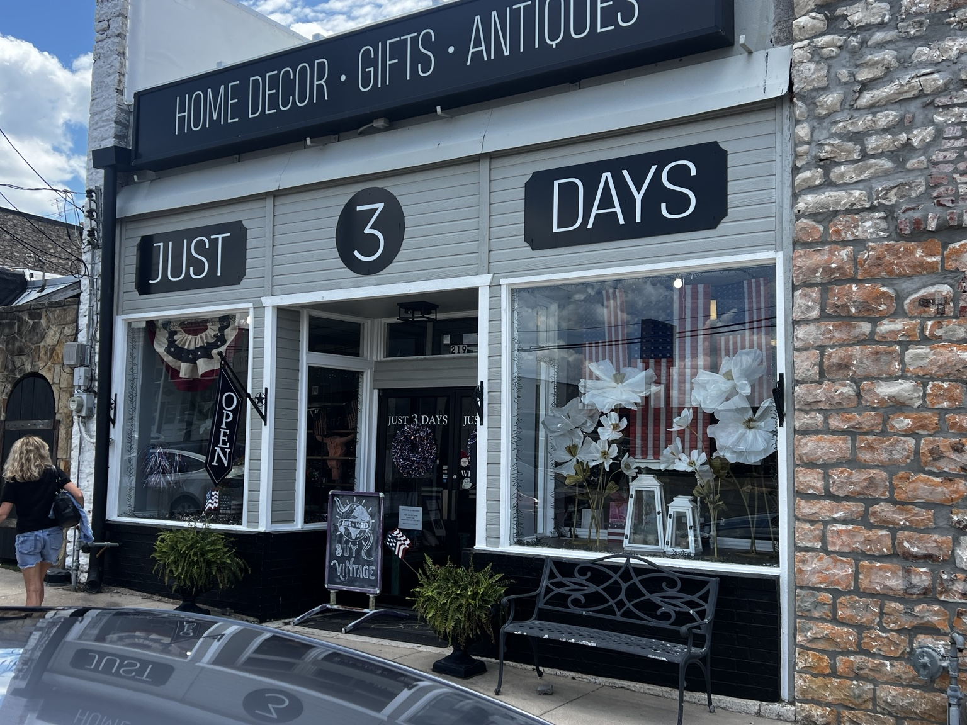
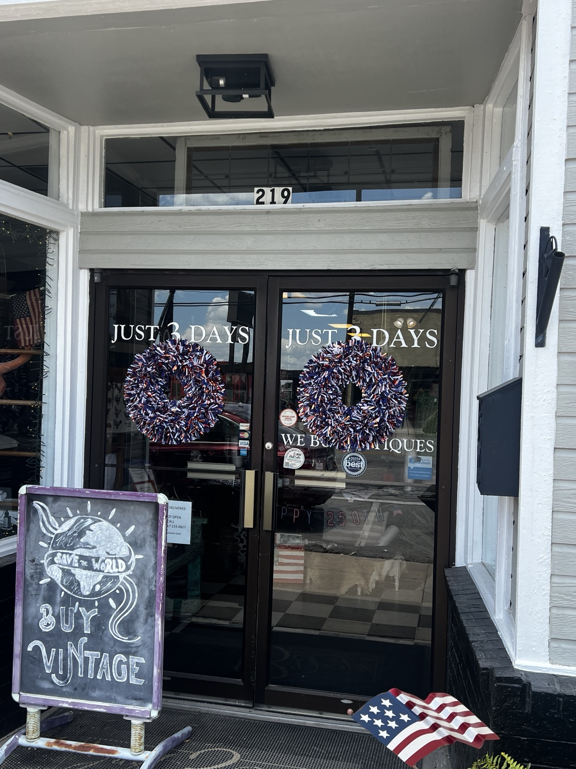

Executive Summary
Just 3 Days occupies a highly visible historic commercial building with frontage on both North Main Street and York Avenue in downtown Weatherford. The approximately 3,750-square-foot property offers exceptional flexibility for an owner-user or investor. The building is currently owner-occupied and is not occupied by tenants. It can be delivered for immediate occupancy at closing unless otherwise agreed, allowing a purchaser to occupy the building, lease one or both storefronts, or implement a customized investment strategy.
The property is being offered for sale at $1,450,000. The seller will consider owner financing for qualified purchasers, subject to mutually agreeable terms.

Investment Highlights
• OFFERING PRICE: $1,450,000
• Approximately 3,750 SF total
• Dual storefront configuration (approx. 1,875 SF each)
• Main Street and York Avenue frontage
• Separate utilities, HVAC systems and restrooms
• NEW $165,000 TPO commercial roof (recent major capital improvement)
• Seller will consider owner financing for qualified purchasers, subject to mutually agreeable terms
• Historic downtown location
• Suitable for retail, office, showroom, specialty retail or mixed-use
• Currently owner-occupied (not tenant occupied), providing immediate occupancy or lease-up flexibility
• Annual Property Taxes: $11,200
• Annual Property Insurance: $12,000
• Combined Annual Taxes & Insurance: $23,200

Property Overview
The through-building design creates two functional storefronts with independent access and utilities, providing leasing flexibility and potential for multiple income streams.

Location Advantages
Located within Historic Downtown Weatherford near restaurants, retail, professional offices, community events and pedestrian activity.

Owner-User Opportunity
Occupy one storefront while leasing the second, or expand into the entire building as your business grows.

Investor Opportunity
Because the building is currently owner-occupied rather than tenant occupied, a purchaser has the opportunity to establish new lease rates, select future tenants, or immediately occupy the property without existing lease obligations.

Redevelopment Potential
Flexible layout may accommodate boutique retail, professional office, gallery, specialty food, or destination retail subject to applicable approvals.

Why This Property Stands Out
Few downtown properties combine through-building access, dual addresses, separate utilities and two distinct storefronts in one investment.

Disclaimer
Buyers should independently verify all measurements, zoning, financial information, and suitability for their intended use.

Property Expense Information
Offering Price: $1,450,000
Annual Property Taxes: $11,200
Annual Property Insurance: $12,000
Combined Annual Taxes & Insurance: $23,200

Flexible Purchase Opportunities
The seller is willing to consider cash, conventional financing, or owner financing for qualified buyers. Financing terms, down payment, interest rate, amortization, and other provisions are negotiable and subject to seller approval.

Contact
Keith Davis
Edge Real Estate, LLC
Commercial Real Estate
Cell: 817-597-9611
Email: Keith.davis@iedge.com


