

1510 E. Colonial Dr. Ste 307
Orlando,FL 32792
Phone: (407) 677-1700

C. Brenner, Inc.

Commercial Real Estate

High Traffic Retail in Busy Corridor

4521 S Orange Blossom Trail,
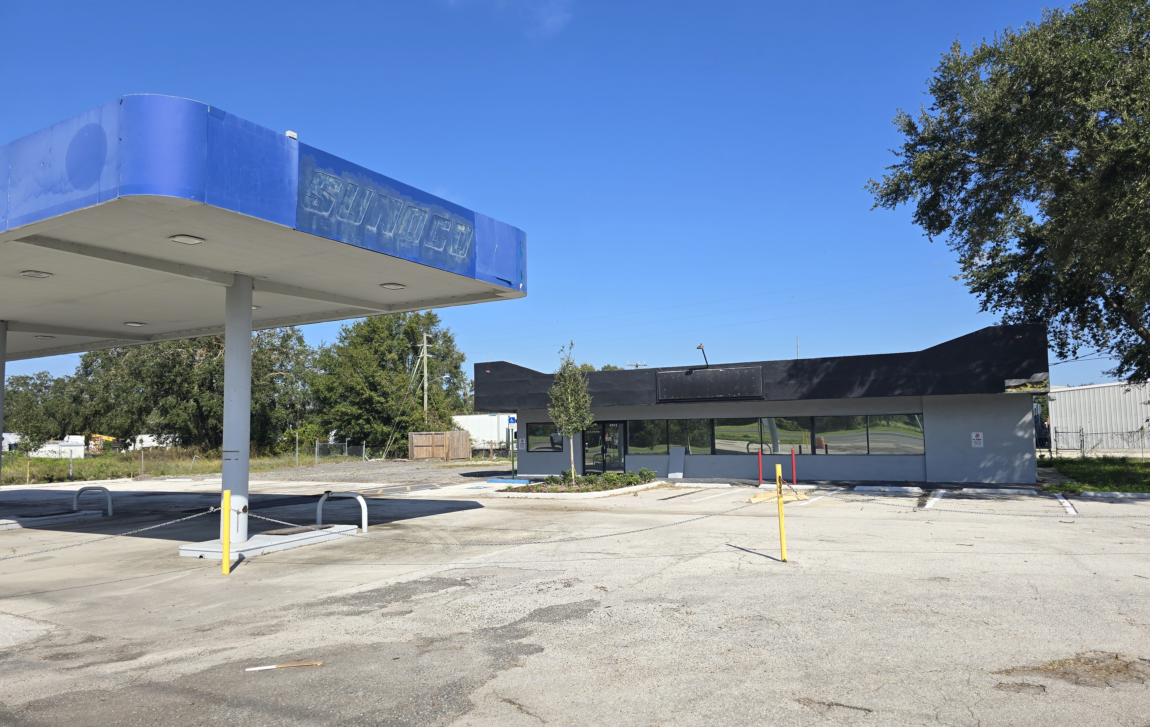
Kissimmee, FL 34746
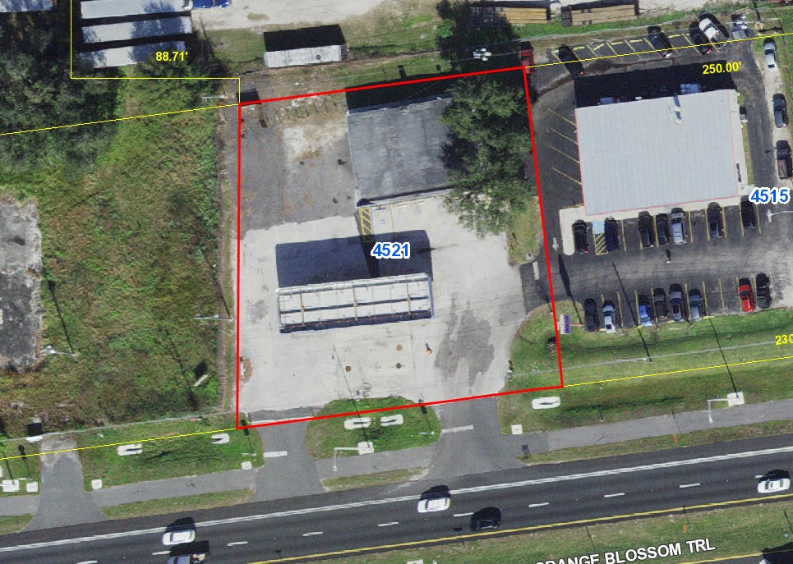

- Former Sunoco station has been fully decommissioned
- 2,400 SF freestanding retail with 2,000 SF canopy
- 0.62 acre lot offers ample parking for any retail use
- 30,000 daily traffic count, two curb cuts on S Orange Blossom Trail
- Open plan building with two restrooms and one private office
- Ideal for vehicle/equipment sales or leasing, great site for bar or restaurant
- 2 miles from Poinciana Sunrail Station, 5 miles from Kissimmee Airport
- High population growth nearby between Poinciana Blvd and Pleasant Hill Rd
- Convenient to I-4 and Florida Turnpike
- $719,000

Ben Brenner Cell: 407-970-6447
Lic. RE Broker Office: 407-677-1700
C. Brenner Inc. Email: bbrenner@cbrenner.com

