For Lease

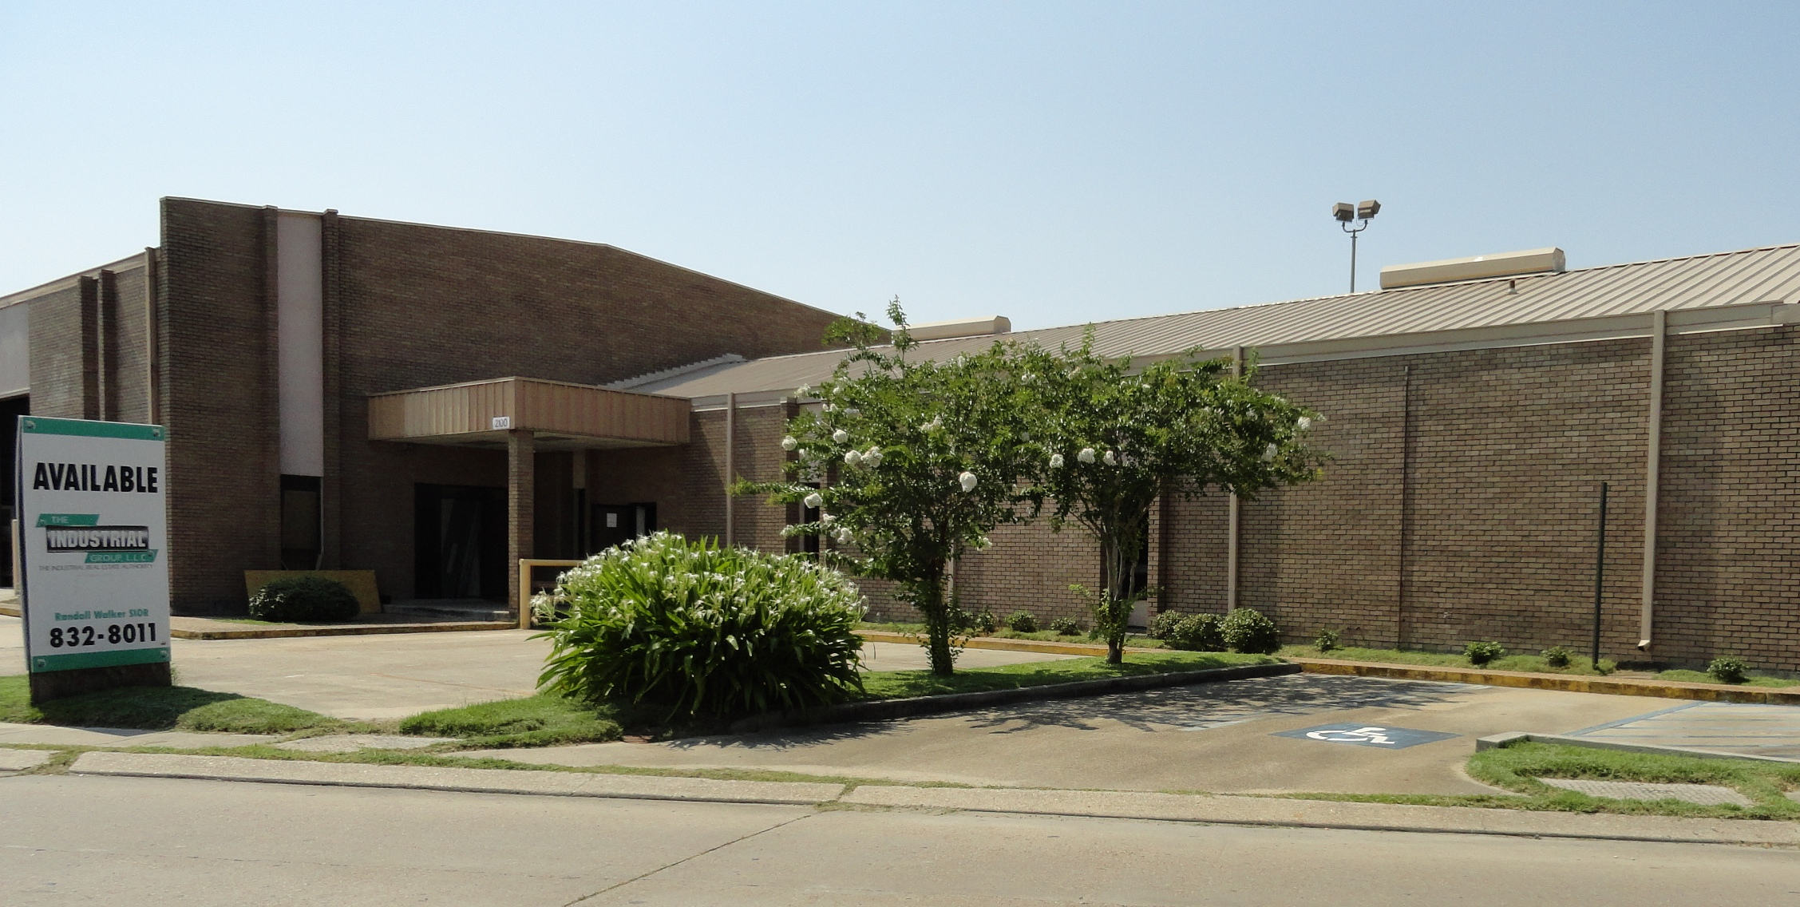

2100 L & A Road, Metairie, LA 70001

Building: 7,142 Square Feet Construction: Brick & Block

Office: 3,456 Square Feet Loading: (1) 12’x14’ Ground Door

Parking: 12 Spaces Eave Height: 18’

Sprinkler: Yes Skylights: No

Lease Price: $5,000.00 per month Net ($8.40 psf)

2023 Taxes: $7,708.44 – ($642.38 per mo.) $1.08 psf

2024-25 Insurance: $9,019.60 – ($751.63 per mo.) $1.26 psf

CAM: $1,304.27 – ($108.69 per mo.) $0.18 psf )

TOTAL PER MONTH: $6,502.70

Further Information: Randall Walker, SIOR
The Industrial Group
1504 L & A Road
Metairie, LA 70001
(504) 832-8012
Randall@igreal.com
Licensed By The Louisiana & Mississippi Real Estate Commissions.
Licensed By The Louisiana State Licensing Board of Contractors.


7/29/2026

