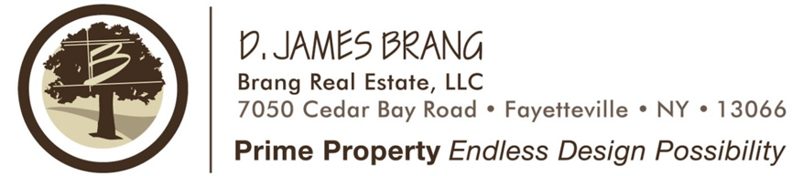

Commercial / Residential Development
103 & 201 E. James St., Syracuse, New York 13206

Approx. .5 Acres – (2) Lots
Tax ID #’s. 13.-04-01.1 & 13.-04-02.0

- Commercial Use:
  - Up to 2,200 sf Stand Alone Building
  - Corner lot offers huge sign exposure.
  - Ideal for a variety of users – Financial, Service, Office, Retail.
  - Ample parking.
  - Unique Building Design.
  - Customize the interior layout per client needs.
  - New construction offers no maintenance for years.
  - Two curb cut site plan.
  - One Way Travel offers easy traffic flow.

- Residential Use:
  - Duplex.
  - (2) - 2 bed / 1.5 baths.
  - Individual Front entrances to each unit.
  - Separate Double car driveways.
  - (2) Car Garage for each Unit.
  - Large yard area for recreation.
  - Driveways located on less traveled East James Street.

Location:
- Excellent exposure from James St. - 23,674 cars/day.
- Located just off Exit 35 of the NYS Thruway and Carrier Circle.
- The Property is located on the corner of James St & E. James St.
- Plenty of over flow street parking.
- Conveniently located close to Thompson Road.
- Easy access for clients, employees or residents.
- Minutes to I-690, Rte. 481, I-81 and entire CNY area.
- Multiple Hotels, Local businesses and Eateries in close proximity.
- Large distribution and Warehousing within minutes.
- Large number of roof tops within a mile radius.

All information furnished, regarding property for sale, rental or financing is from sources deemed reliable, but no warranty or representation is made to the accuracy thereof and same is submitted subject to errors, change of price, rental or conditions prior to sale, lease or financing or withdrawal without notice.

