FOR SALE – Refurbished Warehouse & Multi-Use Commercial Property
3524 Garcon Point, Milton, FL 32583
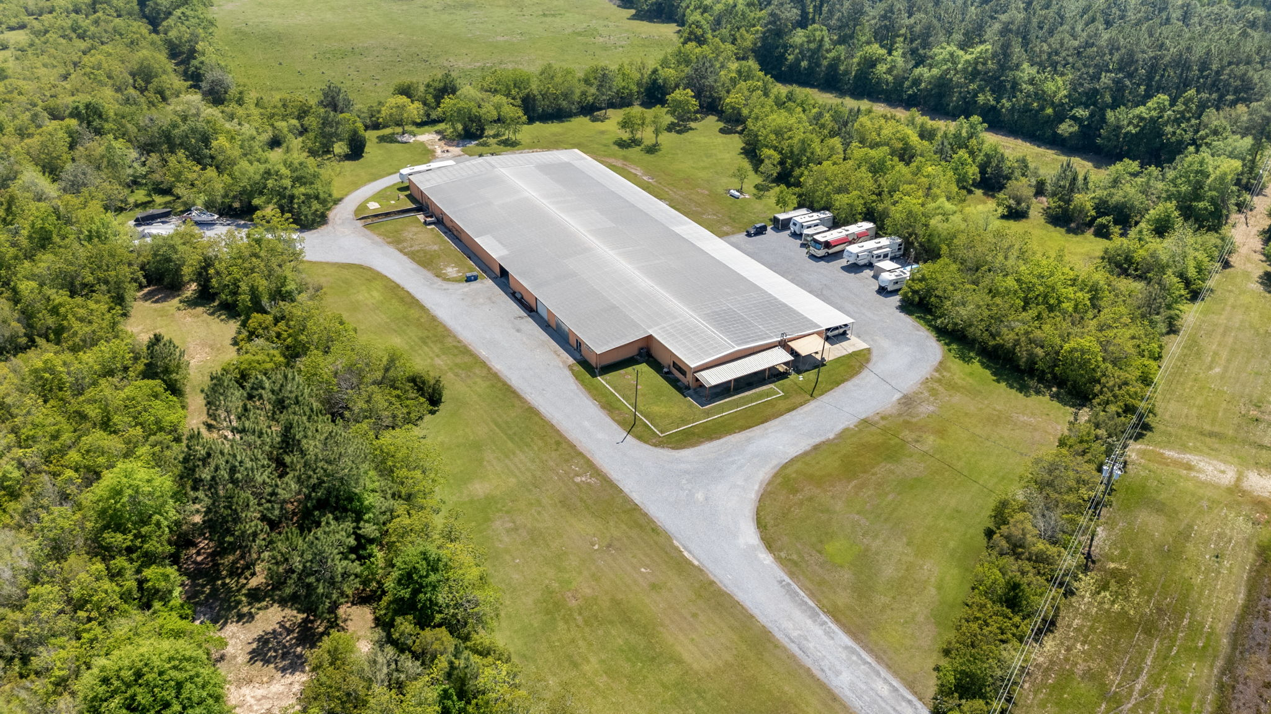

Property Overview
This expansive refurbished warehouse offers unmatched versatility for storage, distribution, light manufacturing, or specialized commercial use. Sitting on over 16 acres of mostly fenced land, the property combines 41,000 sq. ft. of building space with exceptional infrastructure upgrades and bonus RV accommodations — making it a rare and valuable find.

Key Features
- 41,000 sq. ft. metal building with approx. 4,000 sq. ft. air-conditioned space, concrete floors.
- 2 Restrooms (one with shower)
- Three Bay Doors on east side for easy loading/unloading. One is 16 feet.
- West side and rear west section built with new filled concrete block for durability
- Completely replumbed water lines & new well installed
- Mediacom 300 Band Internet
- 600 AMP 3-Phase Power for high-demand operations
- 2 Septic Systems (9 tanks total) with large drain field (approx. ½ acre)
- 3 Grinder Pumps for waste management
- Most of property fenced & gated for security

RV Sites & Additional Land
- 6 RV Sites with water, sewer, and 50 AMP electric
- 4 Sites individually metered
- Level gravel pads, perfect for long-term or transient occupancy
- 16 acres total — 10 acres currently zoned Agricultural (can be easily rezoned)
- Pond on property offering aesthetic appeal or potential use
- Two wells (one requires pump)

Site Improvements
- Approx. 7 acres cleared and cleaned with fresh gravel drives
- Upgraded utility infrastructure for heavy use
- West & rear block wall construction for enhanced protection

Location Advantages
Situated in Milton, Florida, with quick access to major transportation routes. Ample land for expansion or additional development. Peaceful surroundings just minutes from I-10.

Potential Uses
- Distribution & Logistics Hub
- Light Manufacturing Facility
- RV Storage / Service Business
- Agricultural or Mixed-Use Development
- Event / Equipment Storage Space

Floor Plan
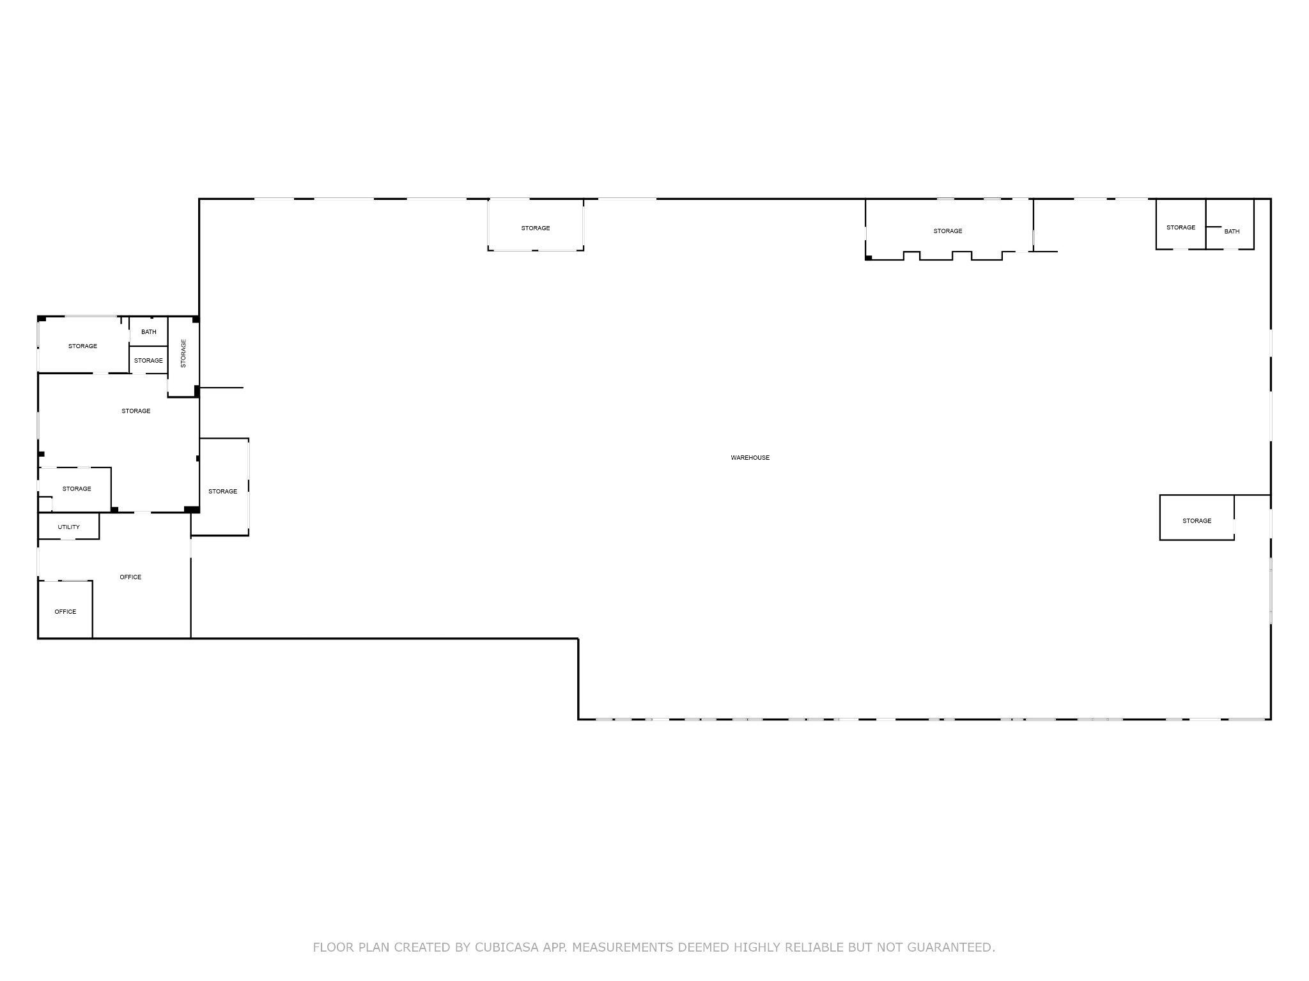
📞 Contact for Viewing Appointments
Andra Morgan 850-450-8844
Berkshire Hathaway HomeServices PenFed Realty

