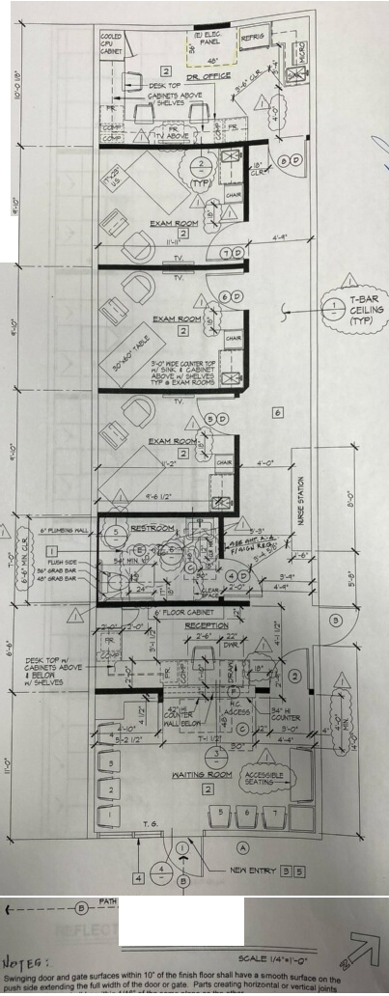
-----
-+-J
PROPOSED PLAN

