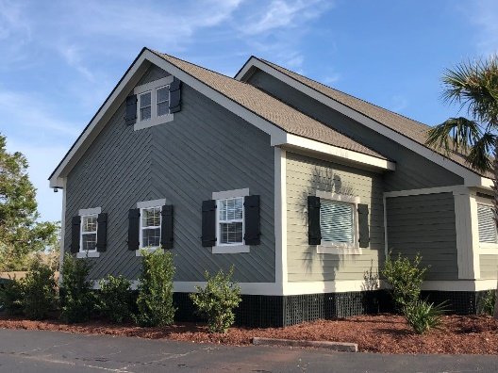
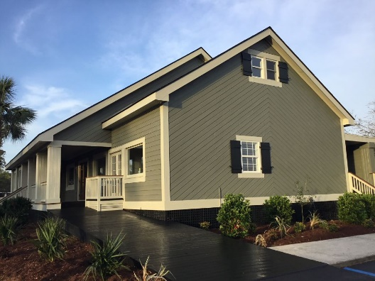
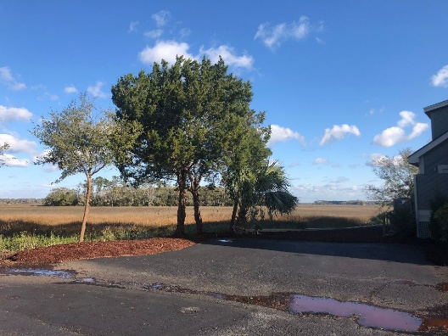
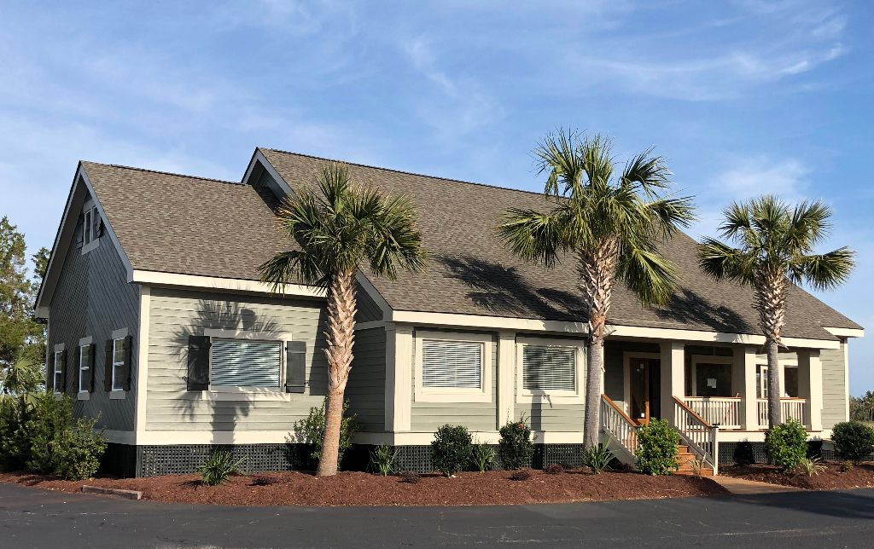
1003 LANDFALL WAY, JOHN’S ISLAND, SC 29455

These opportunities don’t come along very often! Commercial freestanding building in the Kiawah/Seabrook area positioned on approximately ¾ acre marsh front lot with priceless views of Bohicket creek and the surrounding marsh. Currently fully leased, 2 units downstairs and 1 unit upstairs- each with independent HVAC and electrical systems.
JAKE CASA
COAST REAL ESTATE
843-814-5100
JAKECASA1@GMAIL.COM
COMMERCIAL BUILDING FOR SALE
OFFERED AT $ 2,750,000

