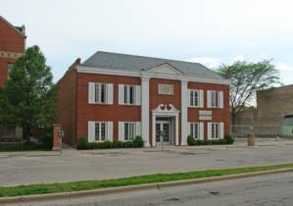

711 South Blvd. Building with 12 private Offices

Promoting and supporting “Green” Influence, Lifestyle and Wellness

Contact: Robert Ransom Phone: (708) 655-8888 E-Mail: archonomics@aol.com
Office Building located in Down Town Oak Park, IL. and close to the Oak Park Ave. “L” Station- Green Line
Numerous building upgrades in offices and common area’s support “Green” efforts in conserving energy
* NEW INSTALLATION - "STATE OF THE ART" SECURITY STARLIGHT CAMERA SYSTEM
- Roof construction has 6 inches of insulation capped with two layer of modified white granulated finish

- Two Stage chilled water system for air conditioning uses 50 % less energy once comfort level is reached

- Two stage hot water system for heating uses 50% less energy once comfort level is reached

- Bathrooms - fixtures are designed to conserve water usage. LED lighting for common areas
- Items listed below are believed to enhance "Wellness" within the working environment:

Three enormous skylights provide natural light & fresh air to Atrium area 1/3 of overall building square footage.

- Large windows of each office look out unto buildings "Atrium" area receiving it's natural sun light

- Center skylight opens to allow fresh air into Atrium & offices for wellness

- Independent HVAC system for each office protects from air born viruses associated with common air systems

- Retrofitting office light fixtures with greater efficiency to increase light quality and reduce power consumption
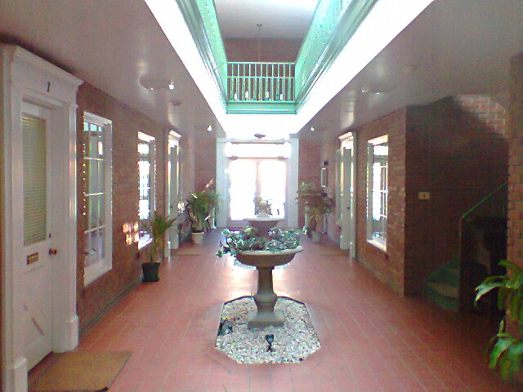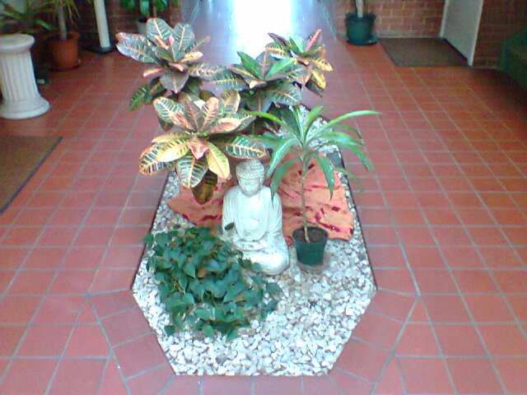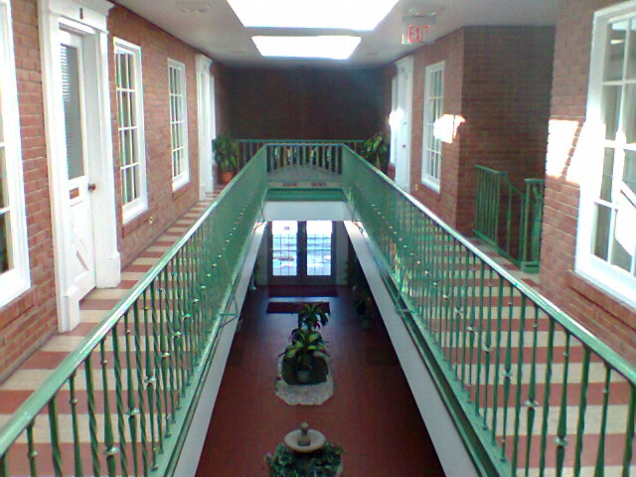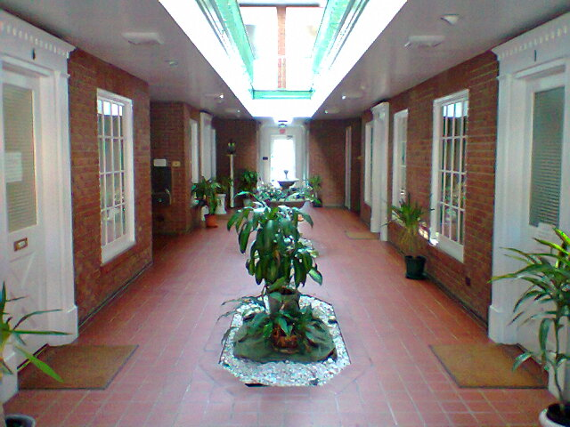

1st Fl. Arcade Area & Dbl. Dr. Entry Arcade Planting & Display Area’s Second Floor Arcade Area 1st Fl. Arcade Area & Rear Exit Dr.

