AVAILABLE FOR SALE: Fully Approved Building Lot
151 East Mt. Vernon Avenue, Lansdale Borough, PA
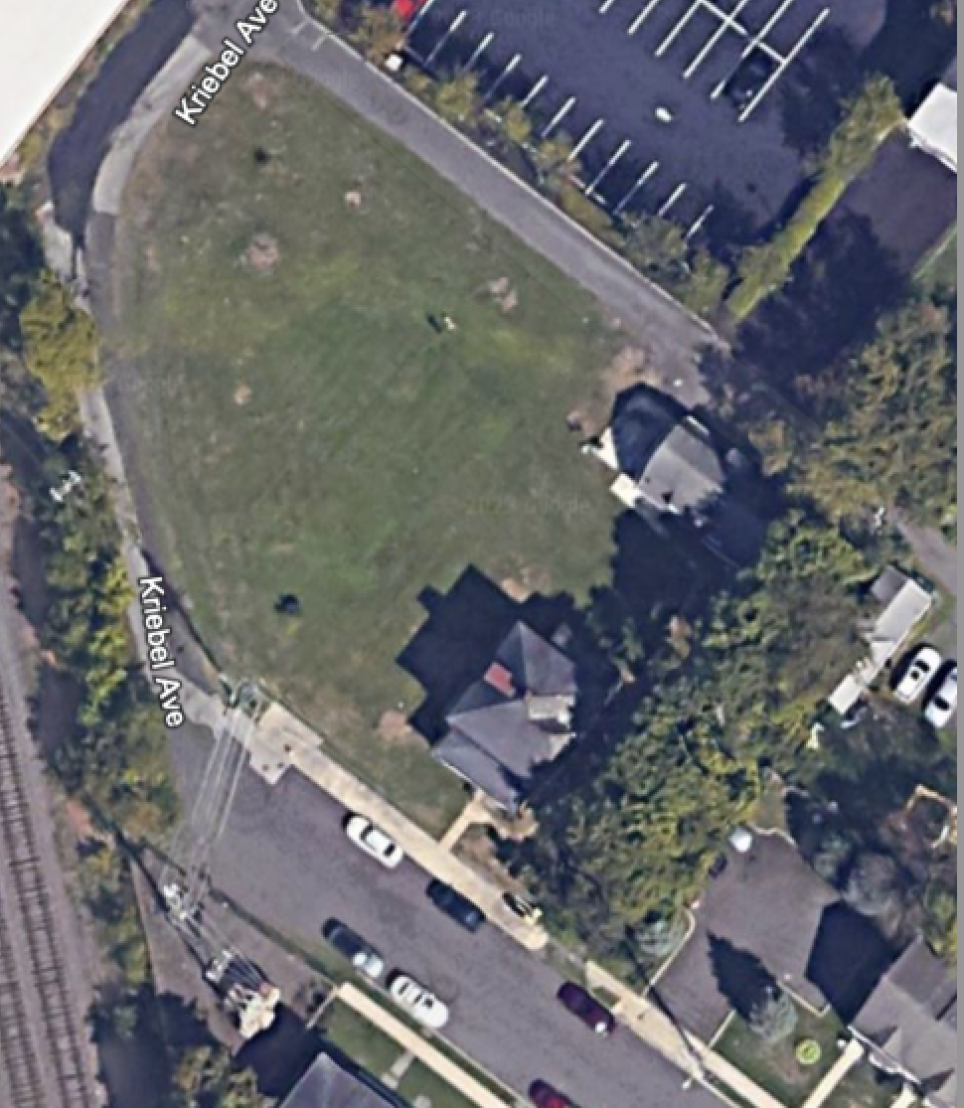

Fully Approved-21,850 Square Feet with two existing duplex residential units and two proposed units; one quad unit and one duplex unit. There are 16 proposed parking spaces. The current annual income is $84,000. ASKING PRICE: $795,000
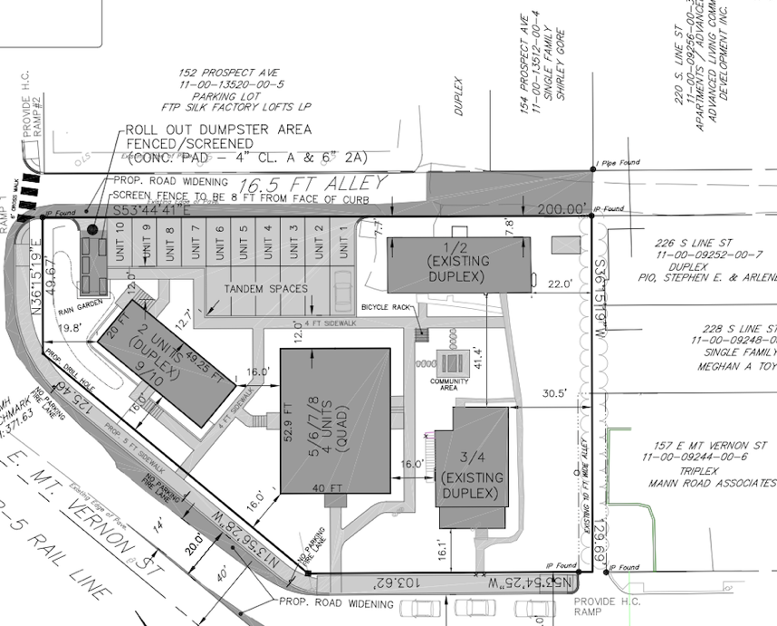

For Further Information Contact:

Lee Rosenthal
Linden Real Estate Corporation
2337 Philmont Avenue
Huntingdon Valley, PA 19006
215-518-6495
lindenre@aol.com

