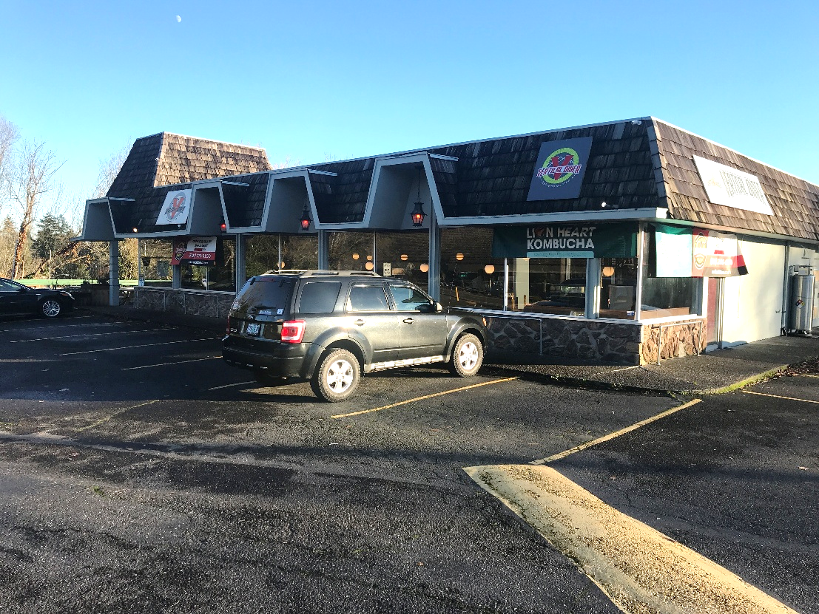
Free Standing Restaurant Building
8124 SW Barbur Blvd., Portland, OR
- Terrific SW Portland location at SW 19th Avenue signalized intersection.
- Lease opportunity with possible 3- 5 year term. Available 7-26.
- $1,311/month property taxes. Base rent only $18.70/sf/yr. Type 1 hood.
- AC, two restrooms, manager’s office, seating in front and back. Liquor lic.
Existing occupant has been successful operator for past six years.
Please do not disturb current occupant. Call office to schedule appointment.
- Rent: $6,000/mo. + ½ Prop. Taxes
- Approx. 3,850 sf

- Excellent parking
- High traffic count

- Terrific signs
- High exposure site

DEVLIN PROPERTIES CONTACT: MIKE DEVLIN
10425 SW 55TH AVENUE phone: 503-246-4045/ 503-901-5407
PORTLAND, OR 97219 mdevprop@hotmail.com

Enclosed information provided by sources deemed reliable, however, not guaranteed
For Lease

