PRE-LEASING | NEW CONSTRUCTION
2150–2190 25th Street SE
Salem, Oregon 97302 • Two-Building Flex Industrial Development
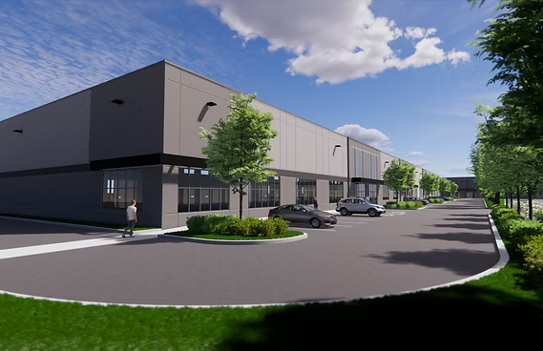
Artist rendering — final building design subject to change
±87,500 SF  TOTAL BUILDING AREA | 2  BUILDINGS (±43,750 SF EA.) | $2.30/SF/Mo  ASKING RATE, NNN | Oct 2026  EST. CONSTRUCTION COMPLETION
Atlas Management is pleased to offer for lease a new-construction, two-building flex industrial development located at 2150–2190 25th Street SE in Salem, Oregon. Totaling approximately 87,500 square feet across two equally-sized, freestanding buildings, the project combines warehouse/loading functionality with finished office space — suited for light industrial, distribution, showroom, contractor, or flex-office users seeking a modern, purpose-built facility in the Mid-Willamette Valley.
Construction is underway with a targeted completion date of October 2026, giving prospective tenants the opportunity to secure space in advance of delivery and, where appropriate, influence interior build-out. Each building is designed with dedicated loading dock access, on-site parking, and an integrated office component, offering flexibility for a single user or divided occupancy across the two buildings.
The property is located in Southeast Salem with convenient access to Oregon's primary north-south freight corridor (I-5) via OR-22, placing tenants within easy reach of the greater Salem-Keizer labor market and the broader Portland-Willamette Valley industrial corridor.

PROPERTY FEATURES
- Two freestanding flex industrial buildings  - ±43,750 SF per building (±87,500 SF total)  - New construction — est. delivery October 2026  - Loading dock access at each building  - Integrated office / showroom component  - Available as individual bays or in combination  - Build-to-suit interior finish opportunity pre-delivery | - Address: 2150–2190 25th St SE, Salem, OR 97302  - Submarket: Southeast Salem industrial corridor  - Convenient access to I-5 via OR-22  - Proximity to Salem-Keizer labor market  - On-site auto and trailer parking  - Zoning: Industrial (buyer/tenant to verify with City of Salem)  - Utilities to site: TBD — contact listing broker
CONCEPTUAL SITE PLAN
Site plan reflects the project's approved civil/architectural plan set (Building A & Building B footprints, parking, and loading configuration) — not to scale, subject to final permitting.
CONTACT
Randy Peabody  Director of Commercial Management  Atlas Management  randy@atlaspnw.com  971-754-7375 |   EXCLUSIVE LISTING AGENT
The information contained herein has been obtained from sources deemed reliable but is not guaranteed as to accuracy or completeness. Buildings are under construction; all dimensions, features, dates, and site plans are conceptual and subject to change without notice. Prospective tenants should verify all information independently, including zoning, utilities, and final construction specifications, prior to executing a lease. This is not an offer to lease where prohibited by law.

