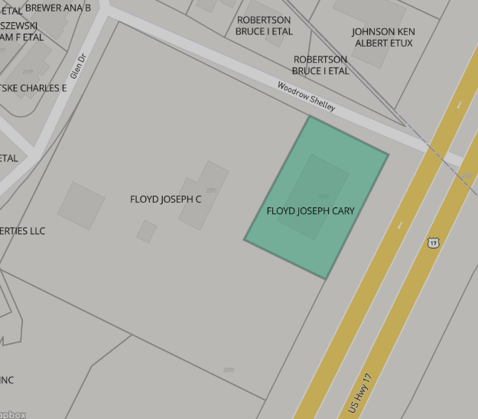
Address
2600 HWY 17
Parcel ID
30711020001.0
County
Horry, SC
Municipality
Little River
Acreage
0.58 (deeded), 0.61 (calculated)
Land Use Class
Commercial
Land Use Code
373
Land Cover
Developed Medium Intensity: 0.57ac (93.5%), Developed Low Intensity: 0.04ac (6.5%)
Elevation (Ft)
48
Mailing Address 1
4312 WOODROW SHELLEY DR
Mailing Address 3
LITTLE RIVER SC 29566-9358
Owner Occupied
Land Lease – April 2024
Num Buildings
2

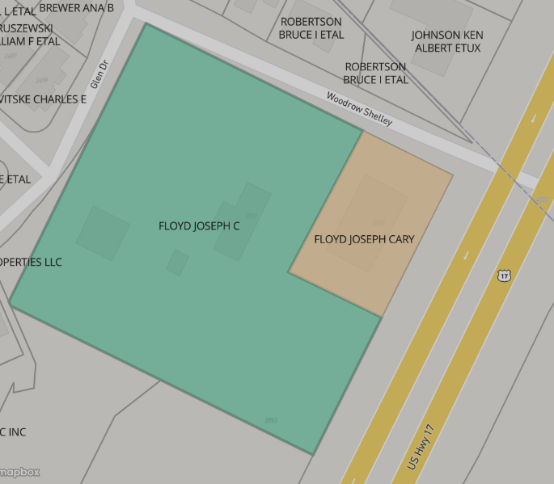
Address
2591 HWY 17
Parcel ID
30711020002.0
County
Horry, SC
Municipality
Little River
Acreage
3.54 (deeded), 3.41 (calculated)
Land Use Class
Commercial
Land Use Code
319
Land Cover
Developed Open Space: 1.79ac (52.4%), Developed Low Intensity: 0.80ac (23.5%), Woody Wetlands: 0.50ac (14.7%), Developed Medium Intensity: 0.32ac (9.5%)
Elevation (Ft)
48

Prime Commercial Property Opportunity on the South Carolina-North Carolina State Line!
Property Highlights:
- Location: Situated perfectly on the bustling state line between South Carolina and North Carolina, this prime commercial property offers a unique opportunity for businesses to tap into two vibrant markets.
- Acreage: 4.12 acres of highly desirable, flexible-use land, ideal for retail, office space, hospitality, or light industrial development.
- Accessibility: Positioned conveniently on Hwy 17 and Hwy 179, ensuring easy access for customers, employees, and distribution networks across both states.
- High Traffic Visibility: This property enjoys excellent traffic exposure, drawing attention from both interstate travelers arriving and departing from SC and local residents. Benefit from vehicle traffic generated by surrounding businesses and residential areas.
- Zoning: Zoned for commercial use with flexible development options, making it a perfect fit for a variety of industries. Whether you're looking to build a retail complex, multifamily, or professional office park, this property offers endless possibilities.
- Growing Region: The SC-NC border region is experiencing rapid economic growth, with expanding residential developments, increasing tourism, and a surge in small to medium-sized businesses. Be part of this thriving community and take advantage of the area's economic momentum.
- Proximity to Major Cities: Located just minutes North Myrtle Beach, Myrtle Beach and major urban centers like Charlotte, NC, and Spartanburg, SC, this property is ideally positioned to serve a broad customer base across two states.
- Utilities & Infrastructure: All essential utilities, including water, electricity, and sewage, are readily available, with potential for additional infrastructure support as needed.
Investment Potential: This property represents a rare opportunity to secure a commercial foothold in one of the most dynamic and fast-growing regions in the Southeast. The combination of prime location, high visibility, and versatility makes it an outstanding investment for any forward-thinking business or investor. With the area's continual growth in commerce, tourism, and residential developments, this property is poised for exceptional long-term returns.

Don’t Miss Out! Explore the potential of this strategically located property today. For more details or to schedule a site visit, contact us at (470) 908-9544.

