Lake Property For Sale
(Approximately 980 feet of water frontage)

Summary Information:
- Option A ($3,750,000.00 - 42.05 acres):
  - 2 Entrances:
    - Dorsey Drive, Gainesville GA 30504.
    - Hidden Hill Drive, Gainesville GA 30504.
  - 980 feet of water frontage and permitted for 2 boat docks with 2 slips each.
    - Permit F-1229
    - Permit F-1228
  - Property has water, sanitary sewer, and gas.
- Option B ($8,500,000.00 – 57 acres):
  - Above Option A ($3,750,000.00) plus:
    - Additional 15 acres of property with additional entrances connected to Browns Bridge Road.
    - Large 6 bedroom / 5 bath house with basement and pool.
    - 3 bedroom / 2 bath house.
- Option C ($10,300,000.00 - ~61 acres):
  - Above Option B ($8,500,000.00) plus:
    - Additional Hidden Hill property with 2 large shops. Value of $1,800,000.00.

Option A ($3,750,000.00):
(Parcels A-G….42.05 acres):
(First pic below shows approximate measurements of the overall proposed property) (Pics of each parcel with exact acres are also listed below)
Summary of Sale:
- 7 Parcels:
- Dorsey Drive (Parcel - 08034 004037) (6.42 acres)
    - 6.418 acres.
    - Lake Frontage: ~604 feet.
    - Permitted for 2 docks with 4 dock slips (2 for each)
- 3580 Dorsey Drive (Parcel - 08034 004007) (.36 acres)
    - Road frontage: 75 feet
- 3588 Dorsey Drive (Parcel - 08034 004006) (.36 acres)
    - Road frontage: 75 feet
- 3931 Hidden Hill Drive (Parcel - 08039 001035) (15.8 acres)
- Browns Bridge (Parcel – Portion of 08034 004036) (14.16 acres)
- Dorsey Drive LT 35 & LOT 36 (Parcel - 08034 003012) (.5 acres)
    - Road frontage: 105 feet
- SW Sweet Magnolia (Parcel - 08021 001542) (4.45 acres)
    - Lake Frontage: ~375 feet.
    - 1 Sewer Easement:
      - Dorsey Drive (Parcel – 08021 001001):
        - 35 foot perimeter buffer of Sewer Rights.
    - Corp property frontage: 673.78 feet

Summary
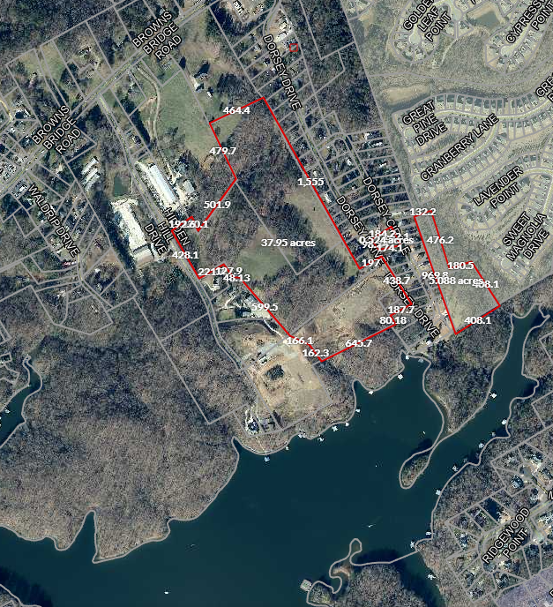
C
B
F
G
E
D
A

Details:
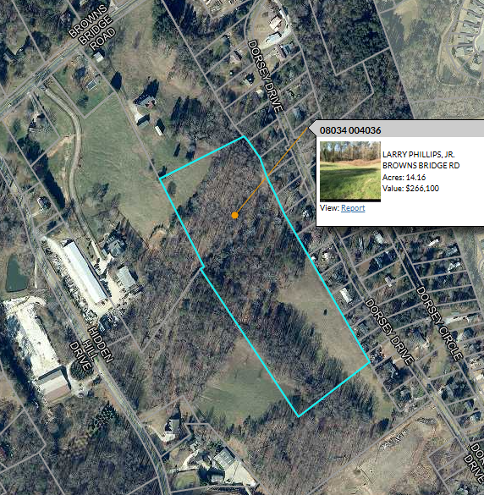
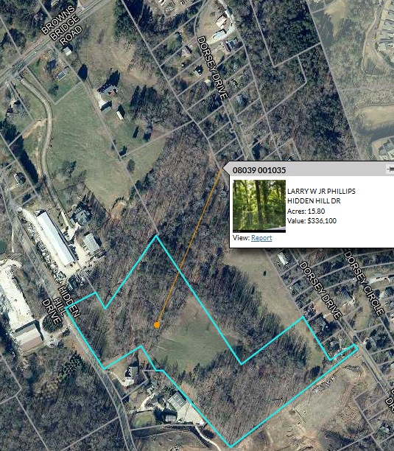
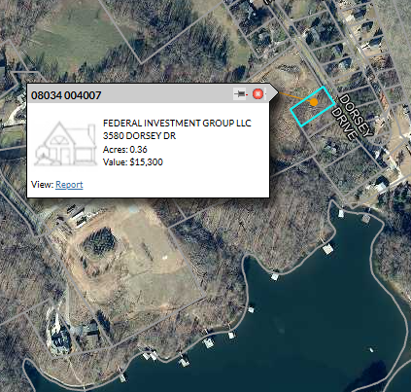
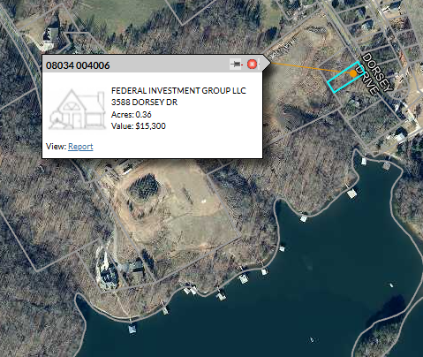
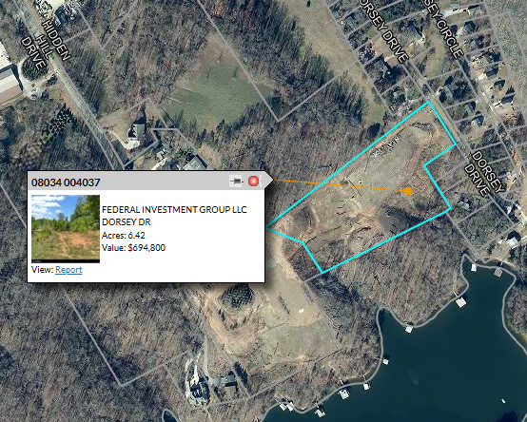
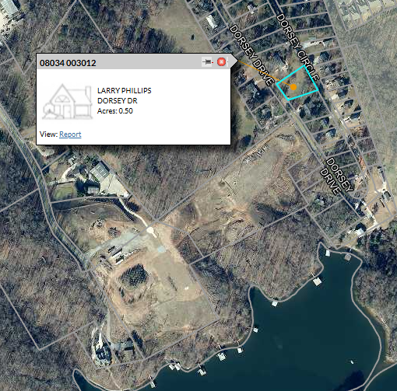
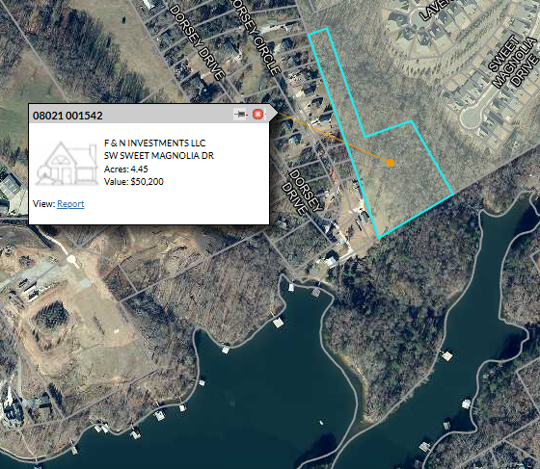

Option B: (Approximately 57 acres) ($8,500,000.00):
(Includes front pasture, front rental house on Browns Bridge Road, corner lot on Browns Bridge Road and Hidden Hill Drive, .17 tract of land near larger shop, and main house. Does NOT include the 2 shops near the main house…..Need to resurvey 12.77 acre front pasture property with driveway to split the little shop from this track of land.)
(Parcels A-K….Approximately 57 acres):
(First pic below shows approximate measurements of the overall proposed property) (Pics of each parcel with exact acres are also listed below)
Summary of Sale:
  - 7 Parcels:
      - Dorsey Drive (Parcel - 08034 004037) (6.42 acres)
        - Lake Frontage: ~604 feet.
        - Permitted for 2 docks with 4 dock slips (2 for each).
      - 3580 Dorsey Drive (Parcel - 08034 004007) (.36 acres)
        - Road frontage: 75 feet
      - 3588 Dorsey Drive (Parcel - 08034 004006) (.36 acres)
        - Road frontage: 75 feet
      - 3931 Hidden Hills Drive (Parcel - 08039 001035) (15.8 acres)
      - Browns Bridge (Parcel – Portion of 08034 004036) (14.16 acres)
      - Dorsey Drive LT 35 & LOT 36 (Parcel - 08034 003012) (.5 acres)
        - Road frontage: 105 feet
      - SW Sweet Magnolia (Parcel - 08021 001542) (4.45 acres)
        - Sewer Easement:
        - Lake Frontage: ~375 feet
        - Dorsey Drive (Parcel – 08021 001001):
          - 35 foot perimeter buffer of Sewer Rights.
          - Corp property frontage: 673.78 feet.
      - 3675 BROWNS BRIDGE RD (Parcel - 08034 004031B) (12.77 acres)
        - Main house with ~7,500 sqft and pool.
        - ~14 foot of road frontage.
      - 3677 BROWNS BRIDGE RD (Parcel - 08039 001032) (1.29 acres)
        - Rental house with 1,800 sqft.
        - ~95 foot of road frontage.
      - 3911 HIDDEN HILL DR (Parcel - 08039 001050) (.78 Acres)
        - ~85 foot of road frontage on Browns Bridge
        - ~350 foot of road frontage on Hidden Hill.
      - 3935 HIDDEN HILL DR (Parcel - 08039 001048) (.17 acres)
        - ~55 foot of road frontage
Summary
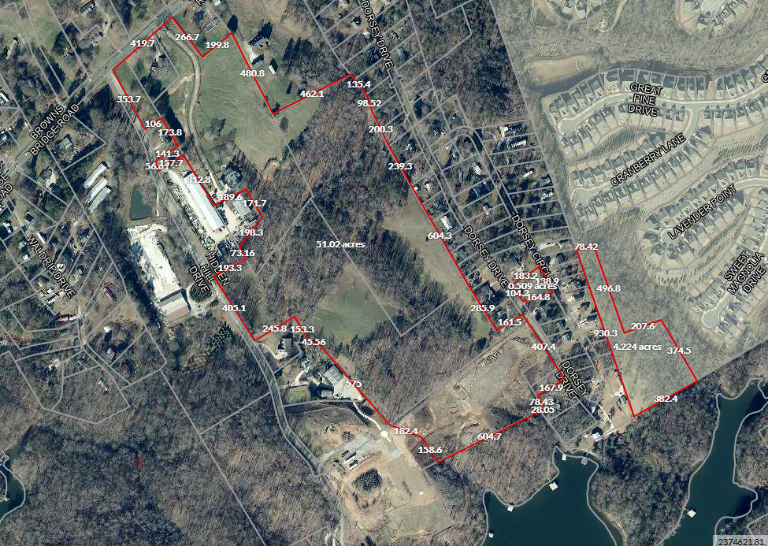
K
J
I
H
G
F
E
D
C
B
A

Details:
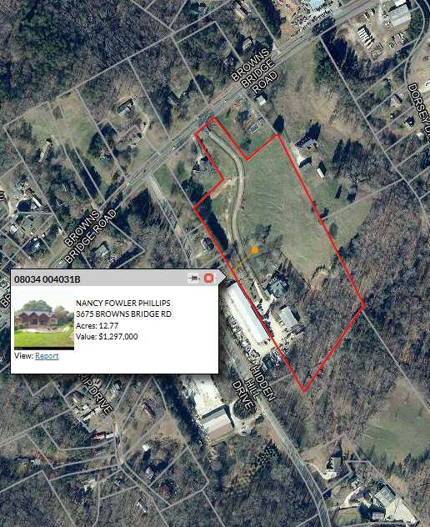
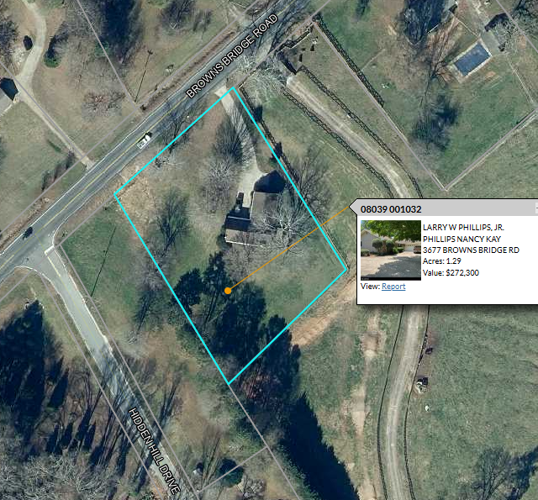
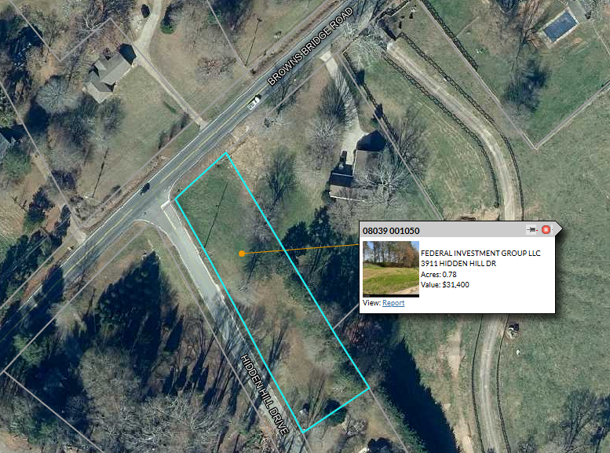
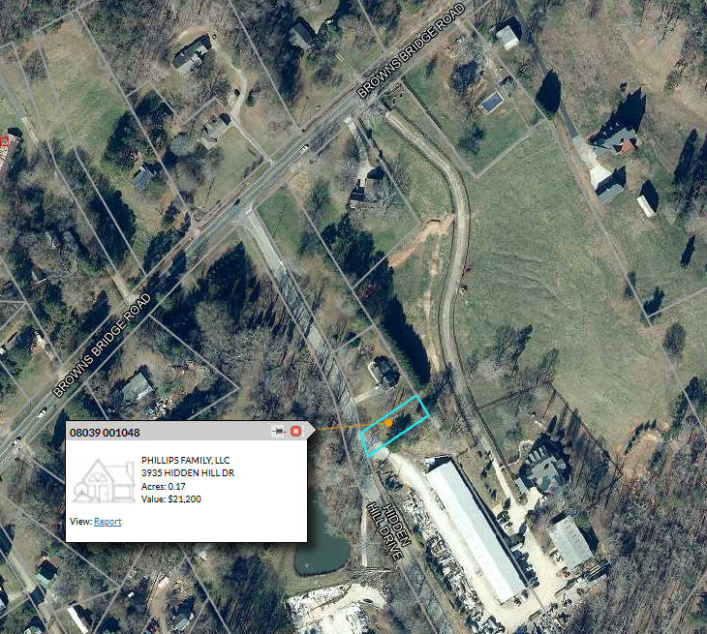

Option C: (Approximately 3.559 acres) ($1,800,000.00)
(Option B purchase required to add this option. This option includes the two shops near the main house that were excluded from Option B. )
Summary of Sale:
  - 2 Parcels:
      - 3943 HIDDEN HILL DR (Parcel - 08039 001047) (2.62 acres)
        - This is the large shop.
        - Approximate Hidden Hill Road frontage: 625 feet.
      - A portion of 3675 Browns Bridge Road (Parcel - 08034 004031B) (Approximately 1.277 acres of the 12.77 acre track behind the large house.)
Summary:
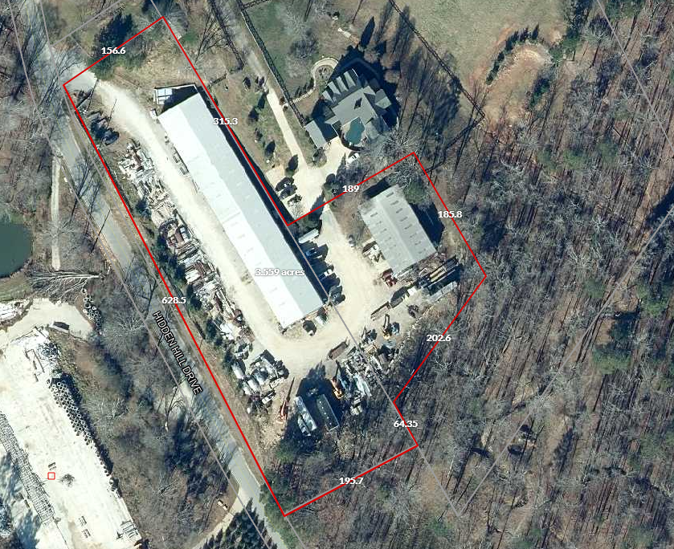

Details:
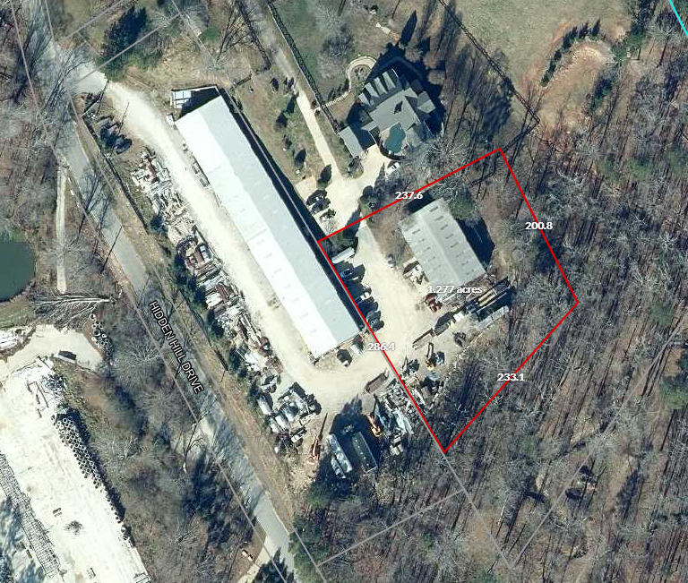
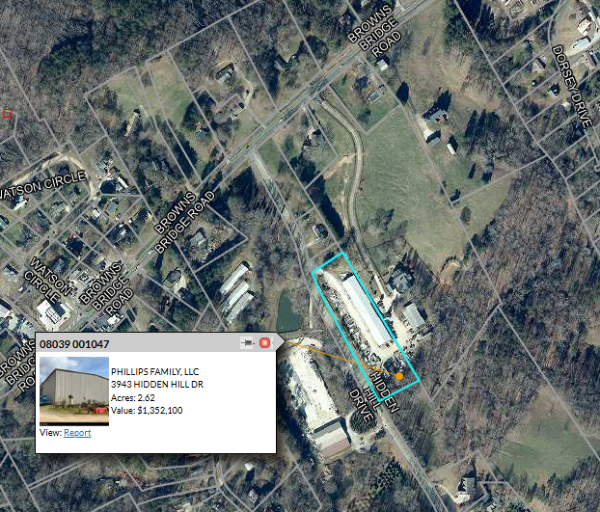

Parcel A (08034 004037) Split for 2 Tracts for 2 Boat Docks with 2 slips each:
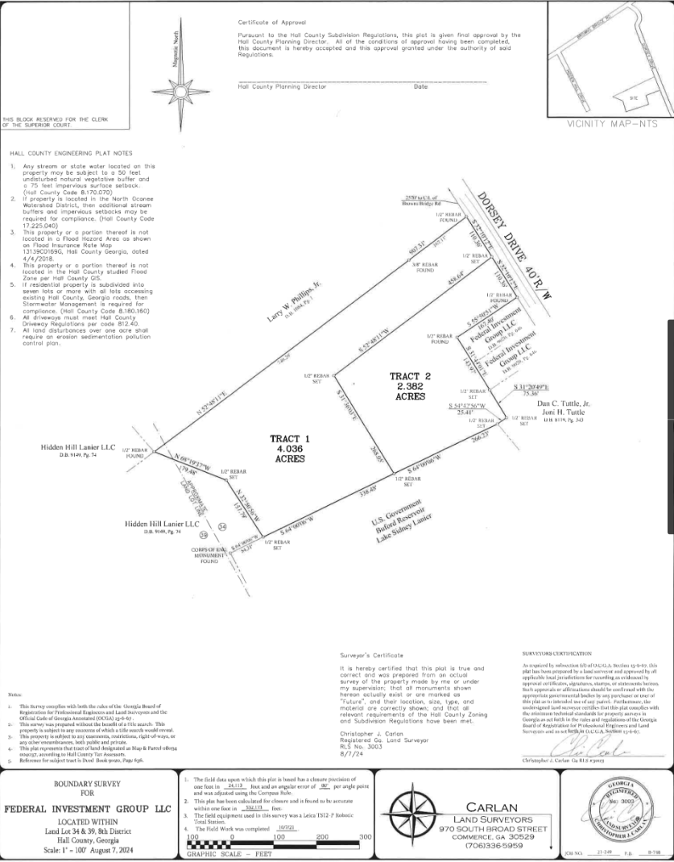

Parcel G - Sewer Easement Detail:
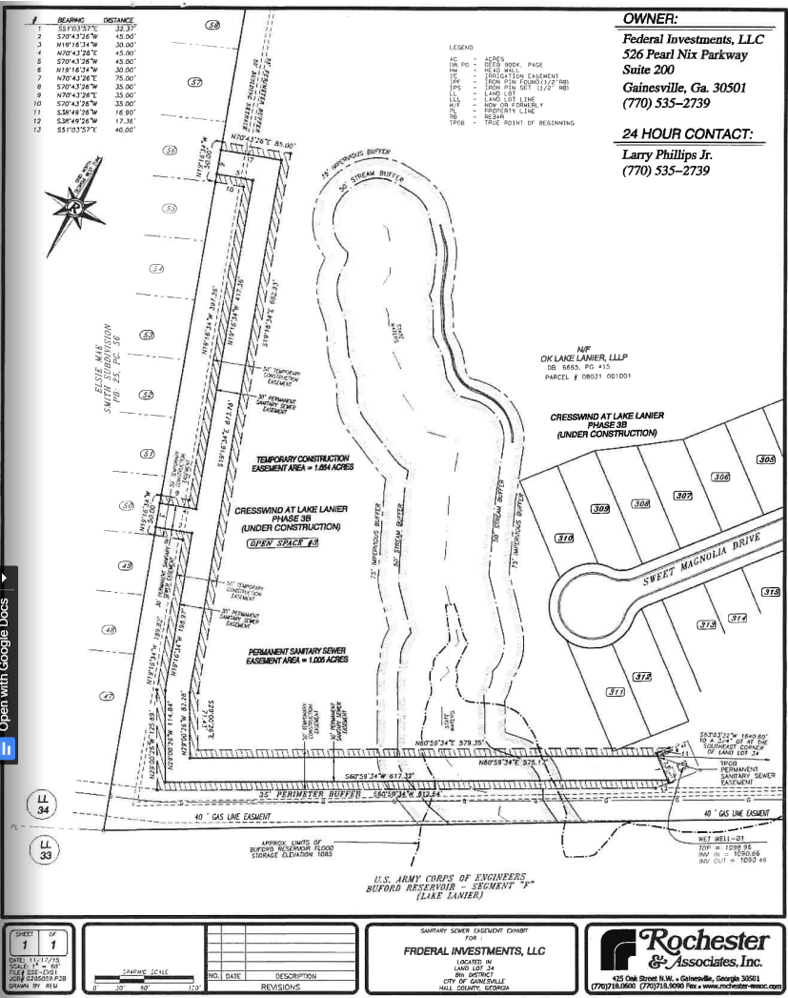

Lake Pictures:
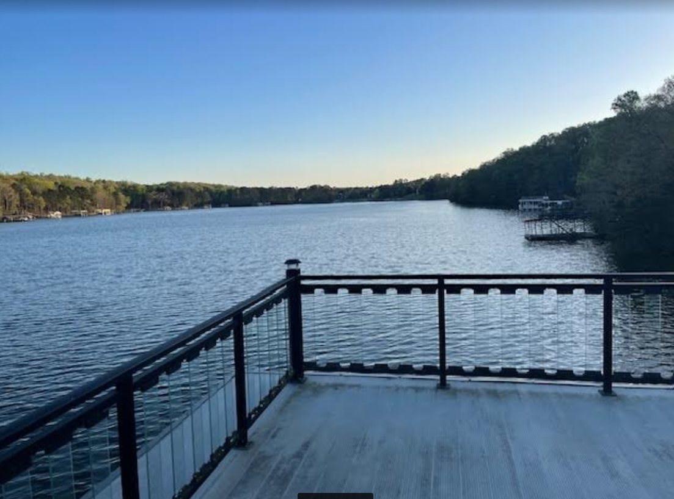

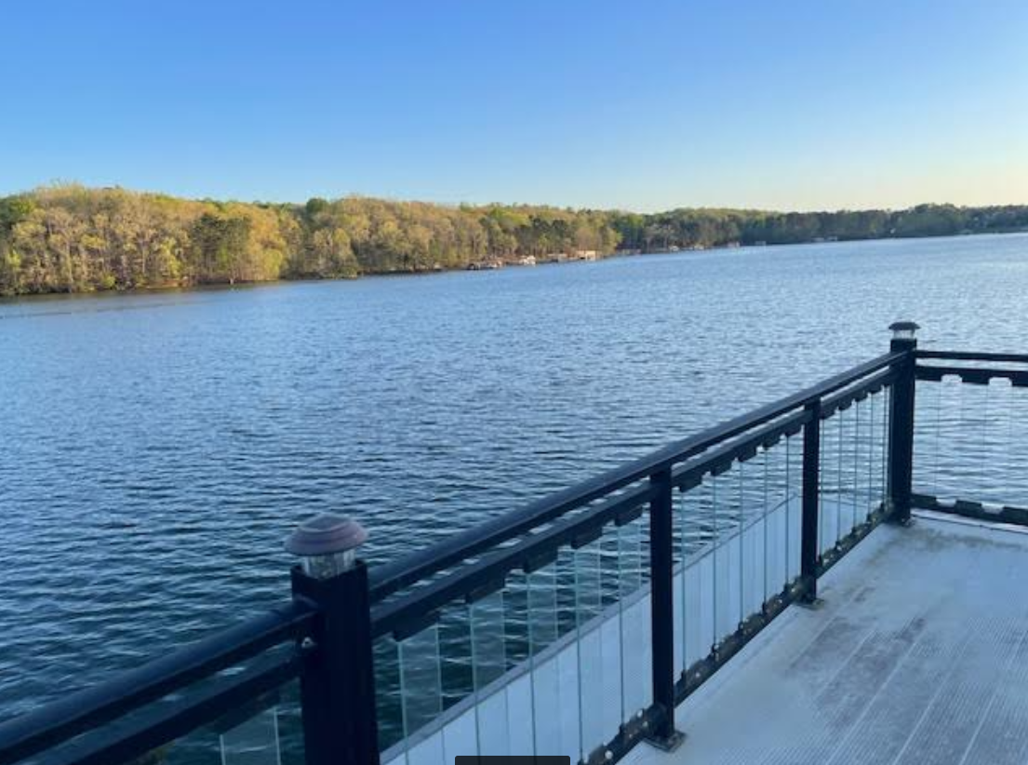
Boat dock available for purchase:


