

PRIME RETAIL SPACE
37 North Dean Street
Englewood, NJ
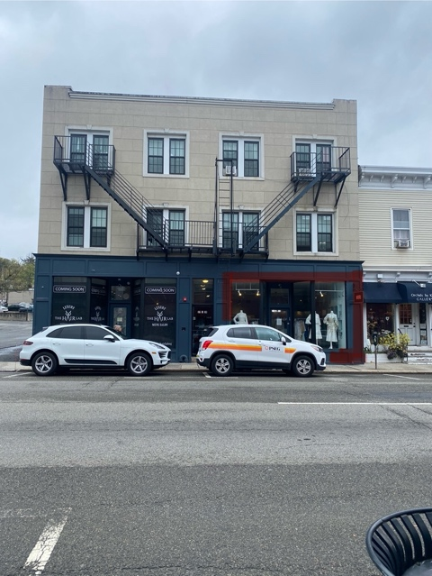
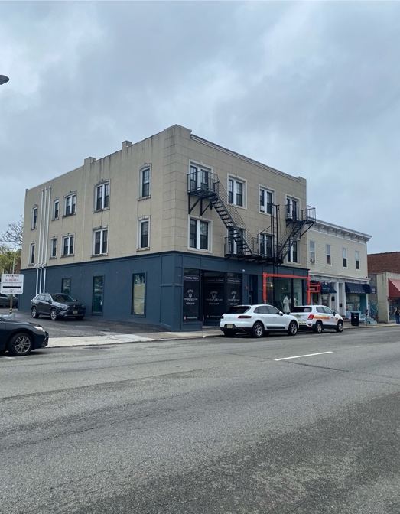

Store Sizes: 20’ x 66’ = 1320 s.f. plus full storage basement

Rent: $45 psf GROSS
Rental Increases: 3% Annually
Real Estate Taxes & CAM Included in Base Year Rent
Term: Minimum of Five (5) Years
Utilities: Independently metered
Present Tenant: Miri Ladies RTW
Condition of Premises: “As is” Ceiling height is 11’ throughout

Availability: September 15th, 2024
Parking: 2 Parking Spaces at Rear Come with Premises
Remarks: This building fronts North Dean Street, a main commercial corridor of Englewood which runs southbound from such affluent town to the north as Tenafly, Cresskill, Alpine, Demarest and Closter. Popular retail neighbors include Bartolomeo’s Deli, One River School, Starbuck’s, Moxie Salon, Marcia’s Attic for Kids and Footnotes, to name a few. In addition, the building is a half-block from a large municipal parking lot directly across from the Bergen PAC (Performing Arts Center) that draws some 200,000 patrons annually from a twenty-mile radius! In addition, Englewood Hospital with 2,900 staff, 900 MDs and 400 volunteers is just 1 mile due north of this location!
For More Information Contact:

Stephanie Greco Cell: 551-486-2548
Exclusive Real Estate Broker
Email: stephanie@thegrecorealtygroup.com

