PROPERTY INFORMATION PACKAGE



1077 RYDAL ROAD

SUITE 303
RYDAL, PENNSYLVANIA 19046
(215) 784-9100 FAX (215) 784-9540

PROPERTY ADDRESS

FOR SALE

2997 FRANKS ROAD
HUNTINGDON VALLEY
LOWER MORELAND TOWNSHIP
PENNSYLVANIA

SUMMARY OF PERTINENT INFORMATION

SUBJECT: Industrial Flex Building for Lease
PROPERTY TYPE: Industrial Complex

ADDRESS: 2997 Franks Road
Huntingdon Valley
Pennsylvania, 19006

TOWNSHIP: Lower Moreland
COUNTY: Montgomery

STATE: Pennsylvania

TOTAL BUILDING SIZE: +/- 20,300 square feet

UNIT DESCRIPTION: One-story clear span masonry/block and brick building.

LOT SIZE: 1.50 acres

OFFICE SIZE: +/- 3,000 square feet office/showroom

CEILING HEIGHTS: Offices – 10’
Plant – 19’7” (clear)

COLUMN SPACING: Clear span throughout the plant.

UTILITIES: Natural gas heat, power, vapor fixtures (plant) & fluorescent fixtures (offices) lighting.

FLOORS: 6” reinforced concrete (plant)
New Updated Flooring in office/showroom.

RESTROOMS: Office/showroom area has one (1) restroom with one (1) lavatory, water closet, and stall shower. Plant/warehouse area has one (1) restroom featuring one (1) water closet and one (1) lavatory. All fixtures within each of the restrooms are new.

There is a third restroom serving a private office that contains one (1) water closet and one (1) lavatory.

HVAC: Office/showroom area air conditioned and heated throughout. The plant is heated by a combination of natural gas fired Re Verber Ray unit heaters and Re Verber Ray radiant tube units.

POWER: Two (2) separate electrical services. One (1) 600 Amp 120/240 Volt, Three Phase, Four Wire Service. One (1) Main disconnect providing 200 Amp 120/240 Volt Single Phase, Three Wire Service.

WATER/SEWER: Public

LOADING: Three (3) individual drive-in doors

CRANES: One (1) 5-ton pendant operated Philadelphia Tram Whale bridge crane and one (1) 5-ton pendant operated Morris Wheller bridge crane.

ZONING: Industrial (“I”)

PARKING: 0.09 spaces per 1,000 SF

TAXES: $35,693.74 (2026)

MISCELLANEOUS: The property is conveniently located in Eastern Montgomery County just minutes from Philadelphia, interstate I-95 Route 1, the Pennsylvania Turnpike, and bridges to New Jersey. Public transportation to the property is serviced by Septa rail, which is just a short walk to the facility.

RENTAL RATE: $10.00 per square foot NNN per year.

2997 FRANKS ROAD
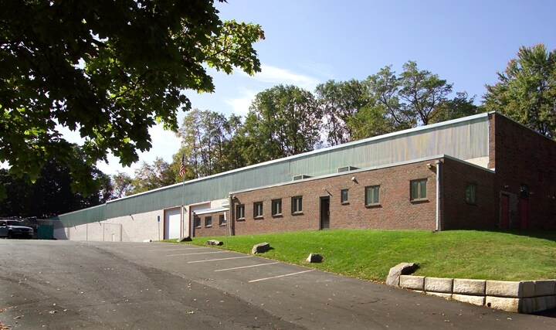

AERIAL PHOTO

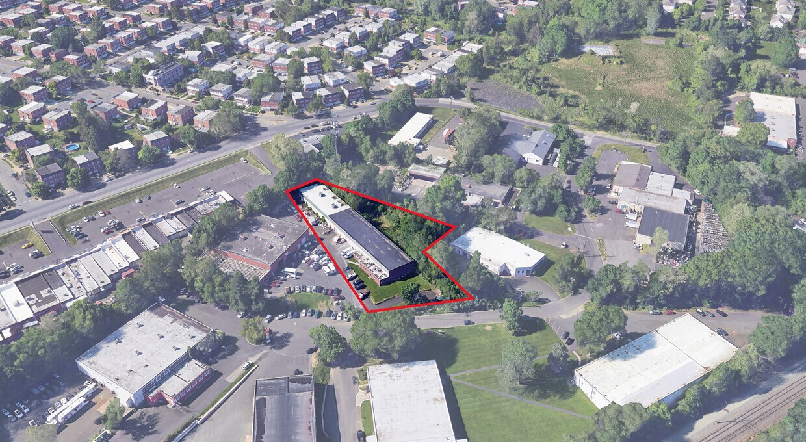

INTERIOR OF PLANT 1

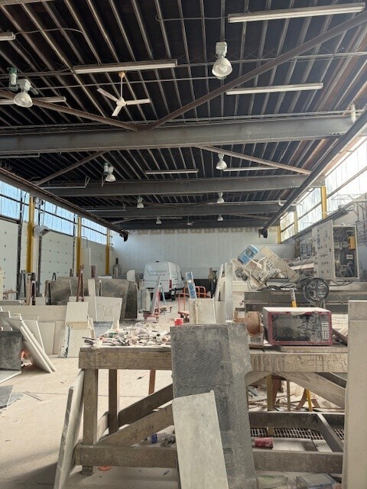
INTERIOR OF PLANT 2

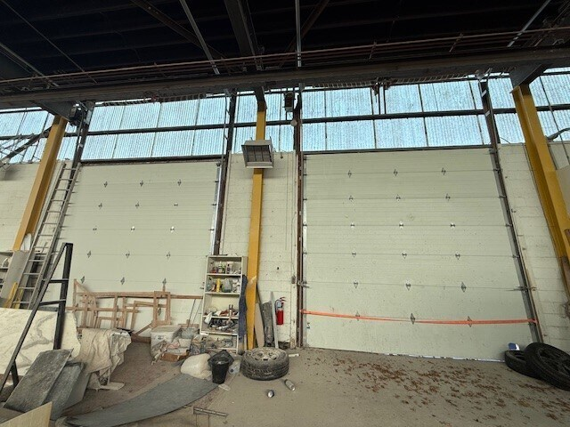

TAX MAP OF SITE



