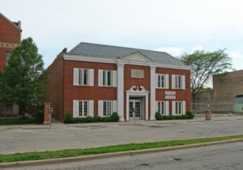

711 South Blvd. Office Building with 12 Private Offices

Contact: Robert Ransom Phone: (708) 655-8888 E-Mail: archonomics@aol.com
Newly installed state of the art StarLight security cameras / system to provide a safe working environment
- Office Building located in Down Town Oak Park, IL. and near Oak Park Ave. “L” Station- Green Line

- Plenty of Client Parking available in front of Office Building or on Euclid Ave.

- Office Building provides a Formal Colonial Façade composed of Large Fluted Columns, Crown Mouldings including Granite and Marble patterned walls accentuating a recessed Double Door Entrance

- Each office has independent HVAC system to eliminate shared air born viruses known in common air systems

- Enormous Interior “ATRIUM" with 18 foot ceiling accented by tropical plants consumes 1/3 of building sq.ft.

- Three Enormous Skylights providing natural light & fresh air to “ATRIUM” and Private Offices for Wellness

- Numerous building upgrades support “Green” efforts in conserving energy reducing carbon foot print

- Elaborate Wrought Iron Railings and Balustrades accent “ATRIUM” with an New Orleans ambience

- Private Tenant Parking available (rare commodity in Oak Park) for a nominal monthly fee

- Office Building Security provides Time Lock system for Double Front Door Entry and Self Locking rear door

- Building common areas including bathrooms are sprayed with anti virus disinfectant for healthier environment
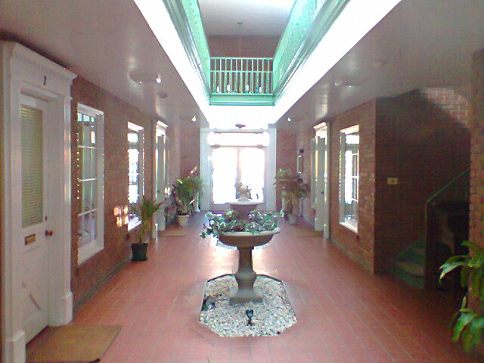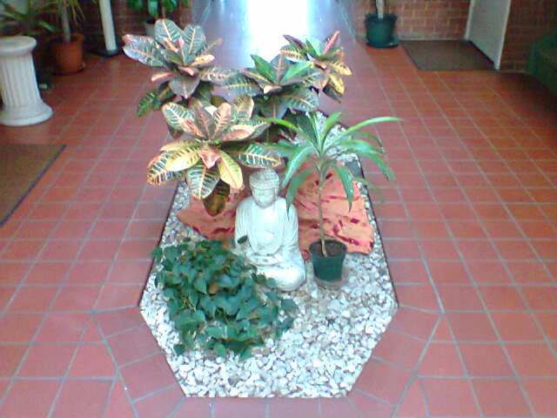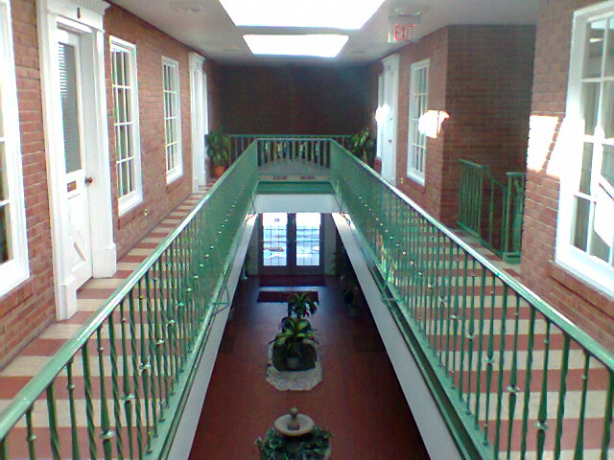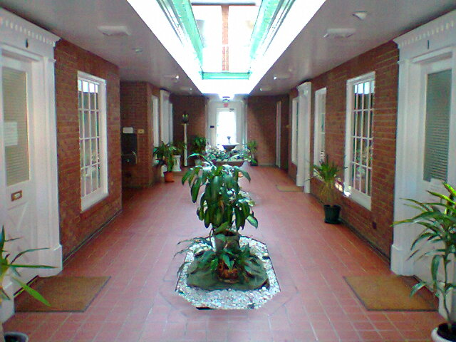

1st Fl. Atrium Area & Dbl. Dr. Entry Atrium Planting & Display Area’s Second Floor Atrium Area 1st Fl. Atrium Area & Rear Exit Dr.

