CONTACT INFORMATION
Cecil County Government – LAND USE AND DEVELOPMENT SERVICES:
Sean Gizzi Planning and Zoning Richard Dahl – Development Plans Review email: sgizzi@cecilcountymd.gov email: rdahl@cecilcountymd.gov phone: 410-996-5220 phone: 410-996-5225

Cecil Maps GIS: https://cecilmaps.org/
Artesian Water: https://www.artesianwater.com
Cecil County Sewer: https://www.cecilcountymaryland.gov/385/water-sewer-planning-division
MD Traffic Counter: roads.maryland.gov
Cecil County Zoning Ordinance: https://www.ccgov.org/home/showpublisheddocument/52637/638899018835430000
Forest Conservation: https://www.ccgov.org/home/showpublisheddocument/1262/637314374619730000
OpenGov Cust Service Request: https://cecilcountymd.portal.opengov.com/categories/1080/record-types/6447
Maryland Land Records, linked here: https://landrec.msa.maryland.gov/
Schedule a preconcept meeting: https://cecilcountymd.portal.opengov.com/categories/1081/record-types/6466
PROPERTIES:
2 COMMERICAL PARCELS
ZONED: Employment Mixed Use (EMU)
PULASKI HWY. ELKTON MD
PARCEL 15: 11 ACRES PARCEL 283: 0.75 ACRES

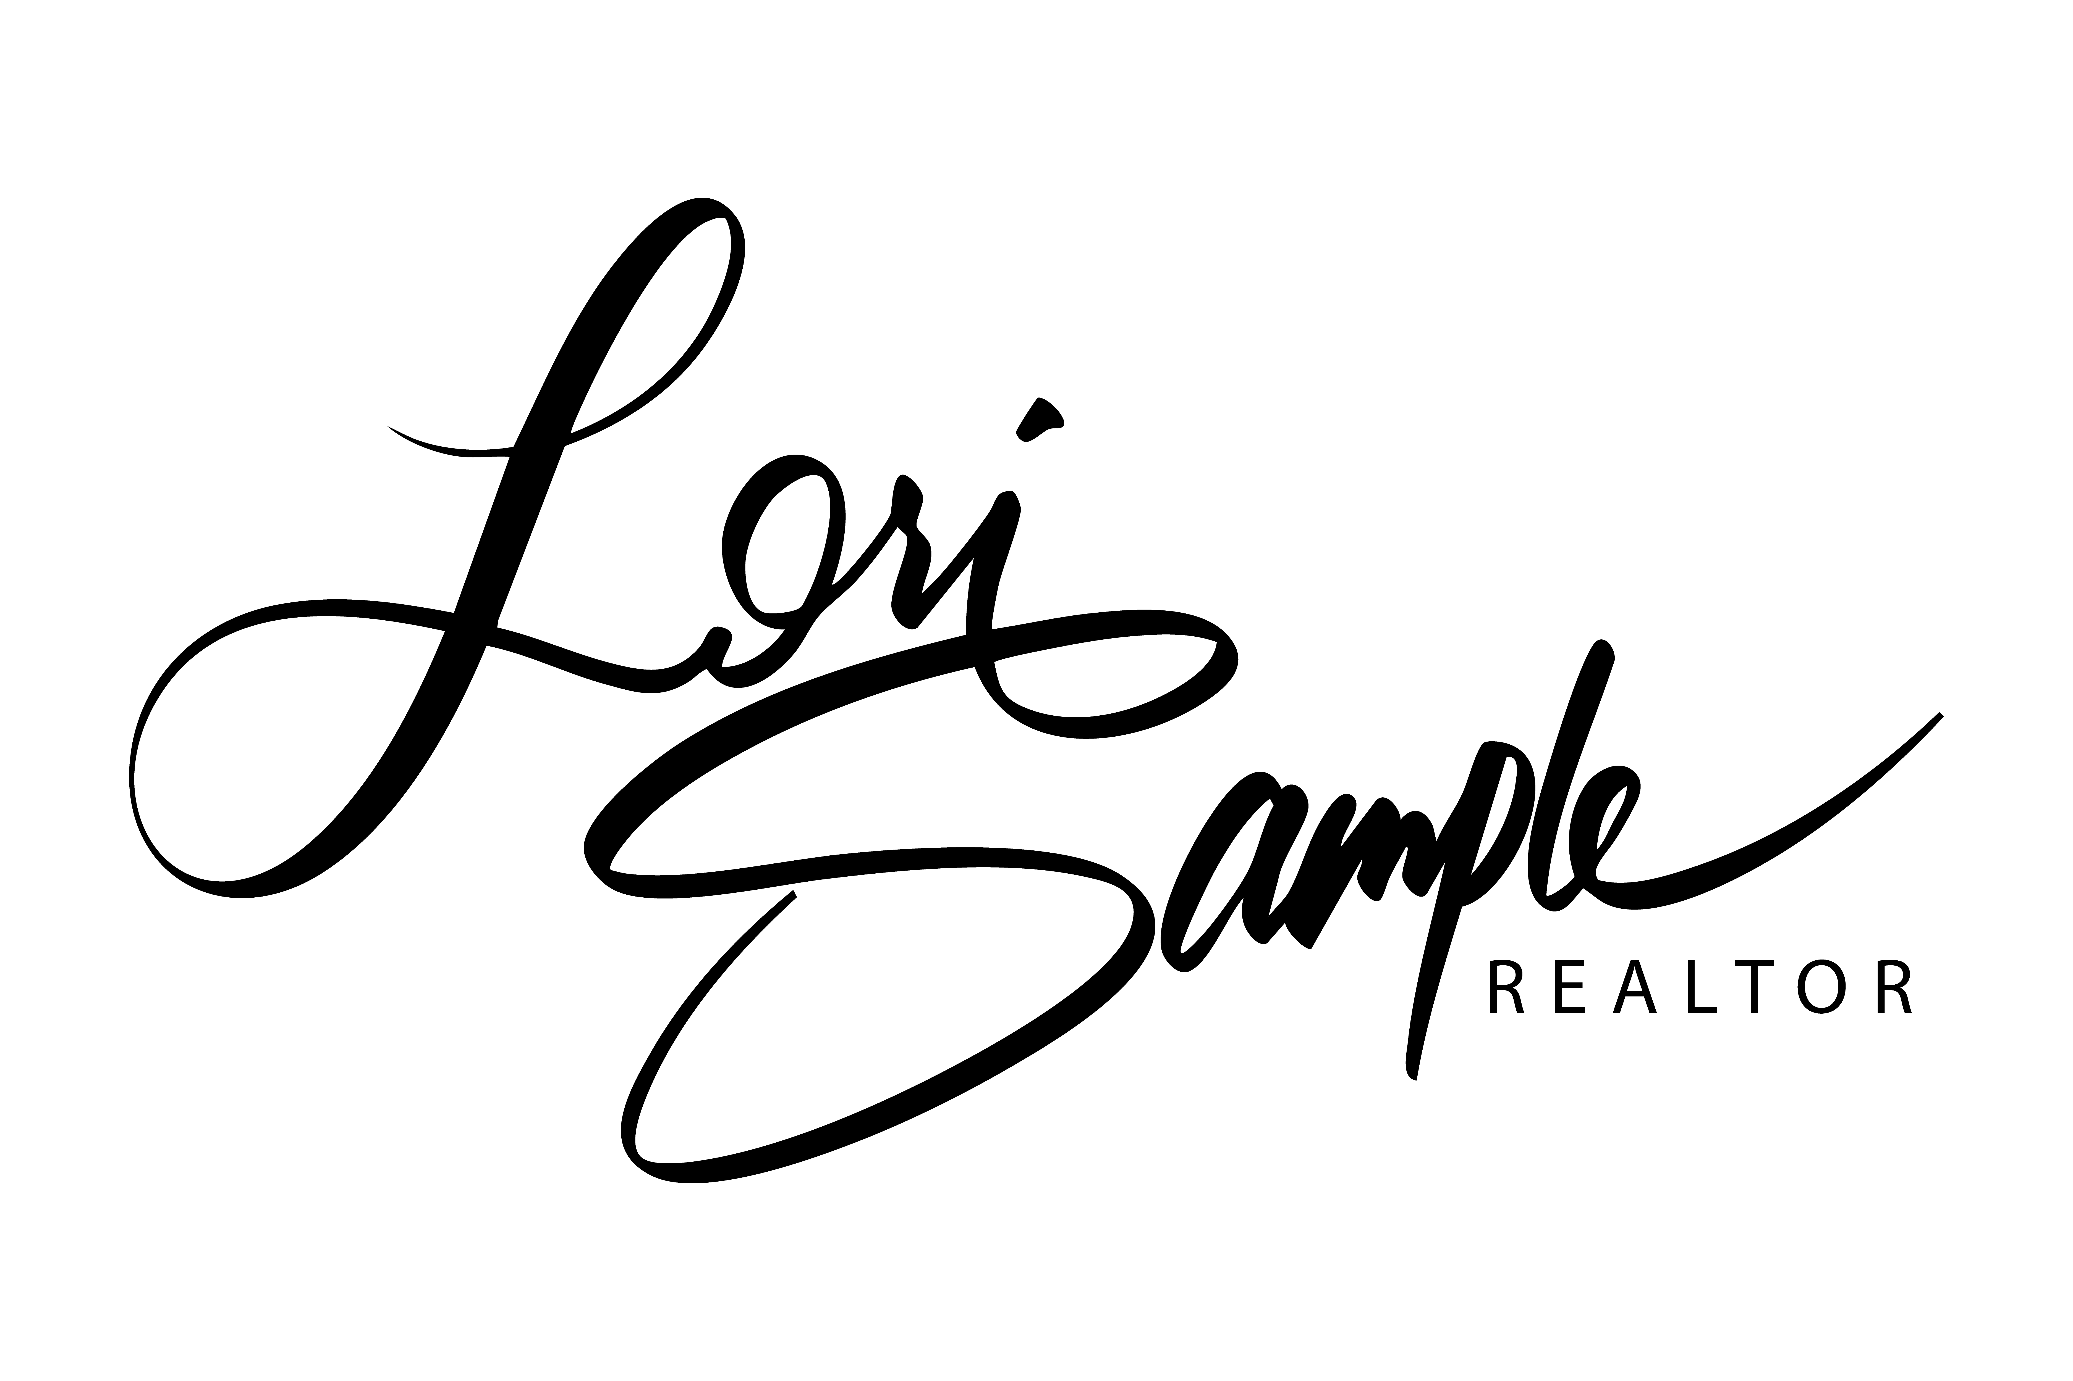


EXIT PREFERRED REALTY 2615 AUGUSTINE HERMAN HWY. CHESAPEAKE CITY, MD 21915 OFFICE: 410-398-9000 DIRECT: 443-350-0137 EMAIL: EXITLORI@GMAIL.COM WEBSITE: WWW.EXITLORI.COM

