Professional Office Suite For Sale
5791B NW 151 St, Miami Lakes, Florida 33014

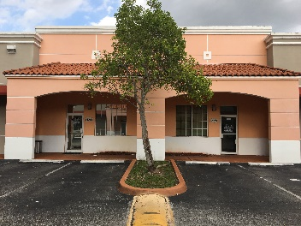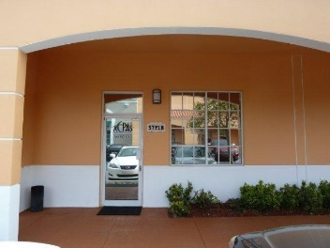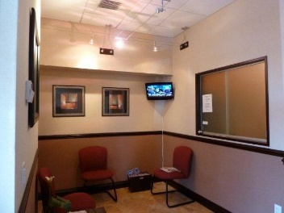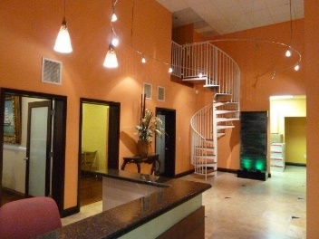
Office Building Covered Entrance Reception Area Open Area
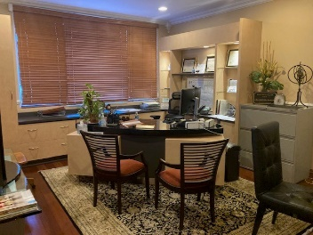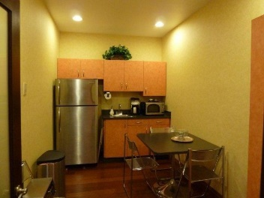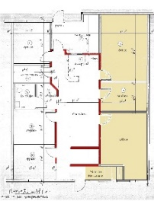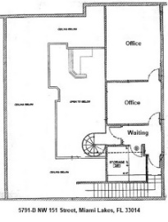
Main Office Kitchen First Floor Mezzanine

Ideal for Medical Research, Professional, or Administrative Offices
Features:

Waiting Room
Built-in Reception Desk
High Ceiling Open Area
Mezzanine Office
6 Private Offices
Full Kitchen/Lounge
Designer Bathroom
Separate File Area
3-room Mezzanine
Large IT/Storage Room
Prewired for Phones and IT
Large Windows for Natural Light

$849,900

To see this unique office suite in person, please call:
Call Ladd: (305) 978-2035, or
Valerie: (305) 557-7770

The FIUR Organization, Inc., Licensed Real Estate Broker
469 W 83 Street, Hialeah, FL 33014
Office: (305) 557-7770 Fax: (305) 557-7746

