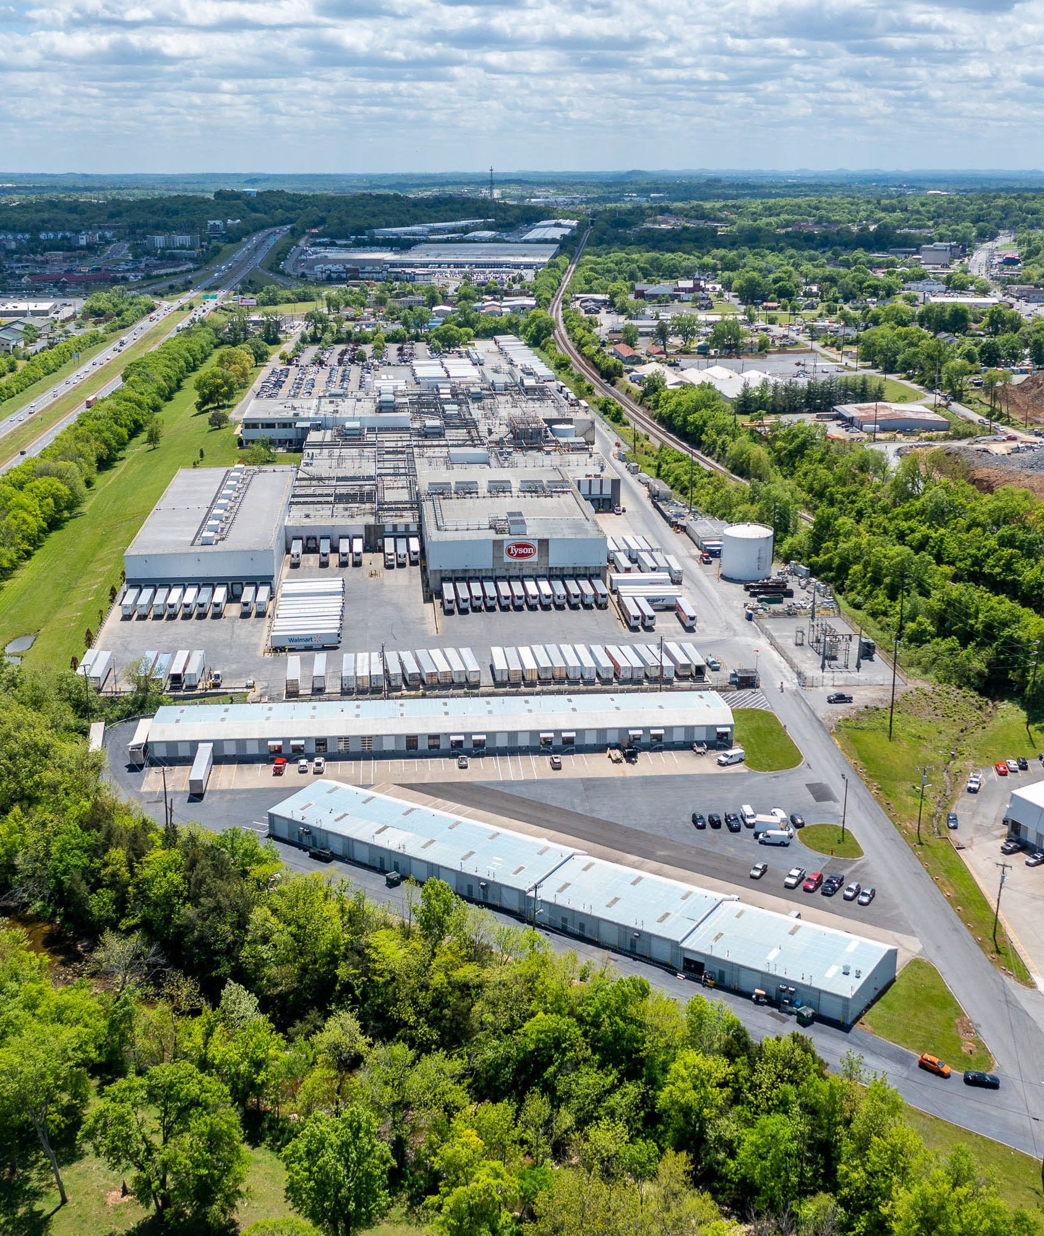
Old Stone Bridge
Industrial Portfolio
Goodlettsville, TN
Acquired By Gorney Realty Co., LLC

