Sec.160-80. REO-2, REO-4 and REO- 5 research, engineering and office districts, and RD research and development districts.
In the REO and RD districts, the following shall apply:
(1) Principal permitted uses on the land and in buildings.
a. REO and RD districts:
1.Office buildings for executive, administrative, business, educational or professionalservices.
2. Buildings used exclusively by the federal, state, county or local municipal government.
3. Activities of an industrial, medical or scientific research laboratory, provided that there are no inherent hazards associated with such research and further provided that no nuisancemay occur from fire or explosion, toxic or corrosive fumes, gas, smoke, odors, obnoxious dust or vapor, offensive noise or vibrations, glare, flashes or objectionable effluent and electrical interference which may adversely affect or impair the normal use and peaceful enjoyment of any property, structure or dwelling located in any other zone or district. The likelihood of groundwater contamination or depletion, air pollution and the problem of waste disposal shall be considered.
4. Commercial printing facilities.
5. Mailing, reproduction, commercial art and photography and stenographic Services.
6. Computer and data processing services.
7. Medical and dental laboratories.
8. Research and engineering activities involving technical investigation or study for product development and similar activities.
9. Publishing houses.
10. Public playgrounds, conservation areas, parks and public purpose uses.
11. Research-office parks, on tracts of land at least 25 acres in area, comprised of uses in accordance with those listed above.
12. All residences existing as of the date of adoption of this chapter. For purposes of evaluating proposed additions or expansions to said residences, the bulk and yardrequirements of those residential zone districts which most closely resemble the size of the lot in question shall be applied.
13. Farms.
14. Child and infant care centers. See section 160-138 for design standards. Notes:
1Convenience stores are permitted in the HC Highway Commercial and GC General Commercial zones only; see, section 160-78(2)ccc.
b. In addition to the above the following are permitted, but only in the RD districts except as provided in subsection 7.i. below:
1. Pharmaceutical products operations.
2. Assembly and treatment of previously prepared materials to produce products as follows:
i. Apparel.
ii. Textiles.
iii. Leather goods.
iv. Books and book binders.
v. Electrical and electronic equipment and supplies.
vi. Professional, scientific, surgical and controlling instruments.
vii. Photographic and optical goods, watches and clocks.
viii. Graphic materials, supplies, instruments and implements.
ix. Fabricated metal products, such as cutlery, hand tools, general hard- ware, fabricated structural metal products, screw machine products, bolts, nuts, screws, rivets, washers, springs, valves, pipe fittings and similar miscellaneous products.
x. Construction materials.
xi. Hardware, plumbing and heating equipment and supplies.
3. Distribution and warehousing. For general requirements see section 160-139.
4. Research and development parks may be permitted on tracts of land at least 25 acres in area comprised of uses in accordance with this section.
5. Telecommunications towers, provided they are not within one-half mile of a residential zone line or within one-half mile of the property line of a residential use, school or public recreation area. The distance shall be measured between the two closest property lines.
6. Radio or television broadcasting stations, including studios, auditoriums and other rooms for performances and including office and other space incident to and necessary for the principal use. Broadcasting towers and antennas may not be located within one-half mile of a residential zone line or within one-half mile of the property line of a residential use, school or public recreation area. The distance shall be measured between the two closest property lines.
7. Planned mixed-use research and development parks, subject to the following requirements and conforming to the findings of a planned development as defined by the Municipal Land Use Law, N.J.S.A. 40:55D-45, and in accordance with an approved general development plan.
i. The minimum total area to be developed as a planned mixed-use research and development park shall be 100 acres. That minimum area may be met with land in the RD district or in both the RD and REO-5 districts provided that the districts are contiguous and that at least 85 acres of the planned mixed-use research and development park are within the RD district. Such area shall be developed in accordance with a single comprehensive general development plan. Streets and rail rights-of-way shall not be deemed to divide acreage for the purposes of this requirement.
ii. The maximum floor area ratio for a planned mixed-use research and development parkshall be 0.25.
iii. No building shall exceed 45 feet in height. In the case of buildings with flat roofs, building height shall be measured to the roof level and not to the top of the parapet wall.
iv. Principal permitted, accessory, and conditional uses within a planned mixed-use research and development park as identified in section 160-80(1), (2), and (3) shall be permitted and be required to satisfy all of the RD requirements as set forth in section 160-80 and throughout the land development ordinance. The planning board shall have the right to modify the requirements for minimum lot area, width or frontage, minimum building setback, maximum impervious surface coverage, requirements as to front, side or rear yards and requirements concerning the location of accessory buildings or structures for any land use in a planned mixed-use research and development park whenever such modifications are necessary to achieve a planned mixed-use research and development park.
v. (a) In a planned mixed-use research and development park, the permitted gross floor areayield to be devoted to a planned commercial development that contains a wide range of retail and commercial and accessory uses serving a regional trade area which embraces a large segment of Hamilton Township, shall be as follows:
1. The planned commercial development located in the RD zone at the intersection of Klockner Road and Route 130 on the land use map and zoning map shall be limited to no more than 25 percent of the permitted gross floor area yield.
2. The planned commercial development located in the RD zone east of Route 130 on the land use plan map and zoning map shall be limited to no more than 40 percent of the permitted gross floor area yield.
3. The planned commercial development located in the RD zone situated at Cabot Drive, east of Interstate 1-195, south of Klockner Road and north of Yardville Hamilton Square Road, on the land use map and the zoning map shall be subject to the following conditions:
(a) Not more than 360,000 square feet of planned commercial retail development shall be permitted.
(b) Minimum landscape buffers along arterial road shall be not less than 100 feet.
(c) Minimum common open space shall be 35 percent of the land area within the planned mixed-use research and development park.
(d) Maximum floor area ratio (FAR) for the planned mixed use research and developmentpark shall be 0.16 FAR or not more than 947,500 square feet.
(e) At the intersection of Yardville Hamilton Square Road and Cabot Drive, there shall be no left turn permitted from Cabot Drive exiting on to Yardville Hamilton Square Road, and there shall be no right turn from Yardville Hamilton Square Road entering onto Cabot Drive.
4. The planned commercial development located in the RD zone bounded by Kuser Road, Route 130, Robbinsville Township and the United Jersey Railroad & Canal Company right-of-way shall be limited to no more than 40 percent of the permitted gross floor area yield for the planned mixed-use research and development park. Although the tract area of the planned mixed-use research and development park may extend northwest of the rail right-of-way all planned commercial development must be physically located within the RD district southeast of the rail right-of-way within the area described above.
(b) The permitted gross floor area yield of a planned commercial development shall be calculated by the applicant and approved by the planning board based upon the submission of a concept site plan and concept subdivision plan which shows development of the site based upon current RD zone standards.
(c) At least 25 percent of the permitted gross floor area of a planned commercial development shall be devoted to anchor tenant or magnet stores as defined in this chapter.
vi. All planned commercial developments shall be required to locate along Route 130. The sites identified on the township land use plan map and zoning map are potential sites for commercial development and the planning board may approve other locations along Route 130 within the planned mixed-use research development zone. The location of the planned commercial development within the planned mixed-use re- search and development park shall be located in a manner to encourage efficient movement of traffic and provide the maximum benefit to the mixed-use nature of the park. If deemed feasible and desirable, the planning board may permit some commercial uses to develop outside of these identified planned commercial locations within a planned mixed-use research and development park located along Route 130.
vii. (a) The planned commercial development located in the RD zone south and west of Klockner Road on the land use plan map and zoning map shall be limited to no more than 40 percent of the permitted gross floor area yield or to a maximum of 500,000 square feet, whichever is lower. Planned commercial development in this area shall front on Route 130 and be located east of the master plan roadway or may front on the master plan roadway and/or the ramp system west of the master plan roadway at its intersection with Route 130.
(b) Prior to the issuance of any construction permits for any buildings and/or appurtenant structures for any planned commercial development greater than 75,000 square feet, all governmental approvals required for the construction of the master plan road (commonly referred to as the Yardville Bypass) along with the signalization of the intersection of the Yardville Bypass with Route 156 and Route 130 must be obtained and performance security for such master plan road posted.
(c) Prior to the issuance of a certificate of occupancy for any planned commercial development greater than 75,000 square feet, the master plan road and intersection improvements referenced in subsection (b) above shall be constructed and open to public traffic.
viii. All planned commercial developments shall have at least one major commercial anchor or magnet store of at least 100,000 square feet. All planned commercial developments shall provide for passive and/or active recreation for patrons. Such area(s) shall be improved in accordance with a consistent design theme which is applied throughout the planned development and in accordance with the standards set forth in section 160-167.
ix. The following principal commercial uses other than anchor tenant and magnet stores as defined herein, as identified in sections 160-76(2), 160-77(2), 160-78(2) and 160-161(o) shall be permitted on the land and in buildings within a planned commercial development. They shall be limited to no more than 75 percent of the gross floor area of the planned commercial development:
(a) Principal permitted uses on the land and in buildings as found in section 160-76(2).
Groceries and foodstuffs.
Confectionery and luncheonettes.
Stationery and tobacco.
Hardware and paints.
Bakery.
Periodicals and newspapers.
Barber and beauty shops.
Tailoring and dressmaking.
Bakery goods store.
Book or gift store.
Candy store and/or fountain.
Clothes cleaning store with two or less trucks associated with it.
Custom dressmaking, millinery and tailoring.
Clothing (new) and dry goods store.
Delicatessen store.
Dress shop.
Drugstore.
Package liquor store.
Ice cream store.
Interior decorating business.
Jewelry store.
Self-cleaning laundry.
Notion and variety store.
Paint and wallpaper store.
Repair or service shops for household or personal goods.
Shoe repair shop.
Tailor shop.
Photography studio, photo supplies, artist's studio.
Antique store.
Art gallery.
Sporting goods store.
Child and infant care centers. See section 160-138 for design standards.
Video store.
All existing residences as of the date of the adoption of this chapter. For purposes of evaluating proposed additions or expansions, bulk and yard requirements of those residential zone districts which most closely resemble the size of the lot in question will be utilized.
Combinations of two or more of the above permitted uses in one principal building.
Principal permitted uses on the land or in buildings as found in section 160-77(2).
Restaurants, bars, and taverns. Banks, including drive-in facilities. Dancing studio.
Florist.
Household appliance store.
Stereo, radio and television stores.
Offices, business and professional.
Funeral homes and mortuaries.
Automobile parts store.
All existing residences as of the date of the adoption of this chapter. For purposes of evaluating proposed additions or expansions, bulk and yard requirements of those residential zone districts which most closely resemble the size of the lot in question will be utilized.
Combinations of two or more of the above permitted uses in one principal building.
Principal permitted uses on the land and in buildings as found in section 160-78(2).
Restaurants, bars, taverns and nightclubs.
Department stores.
Garden centers engaged in the retail sales of living plant material and related garden equipment. Outside storage, sale or display areas shall not exceed four times the buildingcoverage and shall be used only for the storage, sale and display of living plant material.
Bowling alleys.
Supermarkets.
Awning or canvas store.
Bicycle sales, rental or repair.
Blueprinting establishment.
Buildings used exclusively by the federal, state, county or local municipal government for public purposes.
Catering establishment.
Exhibition building.
Furniture and furnishings, sale of.
Laboratory servicing medical and dental requirements.
Museum.
Office furniture, appliances and supply business.
Pet shop, not involving the treatment of or boarding of cats and dogs.
Printing, lithography, publishing and photostating establishments.
Recreation area, public.
Taxidermist.
Theater, not including drive-in or open air, and not to be located in combination with a book or magazine store and not to be located within 1,000 feet of any such store.
Wholesale stores and distributors in a completely enclosed building not involving the processing or treatment of goods or products.
Parcel package shipping store or mailing center.
Indoor recreation uses.
Health clubs.
Miniature golf.
Billiard hall.
All existing residences as of the date of the adoption of this chapter. For purposes of evaluating proposed additions or expansions, bulk and yard requirements of those residential zone districts which most closely resemble the size of the lot in question will be utilized.
Combinations of two or more of the above permitted uses in one principal building.
The above-referenced principal permitted commercial uses other than anchor tenant and magnet stores shall be required to satisfy all of the requirements as set forth in sections 160-76, 160-77, and 160-78 and throughout the land development ordinance. The planning board shall have the right to modify the requirements for minimum lot area, width or frontage, minimum building setback, maximum impervious surface coverage, requirements as to front, side or rear yards and requirements concerning the location of accessory buildings or structures for any land use in a planned mixed-use research and development park whenever such modifications are necessary to achieve a planned mixed-use research and developmentpark.
(b) Hotels, subject to the standards set forth in section 160-161(o).
x. No plan for a planned mixed-use research and development park development shall be approved by the planning board unless the lot areas, widths, depths and frontages, buildingsetbacks, percentages of lot coverage, front, side and rear yards and locations of accessory buildings or structures provided for in the site plan and subdivision plan are appropriate to the type of development permitted.
xi. Not less than 25 percent of the land area within a planned mixed-use research and development park shall be devoted to common open space. The location of common open space shall be consistent with the declared function of the common open space, and where possible, the common open space shall be planned as a contiguous area located for the maximum benefit of the area which it was designed to serve, preserving and where possible enhancing natural features.
xii. A concept site plan and concept subdivision plan shall be required for any developmentproposed within a planned mixed-use research and development park. At a minimum, the concept plan shall indicate the proposed location of all buildings, structures, parking, landscaping, open space, utilities, signage, pedestrian walkways and driveways. The concept plan shall be submitted to the planning board for review prior to any formal preliminary siteplan or subdivision plan.
xiii. In order to foster the attractiveness of a site designated as a planned mixed-use research and development park and the surrounding neighborhoods and in order to provide an efficient road and utility network, ensure the movement of traffic, implement comprehensive planning and better serve the public health, safety and general welfare, the design standards and criteria in section 160-167 shall be utilized by the planning board in reviewing all siteplans and subdivision plats relating to a planned mixed-use research and development park. These standards shall not be regarded as inflexible requirements. They are not intended to discourage creativity, invention and innovation.
xiv. A planned mixed-use research and development park shall adhere to the general development plan submission requirements as identified in section 160-228.
(2) Accessory uses permitted.
a. Off-street parking.
b. Fences and walls. (See section 160-114.)
c. Signs.
d. Temporary sales or construction trailer(s).
1. The trailer(s) shall be located on the same lot as the principal permitted use and shall meet all setback requirements for principal buildings in the zone.
2. The trailer(s) shall be shown on the site plan for the principal permitted use and shall be reviewed by the administrative officer on an individual case basis in accordance with the performance standards in section 160-120.
3. The trailer(s) shall be permitted to remain only for the period of construction, renting or sale of the permitted use.
4. Only one sales trailer and two construction trailers are permitted per project.
e. Restaurants or cafeterias located within a principal building.
f. Banks located within a principal building containing a permitted use in accordance with this section.
g. Recreational areas and parks, provided that the facility is owned and operated by an industry situated within the REO or RD districts for the use of its employees or guests.
h. Amateur radio antennas and antenna support structure not to exceed 45 feet in height, unless the structure is retractable. The height of a retractable antenna structure shall not exceed 45 feet when the structure is not being used for the transmission and/or reception of amateur radio signals and 65 feet when the structure is fully extended and in use for the transmission and/or reception of amateur radio signals. Satellite dish antennas shall be installed in accordance with the standards specified in section 160-137.
i. Roof mounted solar or photovoltaic energy generating facility.
(3) Other uses permitted upon application to the municipal agency for a conditional usepermit.
a. Public utility installations.
b. Hospitals, medical institutions, philanthropic or eleemosynary uses in the REO-5 district only, provided that plans for such facilities have met all requirements of state and townshiphealth regulations, but not including correctional uses or hospitals exclusively for the isolation of contagious diseases or for the insane.
c. Private clubs, lodges, social buildings and fraternal organizations.
d. Ground mounted solar or photovoltaic energy generating facility as a conditional accessory use in the RD district only.
e. Solar or photovoltaic energy generating parking structure as a conditional accessory use in the RD district only.
(4) Maximum building height. No building shall exceed 45 feet in height except in the RE0-2 zone, where the maximum height is limited to 35 feet. In the case of buildings with flat roofs, building height shall be measured to the roof level and not to the top of the parapet wall.
(5) Area and yard requirements.
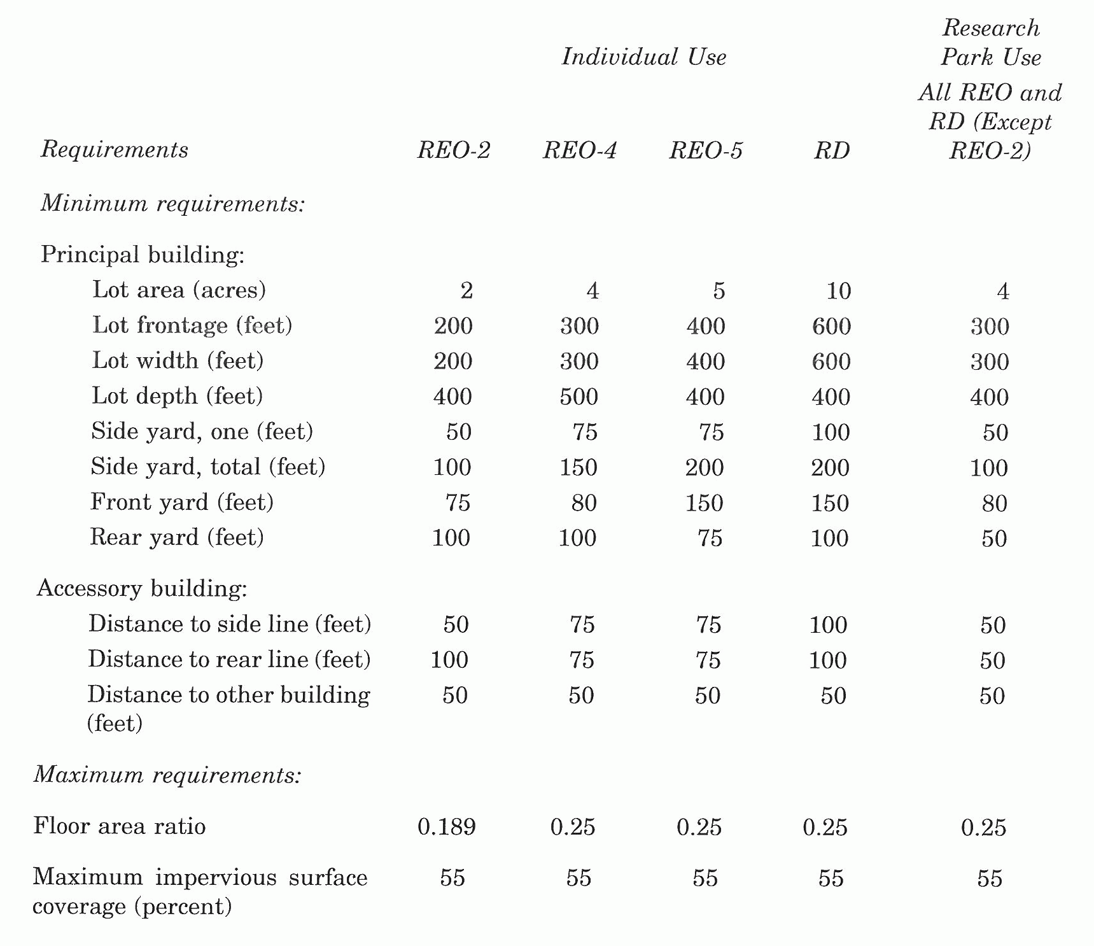
(6) General requirements.
a. Any principal building may contain more than one use or organization. More than one principal building may be constructed on any lot, provided that all ordinance requirements are met and that a minimum distance of 50 feet is provided between the principal buildings.
b. At least the first 50 feet adjacent to any street line, including state and interstate roadways, and 50 feet adjacent to any lot line shall not be used for parking and shall be planted and maintained in lawn area or ground cover or landscaped with evergreen shrubbery. Within a research park and within the REO-2 zone, the required buffer along the side or rear property lines may be reduced to 25 feet in width.
c. Any parking proposed within the front yard shall be screened by a landscaped berm of at least 4 1/2 feet in height and having a slope of three to one. The berm shall be required to screen parking located between buildings and any street, including any state or interstate roadway.
d. A minimum buffer area of 150 feet in width shall be provided along any common property line with a residential district, and a minimum buffer area of 75 feet in width shall be provided along any common property line with any residential use; except that, in the REO-2 and the REO-4 districts, these buffers may be reduced by two-thirds.
e. Yard requirements adjoining railroads. The side and rear yard requirements shall be reduced by 50 percent where they apply to those portions of a lot immediately adjoining and bounded by the right-of-way of a railroad.
f. Where the front yard area abuts a residential zone, the minimum front setback shall be 100 feet in all research parks in the REO and RD zones. Off-street parking shall be prohibited within the front yard area in these instances.
g. Cross easements to allow for traffic and pedestrian circulation between properties within the REO-2 zone shall be required as a part of any site plan approval.
h. For additional general requirements see section 160-83, General requirements in nonresidential districts.
(7) Specific requirements.
a. For uses in the RD district abutting Edgebrook Road, access shall not be permitted directly onto Edgebrook Road. However, a secondary emergency or service access may be permitted, provided that the applicant demonstrates that there will be no adverse impact on the roadway or properties in the area resulting from use of this access.
b. For uses in the RD district abutting Edgebrook Road, a buffer of at least 300 feet in width shall be provided adjacent to Edgebrook Road and shall not be used for parking and maintained in lawn area or ground cover or landscaped with evergreen shrubbery.
c. For uses in the RD district along the Edgebrook stream corridor and abutting residential districts, a buffer at least 300 feet in width shall be provided from the residential district boundary.
d. For uses in the RD district along Route 130 affected by the master plan parallel service road system the following shall apply:
1. The master plan roadway as depicted on the master plan map calls for a 50-foot wide right-of-way. Any land dedicated by a property owner will not be deducted from the properties prededication gross lot area when calculating permitted development based on FAR or MIS.
2. Applicants are to size basins, pipes, and other drainage infrastructure to accommodate that portion of the master plan roadway that is on the site subject to development.
3. Buffers, parking, and loading areas must be set back a minimum of 15 feet from the master plan road right-of-way. Parking and loading buffers are to consist of the following:
i. Parking buffer:
(a) Deciduous trees with a minimum 2 1/2-inch caliper are to be planted 35 feet on center along the entire length of the 15-foot wide buffer.
(b) A continuous buffer of three feet to four feet high shrubs is to be planted along the entire length of the 15-foot wide buffer. A minimum 3 1/2-foot high masonry wall may be substituted for the shrubs. The design of the walls must be approved by the planning board or zoning board of adjustment.
ii. Loading area buffer:
(a) Portions of the site where loading areas abut the master plan roadway, a continuous double row of evergreen trees shall be planted. Trees shall be six feet to eight feet high at time of planting and they shall be planted a maximum of 15 feet on center. Acceptable trees shall include: White pines, Douglas fir, spruce varieties, Canadian hemlock, or equal.
4. The right-of-way for the master plan roadway shall be set back a minimum of 100 feet from residential zones.
5. Principal buildings and accessory structures shall be set back a minimum of 150 feet from residential zones and a minimum of 30 feet from the right-of-way of the master planroadway.
6. Parking areas shall be setback a minimum of 150 feet from residential zones.
7. Properties affected by the master plan road system shall be required to construct that portion of the master plan roadway that traverses their property. In addition, TID obligations shall be required per ordinance with priority spending to be applied to the cost of constructing bridges within the Route 130 study area and the Route 156/Route 130 traffic signal.
(8) Minimum off-street loading. See section 160-119(e), (f), (g) and (h) for additional standards.
(9) Minimum off-street parking. See section 160-119 of this chapter for standards.
(10) Signs. See section 160-124 of this chapter for standards.
(11) Previously approved industrial parks.
a. All previously approved industrial parks, approved prior to the date of the adoption of this chapter, and now located within the REO and RD districts may be developed in accordance with the following provisions:
1. Minimum requirements.
i. Principal building:
(a) Lot area: two acres.
(b) Lot frontage: 250 feet.
(c) Lot width: 250 feet.
(d) Lot depth: 250 feet.
(e) Side yard, minimum: 35 feet.
(f) Side yard, total: 100 feet.
(g) Front yard: 75 feet.
(h) Rear yard: 50 feet.
ii.Accessory building:
(a) Distance to side line: 40 feet.
(b) Distance to rear line: 40 feet.
(c) Distance to other building: 40 feet.
2. Maximum requirements.
i. Combined coverage of principal and accessory building(s): 30 percent.
b. Uses on these properties, however, shall be limited to those listed as permitted in accordance with section 160-80(1), (2) and (3).
(12) Development credit adjustments for environmentally constrained areas. See section 160-83(11) of this chapter for standards.
(13) [Architectural design standards.] For architectural design standards see section 160-112 of this chapter.
(14) Landscaping and preservation of natural features. See sections 160-117, 160-119, and 160-130 of this chapter for design standards.
(15) Fences, walls and sight triangles. See section 160-114 for details.
(16) Source-separation or recycling plan. See section 160-134 of this chapter for require- ments.
(17) Accessory buildings. See section 160-111 of this chapter for design standards. (Code 1979, § 160-410; Ord. No. 93-008, § 12, 1-20-93; Ord. No. 95-047, 8-16-95; Ord. No. 96-010, 1-3-96; Ord. No. 96-042, 9-18-96; ;Ord. No. 96-048, 10-30-96; Ord. No. 98-045, 12-16-98; Ord. No. 02-037, 12-4-02; Ord. No. 09-013, 5-20-09; Ord. No. 11-043, 12-21-11)

