Sec. 3.22 GB General Business District Standards.
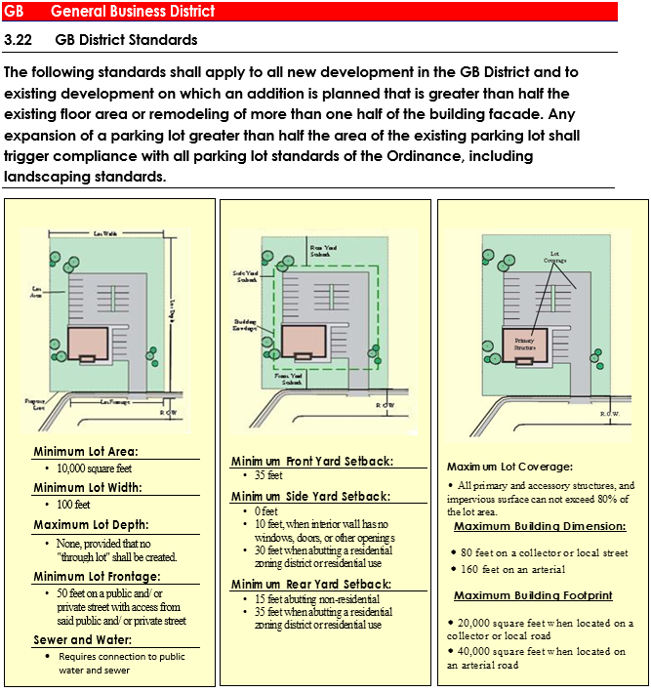
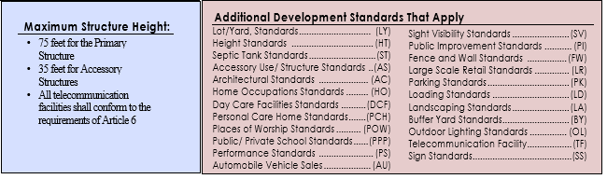
Additional Development Standards for GB
Sec. 1.0 Building Orientation
1. All buildings shall be oriented to the thoroughfare of greatest traffic intensity based on traffic volume, number of travel lanes and pedestrian activity.
2. Individual uses shall have pedestrian entrances accessible from the public sidewalk and oriented toward the thoroughfare of greatest intensity. This requirement shall not preclude secondary entrances at the side or rear of buildings.
Sec. 2.0 Architectural Standards
A. Fenestration in the BG District. Architectural design of all buildings and structures shall adhere to the following standards:
1. Display windows and pedestrian entrances shall be provided on all primary building facades. Buildings on corner lots shall also provide display windows on the secondary facade with pedestrian entrances on such facades provided at the owner's option.
2. Primary facades shall be detailed as storefronts and glazed with clear glass no less than 50 percent of the length of the facade to a minimum height of eight feet.
3. The length of primary facades shall not exceed 40 feet without intervening fenestration, articulation, architectural detailing or entryway.
4. A maximum of 15 percent of fenestration treatments may utilize architectural detailing in lieu of glass materials to meet the fenestration treatment standards.
5. Pedestrian entrances may be used to comply with fenestration treatment standards.
6. Service and utility equipment shall be screened to a minimum height of height feet using materials consistent with the building facade.
B. Building Materials. Exterior facades visible from any thoroughfare shall utilize brick, glass, hard coat stucco or approved Dryvit stucco, stone (including faux stone) or cement-based siding materials.
Metal or metallic materials may be permitted, but shall not constitute more than 40 percent of any individual facade.
C. Streetscape/Pedestrian Scale.
1. Pavements, street trees, pedestrian scale lighting, street lights, benches, signs, trash receptacles, etc. along streets shall be consistent and help create an identifiable character for the area.
2. Street trees with tree grates and landscaping are required on primary and secondary streets.
3. Sidewalks shall be constructed of concrete. Special textured pavers, brick, colored concrete, and pavers or a combination of these materials that provide patterns and/or decorative tones shall be used to accent sidewalks.
4. A 10-foot wide streetscape shall be required on the road frontage of any development. The streetscape shall include a curb zone having a minimum width of four feet (to accommodate street trees, street lights, landscaping and pedestrian amenities) and a sidewalk having a minimum width of six feet.
D. Parking Lot Landscaping.
1. One (1) canopy tree for every eight parking spaces distributed throughout designated parking areas shall be provided.
2. Individual parking bays shall be separated by a landscape median having a minimum width of eight feet. In addition, end aisle landscaped islands having a minimum width of eight feet and a minimum depth of 16 feet shall be established for every 10 parking spaces.
3. Parking lots fronting on any street shall be screened by a landscaped buffer having a minimum horizontal dimension of five feet and using the following, additional screening techniques. Acceptable screening shall be of durable construction materials and/or appropriate landscaping including:
a. A trellis or grillwork of steel or cast iron with vines;
b. A low masonry or stone wall or planter having a height of 36 to 42 inches;
c. Landscaped buffer of trees and evergreen shrubs sufficient to form a solid screen.
d. Landscaped berm of sufficient height and width to visually obscure parking areas.
E. Parking Lot Standards.
1. Shared parking between land uses is encouraged where it can be demonstrated that parking demands of the respective uses occur at different times of the day or on different days.
2. Parking lots shall not be located between the primary facade of commercial buildings and the street.
3. Parking lots exceeding 100 spaces shall be divided into smaller connected lots to minimize the impact of vehicles. Creation of substantially landscaped areas having a minimum horizontal dimension of eight feet wide shall be provided to divide large parking areas.
4. Curb cuts for parking lots shall be minimized through the use of shared driveways, where appropriate. All developments shall provide interparcel access, with written agreements between adjacent property owners subject to approval by the Clayton County Department of Transportation.
5. A pedestrian crosswalk shall be provided at all parking lot entrances and exits.
6. Lighting shall be provided in parking lots and adjacent landscaped areas for greater visibility and security.
7. Permeable pavements, excluding such materials intended for industrial applications such as #57 stone, are permitted. Parking requirements may be reduced up to 10 percent in exchange for application of Low Impact Development design that routes stormwater into landscaped areas rather than sheet flowing to a storm water collection device.
(Ord. No. 2017-41, § 3, 5-30-17)

