OFFICE/WAREHOUSE
SPACE FOR LEASE
CHESNUT BUSINESS PARK
411C Chestnut Business Park Drive, Tomball, TX, 77375
249
99
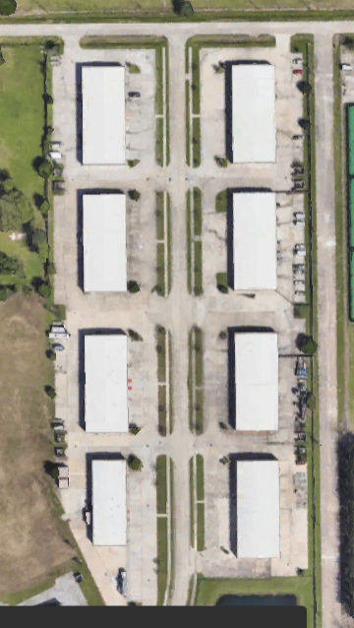
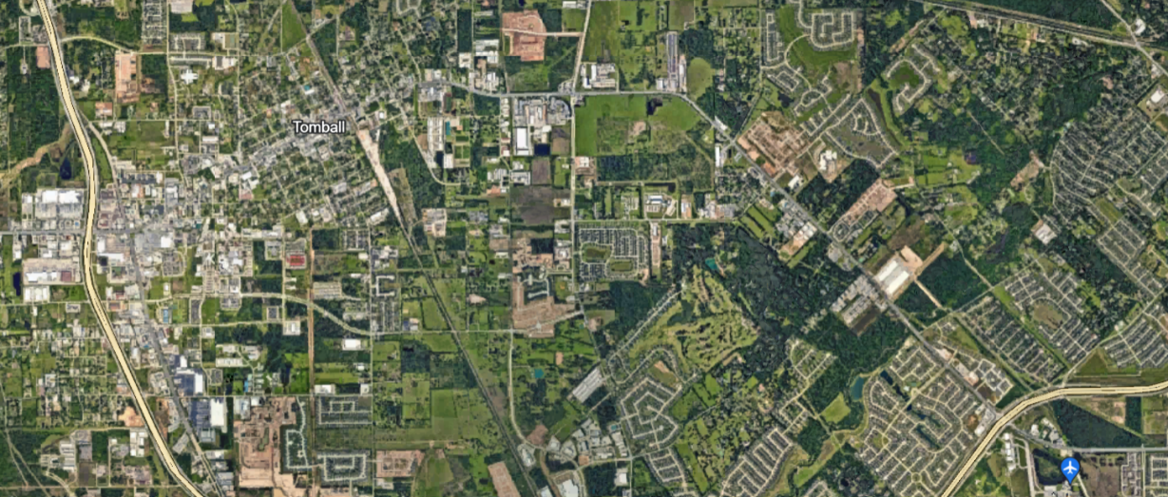
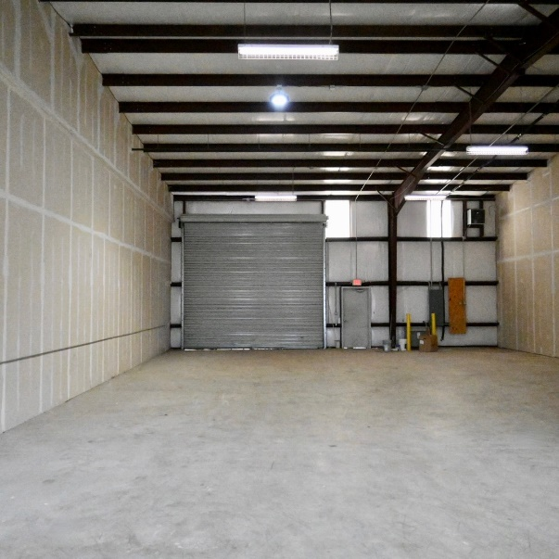
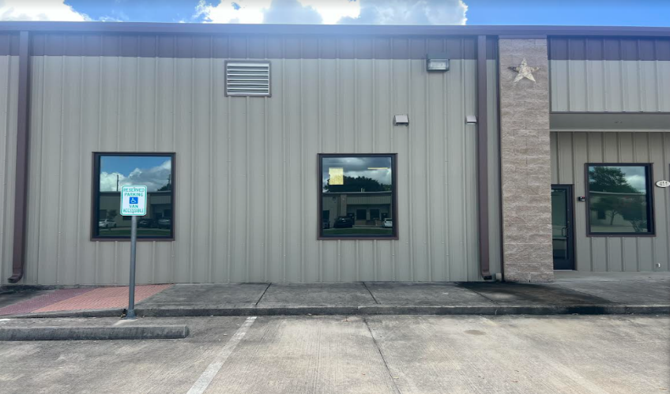
PROPERTY DETAILS

- OFFICE/WAREHOUSE FLEX SPACE AVAILABLE
- ±2,800 SF TOTAL
- ±280 Office
- LOCATED IN THE HEART OF TOMBALL, TX
- EASY ACESSS AND CLOSE PROXIMITY TO 249 & 99
- PARKING IN FRONT AND BACK
- ADDITIONAL SPACES FOR LEASE
- ONE GRADE LEVEL DOOR
- Rent: $15 SF/YR +NNN
Contact: Vanessa Guerra
Phone: 210-844-6751
Email: vguerra@vanjen.net

