The “Venus Heights” Build-to-Suit SF/MF
Development Property Purchase Opportunity
Executive Brief
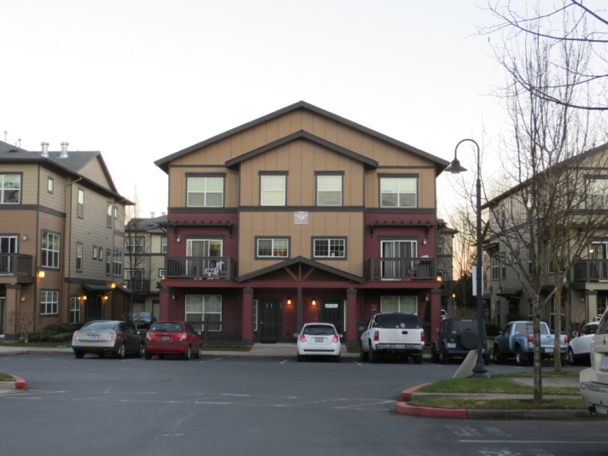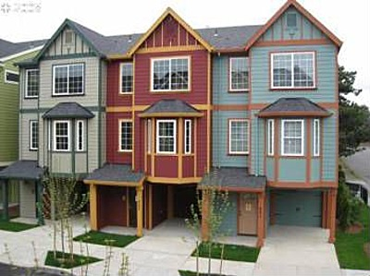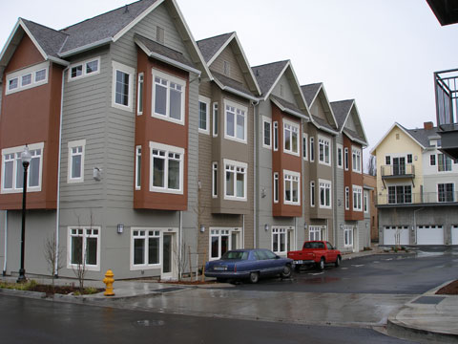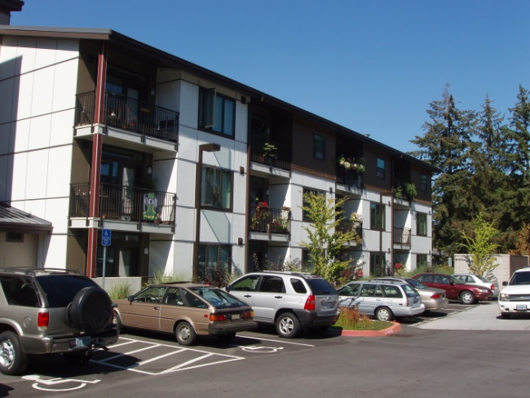
“Venus Heights” is simply your best
current investment opportunity towards
SF, MF, or other “optimal profit” build-out on 2017
Builder Ready Transit Corridor Land Use Solutions!

