THE SHENIAN COMPANY
COMMERCIAL REAL ESTATE BROKERAGE

Brownstone Building for lease!
148 North 17th Street
Philadelphia, PA 19103

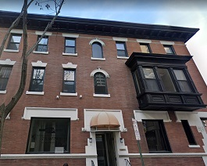
Building Features:
Private entrance brownstone
3,025 square feet over three floors
Located in the heart of Center City
Brand new hvac systems
Private kitchen and restrooms
Mix of office and open layout
Tenant has full control of hvac
Easy access to I-676
Asking rent: $17.00 + U + J
For further information contact:
P. Chris Shenian
The Shenian Company
1518 Walnut Street
Philadelphia, PA 19102
Office: 215-670-5800
Mobile: 610-331-2797
Email: shenian@aol.com
www.shenian.com

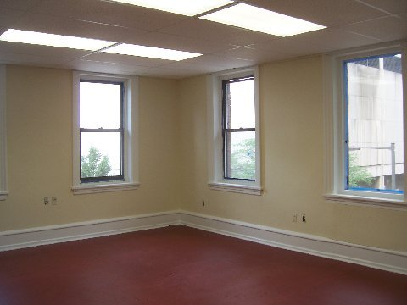

Disclaimer: This information has been obtained from sources believed reliable. We have not verified it and make no guarantee, warranty or representation about it. Any projections, opinions, assumptions or estimates used are for example only and do not represent the current or future performance of the property. You and your advisors should conduct an independent investigation of the property to determine to your satisfaction the suitability of the property for your needs.

